
Fatima Michael College of Engineering & Technology

ME6502 | HEAT AND MASS TRANSFER | L T P C
 |  | 3 0 0 3
UNIT I CONDUCTION |  | 9
Basic Concepts – Mechanism of Heat Transfer – Conduction, Convection and Radiation – Fourier Law of Conduction - General Differential equation of Heat Conduction –– Cartesian and Cylindrical Coordinates

– One Dimensional Steady State Heat Conduction – Conduction through Plane Wall, Cylinders and Spherical systems – Composite Systems – Conduction with Internal Heat Generation – Extended Surfaces

– Unsteady Heat Conduction – Lumped Analysis – Use of Heislers Chart.

UNIT II CONVECTION | 9
Basic Concepts –Heat Transfer Coefficients – Boundary Layer Concept – Types of Convection – Forced Convection – Dimensional Analysis – External Flow – Flow over

Plates, Cylinders and Spheres – Internal Flow – Laminar and Turbulent Flow – Combined Laminar and Turbulent – Flow over Bank of tubes – Free Convection – Dimensional Analysis – Flow over Vertical Plate, Horizontal Plate, Inclined Plate, Cylinders and Spheres.

UNIT III PHASE CHANGE HEAT TRANSFER AND HEAT EXCHANGERS | 9
Nusselts theory of condensation-pool boiling, flow boiling, correlations in boiling and condensation. Types of Heat Exchangers – Heat Exchanger Analysis – LMTD Method and NTU - Effectiveness – Overall Heat Transfer Coefficient – Fouling Factors.

UNIT IV RADIATION | 9
Basic Concepts, Laws of Radiation – Stefan Boltzman Law, Kirchoffs Law –Black Body Radiation –Grey body radiation -Shape Factor Algebra – Electrical Analogy – Radiation Shields –Introduction to Gas Radiation

UNIT V MASS TRANSFER | 9
Basic Concepts – Diffusion Mass Transfer – Fick‘s Law of Diffusion – Steady state Molecular Diffusion – Convective Mass Transfer – Momentum, Heat and Mass Transfer Analogy – Convective Mass Transfer Correlations

45 PERIODS

TEXT BOOKS

- Yunus A. Cengel, "Heat Transfer A Practical Approach", Tata McGraw Hill, 2010
REFERENCE BOOKS

  - Frank P. Incropera and David P. Dewitt, "Fundamentals of Heat and Mass Transfer", John Wiley & Sons,
1998.
  - Ven kateshan. S.P., " Heat Transfer", Ane Books, New Delhi, 2004.
  - Ghoshdastidar, P.S, "Heat Transfer", Oxford, 2004,

  - Nag, P.K., "Heat Transfer", Tata McGraw Hill, New Delh i, 2002
  - Ho lman, J.P., "Heat and Mass Transfer", Tata McGraw Hill, 2000

  - Ozisik, M.N., "Heat Transfer", McGraw Hill Book Co., 1994.
  - Kothandaraman, C.P., "Fundamentals of Heat and Mass Transfer", New Age International, New Delhi, 1998.

  - Yadav, R., "Heat and Mass Transfer", Central Publishing House, 1995.
  - M.Thiru maleshwar : Fundamentals of Heat and Mass Transfer, "Heat and Mass Transfer", First Edit ion, Dorling Kindersley, 2009


Fatima Michael College of Engineering & Technology1
www.studentsfocus.com


Fatima Michael College of Engineering & Technology

UNIT I - CONDUCTION

INTRODUCTORY CONCEPTS AND BASIC LAWS OF HEAT TRANSFER

We recall from our knowledge of thermodynamics that heat is a form of energy transfer that takes place from a region of higher temperature to a region of lower temperature solely due to the temperature difference between the two regions. With the knowledge of thermodynamics we can determine the amount of heat transfer for any system undergoing any process from one equilibrium state to another. Thus the thermodynamics knowledge will tell us only how much heat must be transferred to achieve a specified change of state of the system. But in practice we are more interested in knowing the rate of heat transfer (i.e. heat transfer per unit time) rather than the amount. This knowledge of rate of heat transfer is necessary for a design engineer to design all types of heat transfer equipments like boilers, condensers, furnaces, cooling towers, dryers etc. The subject of heat transfer deals with the determination of the rate of heat transfer to or from a heat exchange equipment and also the temperature at any location in the device at any instant of time.

The basic requirement for heat transfer is the presence of a ―temperature difference‖. The temperature difference is the driving force for heat transfer, just as the voltage difference for electric current flow and pressure difference for fluid flow. One of the parameters , on which the rate of heat transfer in a certain direction depends, is the magnitude of the temperature gradient in that direction. The larger the gradient higher will be the rate of heat transfer.

Heat Transfer Mechanisms :-

There are three mechanisms by which heat transfer can take place. All the three modes require the existence of temperature difference. The three mechanisms are: (i) conduction, (ii) convection and (iii) radiation

Conduction:-

It is the energy transfer that takes place at molecular levels. Conduction is the transfer of energy from the more energetic molecules of a substance to the adjacent less energetic molecules as a result of interaction between the molecules. In the case of liquids and gases conduction is due to


Fatima Michael College of Engineering & Technology2
www.studentsfocus.com


Fatima Michael College of Engineering & Technology

collisions and diffusion of the molecules during their random motion. In solids, it is due to the vibrations of the molecules in a lattice and motion of free electrons.

Fourier’s Law of Heat Conduction:-

The empirical law of conduction based on experimental results is named after the French Physicist Joseph Fourier. The law states that the rate of heat flow by conduction in any medium in any direction is proportional to the area normal to the direction of heat flow and also proportional to the temperature gradient in that direction. For example the rate of heat transfer in x-direction can be written according to Fourier‘s law as

Q_{x} α − A (dT / dx) …………………….(1.1)

Or

Q_{x} = − k A (dT / dx) W………………….. ..(1.2)

In equation (1.2), Qx is the rate of heat transfer in positive x-direction through area A of the medium normal to x-direction, (dT/dx) is the temperature gradient and k is the constant of proportionality and is a material property called ―thermal conductivity‖. Since heat transfer has to take place in the direction of decreasing temperature, (dT/dx) has to be negative in the direction of heat transfer. Therefore negative sign has to be introduced in equation (1.2) to make Qx positive in the direction of decreasing temperature, thereby satisfying the second law of thermodynamics. If equation (1.2) is divided throughout by A we have

q_{x} is called the heat flux.

q_{x} = (Q_{x} / A) = − k (dT / dx) W/m²………..(1.3)

In the case of solids heat conduction is due to two effects: the vibration of lattice induced by the vibration of molecules positioned at relatively fixed positions, and energy transported due to the motion of free electrons. The relatively high thermal conductivities of pure metals are primarily due to the electronic component. The lattice component of thermal conductivity strongly depends on the way the molecules are arranged. For example, diamond, which is highly ordered crystalline solid, has the highest thermal conductivity at room temperature.


Fatima Michael College of Engineering & Technology3
www.studentsfocus.com


Fatima Michael College of Engineering & Technology
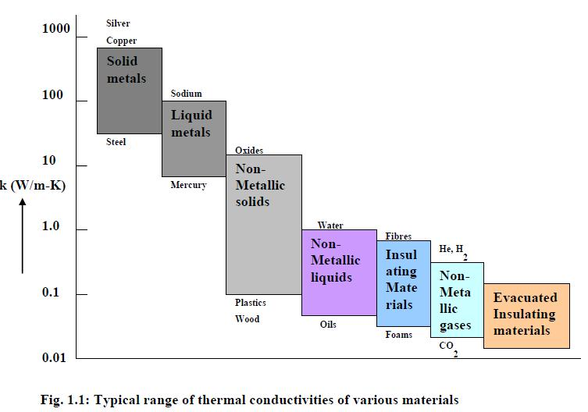

Unlike metals, which are good electrical and heat conductors, crystalline solids such as diamond and semiconductors such as silicon are good heat conductors but poor electrical conductors. Hence such materials find widespread use in electronic industry. Despite their high price, diamond heat sinks are used in the cooling of sensitive electronic components because of their excellent thermal conductivity. Silicon oils and gaskets are commonly used in the packaging of electronic components because they provide both good thermal contact and good electrical insulation.

One would expect that metal alloys will have high thermal conductivities, because pure metals have high thermal conductivities. For example one would expect that the value of the thermal conductivity k of a metal alloy made of two metals with thermal conductivities k1 and k2 would lie between k1 and k2.But this is not the case. In fact k of a metal alloy will be less than that of either metal.

Fatima Michael College of Engineering & Technology4
www.studentsfocus.com

Fatima Michael College of Engineering & Technology

The thermal conductivities of materials vary with temperature. But for some materials the variation is insignificant even for wide temperature range. At temperatures near absolute zero, the thermal conductivities of certain solids are extremely large. For example copper at 20 K will have a thermal conductivity of 20,000 W / (m-K), which is about 50 times the conductivity at room temperature. The temperature dependence of thermal conductivity makes the conduction heat transfer analysis more complex and involved. As a first approximation analysis for solids with variable conductivity is carried out assuming constant thermal conductivity which is an average value of the conductivity for the temperature range of interest.

Derive general heat conduction equation in Cartesian coordinates?

Consider a small rectangular element of sides dx, dy and dz as shown in figure. The energy balance of this rectangular element is obtained from first law of thermodynamics.

Net heat conducted into Heat generated = Heat stored in the

element from all the + within the element element -----1

coordinate directions

Net heat conducted into element from all the coordinate directions:

As per the Fourier law of heat conduction the rate of heat flow into the element in X, Y, Z directions through face ABCD, ABEF, ADHE are
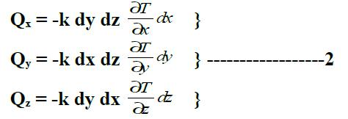

The rate of heat flow out of the element in X direction through the face EFGH is

Fatima Michael College of Engineering & Technology5
www.studentsfocus.com

Fatima Michael College of Engineering & Technology
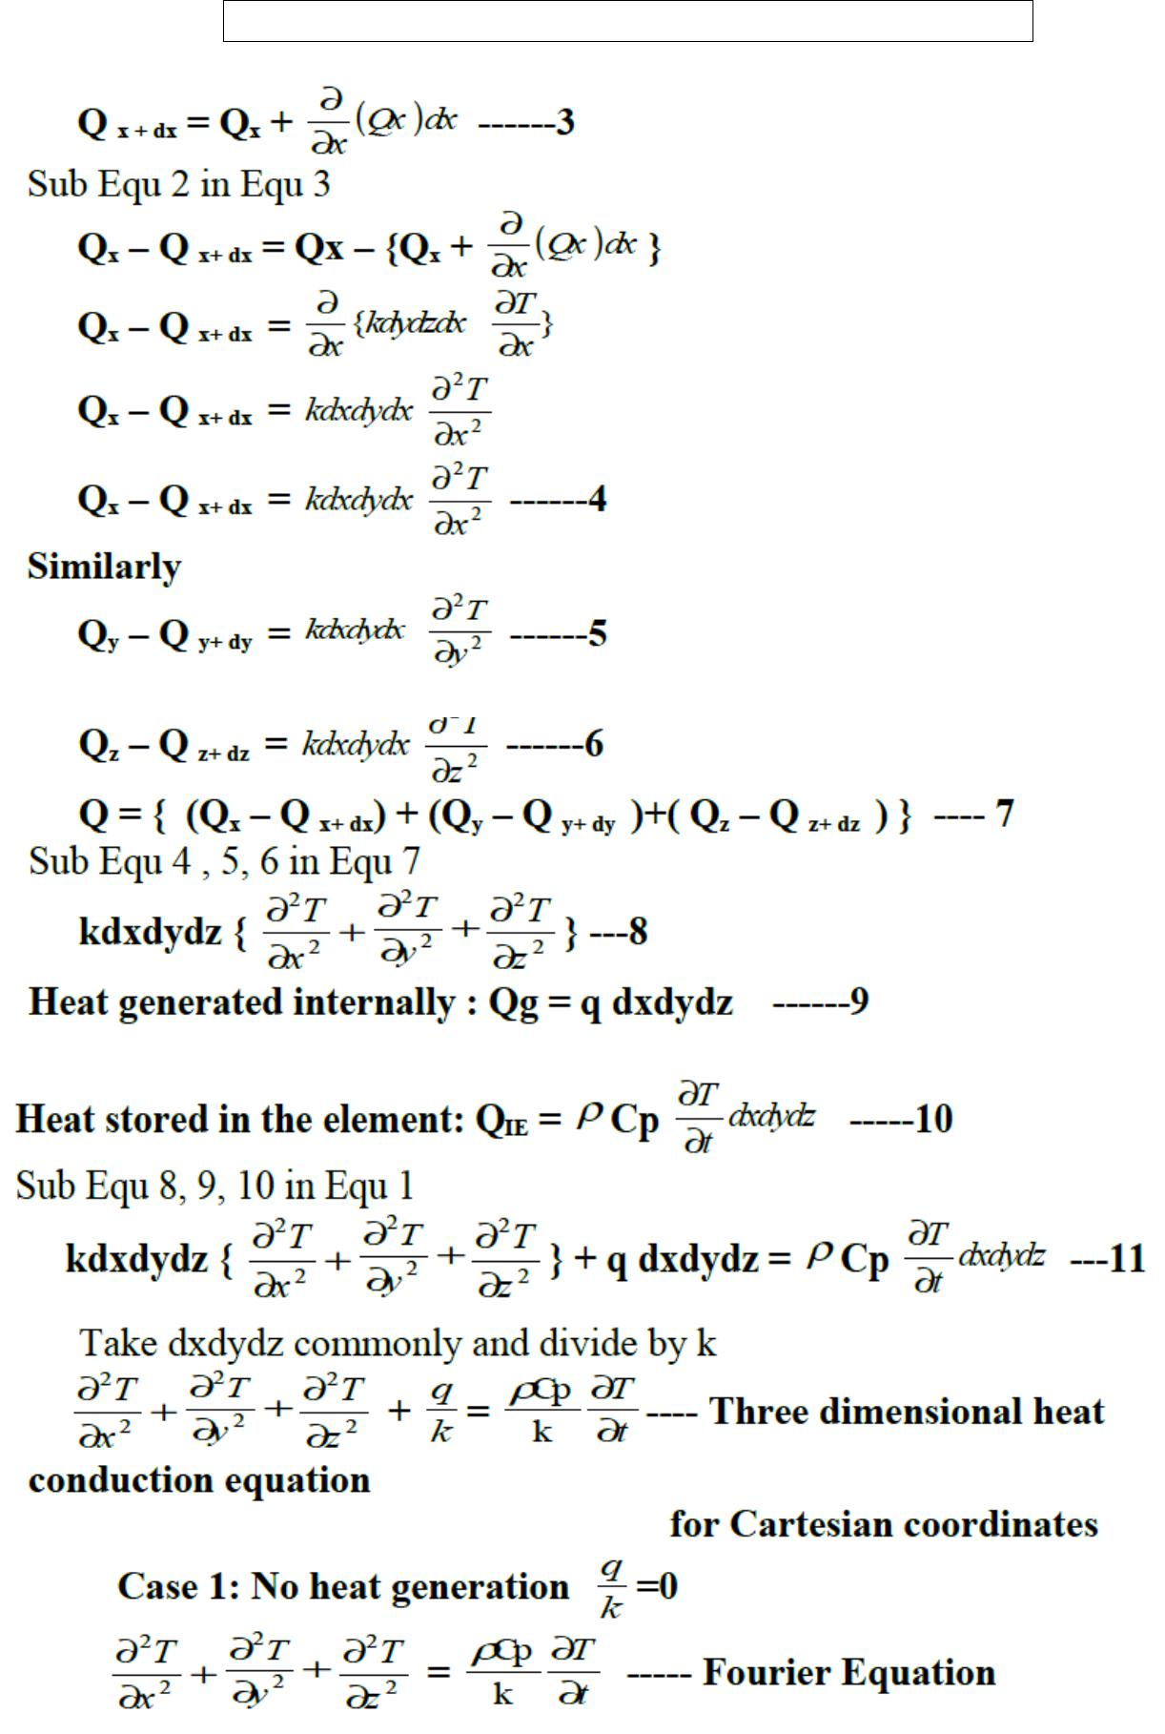

Fatima Michael College of Engineering & Technology6
www.studentsfocus.com

Fatima Michael College of Engineering & Technology
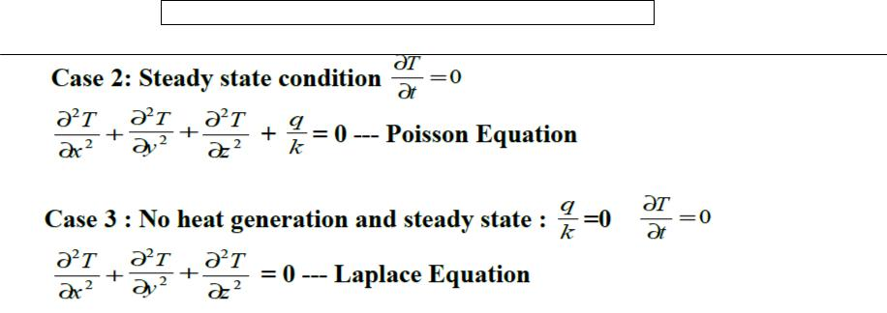

Heat transfer by conduction through a simple plane wall

A good way to start is by looking at the simplest possible case, a metal wall with uniform thermal properties and specified surface temperatures.

T 1 and T 2 are the surface temperatures either side of the metal wall, of thickness L; and the temperature difference between the two surfaces is ΔT.
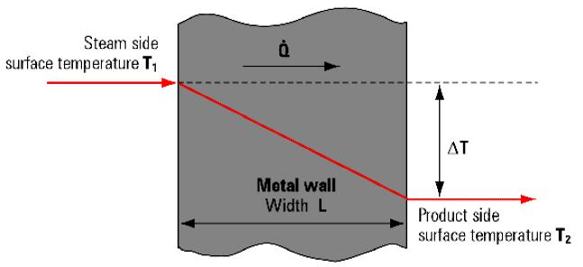

Ignoring the possible resistance to heat flow at the two surfaces, the process of heat flow through the wall can be derived from Fourier's law of conduction as shown in following equation. The term 'barrier' refers to a heat resistive film or the metal wall of a heat exchanger.
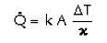

Fatima Michael College of Engineering & Technology7
www.studentsfocus.com

Fatima Michael College of Engineering & Technology
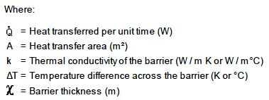
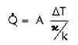

Heat Conduction through Hollow Cylinder
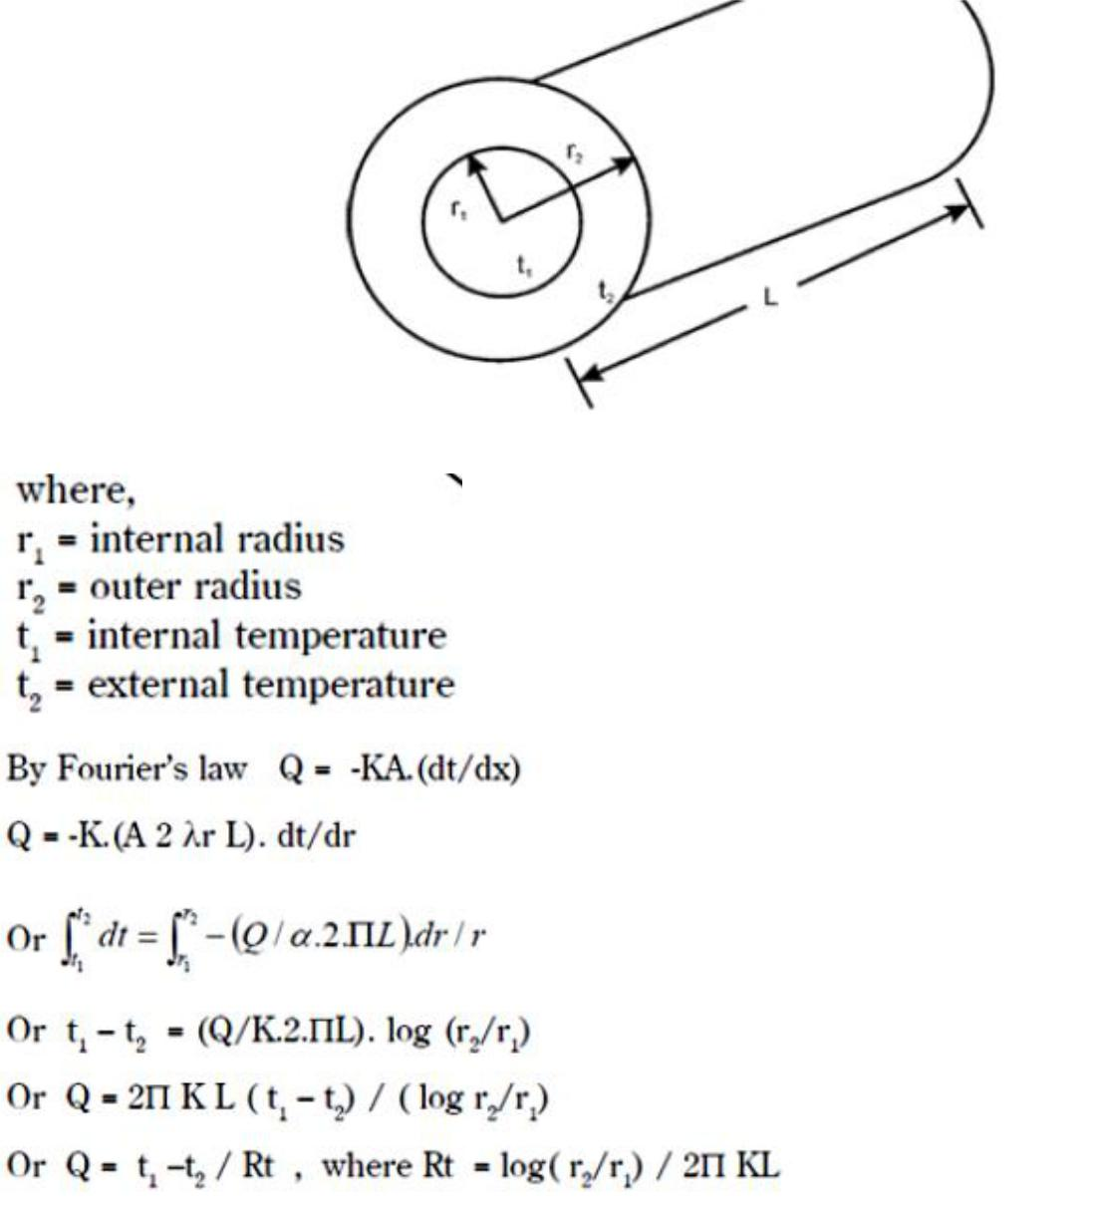

Fatima Michael College of Engineering & Technology8
www.studentsfocus.com

Fatima Michael College of Engineering & Technology

Heat Conduction through Hollow Sphere
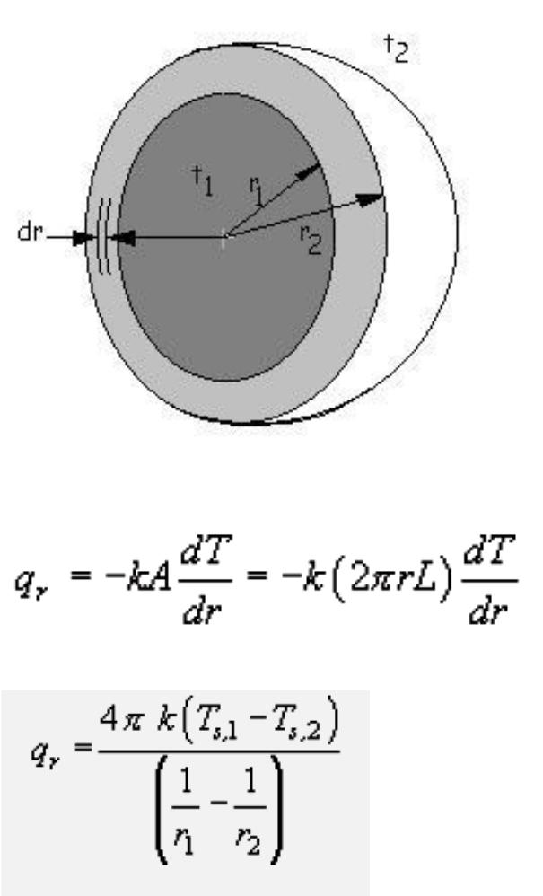

Conductance through a Flat Composite Wall
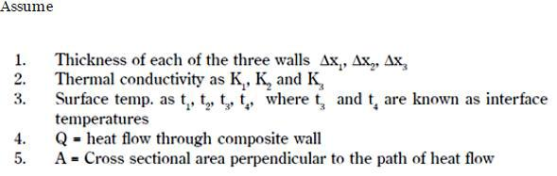

Fatima Michael College of Engineering & Technology9
www.studentsfocus.com

Fatima Michael College of Engineering & Technology
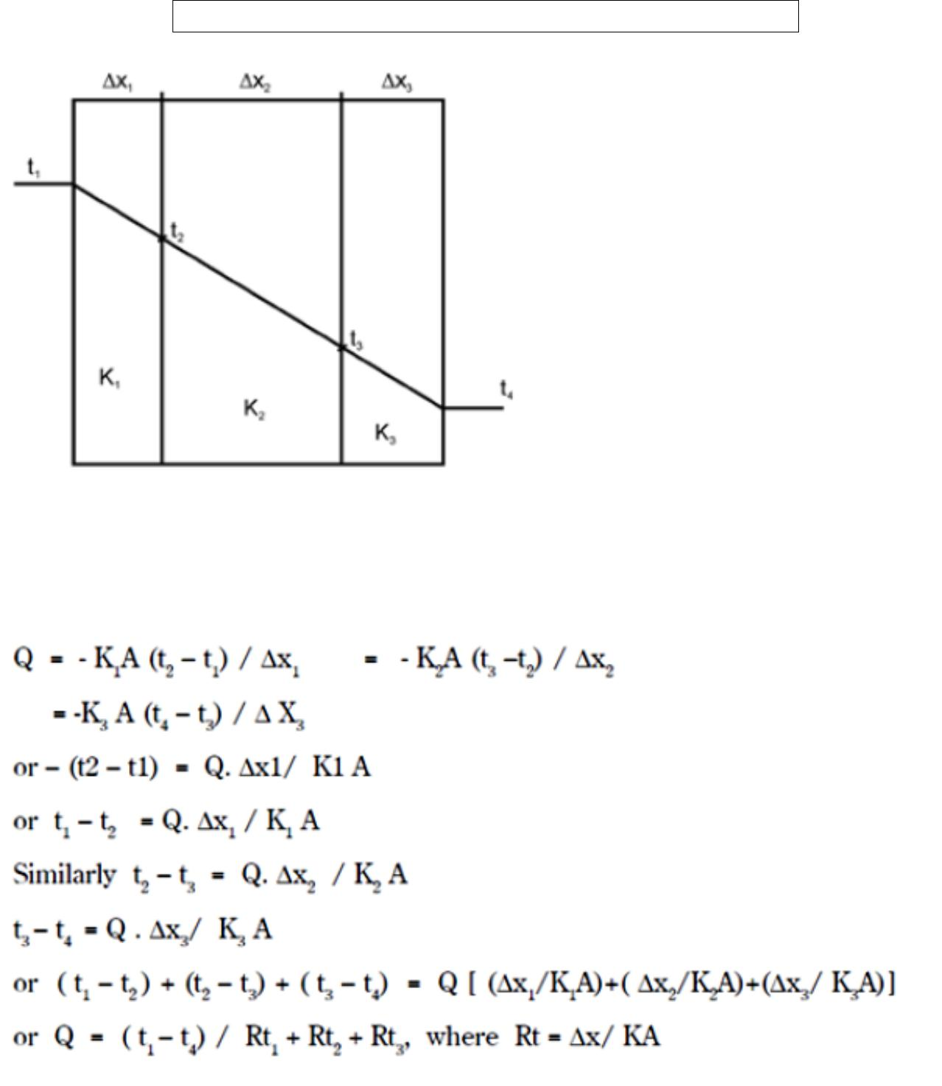

Heat Transfer From a Fin

Fins are used in a large number of applications to increase the heat transfer from surfaces. Typically, the fin material has a high thermal conductivity. The fin is exposed to a flowing fluid, which cools or heats it, with the high thermal conductivity allowing increased heat being conducted from the wall through the fin. The design of cooling fins is encountered in many situations and we thus examine heat transfer in a fin as a way of defining some criteria for design.

Fatima Michael College of Engineering & Technology10
www.studentsfocus.com

Fatima Michael College of Engineering & Technology
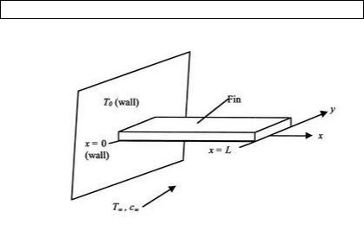

Solved Problems

- Consider a 4- m-high, 6- m-wide, and 0.3-m-thick brick Wall whose thermal conductivity is k =0.8 W/m · °C. On a Certain day, the temperatures of the inner and the outer surfaces Of the wall are measured to be 14°C and 6°C, respectively. Determine the rate of heat loss through the wall on that day.
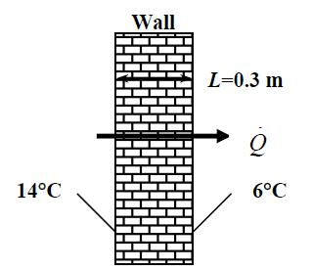

Assumptions 1 Heat transfer through the wall is steady since the surface temperatures remain constant at the specified values. 2 Heat transfer is one-dimensional since any significant temperature gradients will exist in the direction from the indoors to the outdoors. 3. Thermal conductivity is constant. Properties The thermal conductivity is given to be k = 0.8 W/m°C

Analysis

The surface area of the wall and the rate of heat loss through the wall are

Fatima Michael College of Engineering & Technology11
www.studentsfocus.com

Fatima Michael College of Engineering & Technology
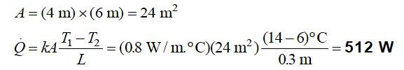

2. Consider a 4- m-high, 6- m-wide, and 0.3- m-thick brick wall whose thermal conductivity is k =0.8 W/m · °C. On a certain day, the temperatures of the inner and the outer surfaces of the wall are measured to be 14°C and 6°C, respectively. Determine the rate of heat loss through the wall on that day. assuming the space between the two glass layers is evacuated.

Assumptions 1 Heat transfer through the window is steady since the indoor and outdoor temperatures remain constant at the specified values. 2 Heat transfer is one-dimensional since any significant temperature gradients will exist in the direction from the indoors to the outdoors. 3 Thermal conductivities of the glass and air are constant. 4 Heat tra nsfer by radiation is negligible.

Properties The thermal conductivity of the glass and air are given to be kglass = 0.78 W/m.°C and kair = 0.026 W/m.°C.

Analysis The area of the window and the individual resistances are
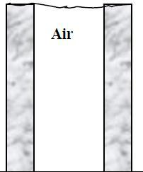

Fatima Michael College of Engineering & Technology12
www.studentsfocus.com

Fatima Michael College of Engineering & Technology
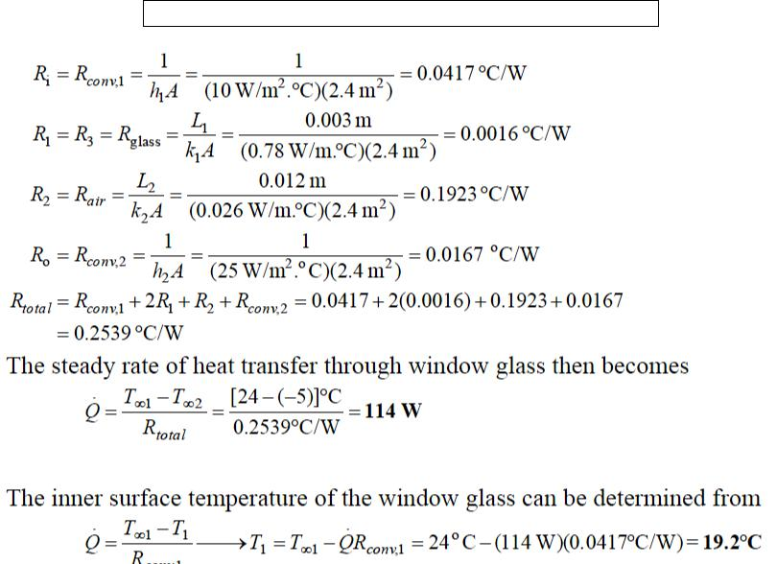

- A cylindrical resistor element on a circuit board dissipates 0.15 W of power in an environment

at 40°C. The resistor is 1.2 cm long, and has a diameter of 0.3 cm. Assuming heat to be

transferred uniformly from all surfaces, determine (a) the amount of heat this resistor dissipates during a 24- h period, (b) the heat flux on the surface of the resistor, in W/m2, and (c) the surface temperature of the resistor for a combined convection and radiation heat transfer coefficient of 9 W/m2 · °C.

Assumptions 1 Steady operating conditions exist. 2 Heat is transferred uniformly from all surfaces of the resistor.
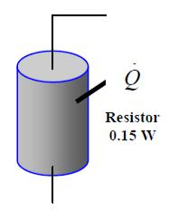

Analysis (a) The amount of heat this resistor dissipates during a 24-hour period is

Fatima Michael College of Engineering & Technology13
www.studentsfocus.com

Fatima Michael College of Engineering & Technology
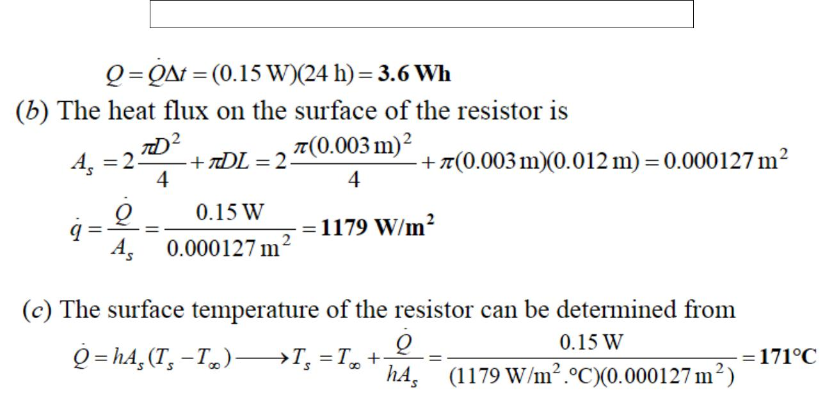

- Heat is to be conducted along a circuit board that has a copper layer on one side. The circuit board is 15 cm long and 15 cm wide, and the thicknesses of the copper and epoxy layers are 0.1

mm and 1.2 mm, respectively. Disregarding heat transfer from side surfaces, determine the percentages of heat conduction along the copper (k =386 W/m · °C) and epoxy (k = 0.26 W/m · °C) layers. Also determine the effective thermal Conductivity of the board.

Assumptions 1 Steady operating conditions exist. 2 Heat transfer is one-dimensional since heat transfer from the side surfaces is disregarded 3 Thermal conductivities are constant.
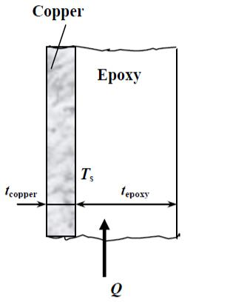

Properties The thermal conductivities are given to be k = 386 W/m °C for copper and 0.26 W/m °C for epoxy layers.

Analysis We take the length in the direction of heat transfer to be L and the width of the board to be w. Then heat conduction along this two- layer board can be expressed as

Fatima Michael College of Engineering & Technology14
www.studentsfocus.com

Fatima Michael College of Engineering & Technology

Heat conduction along an ―equivalent‖ board of thickness t = tcopper + tepoxy and thermal conductivity keff can be expressed as
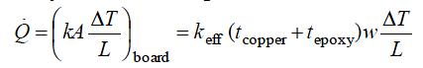

Setting the two relations above equal to each other and solving for the effective conductivity gives
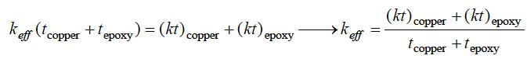

Note that heat conduction is proportional to kt. Substituting, the fractions of heat conducted along the copper and epoxy layers as well as the effective thermal conductivity of the board are determined to be
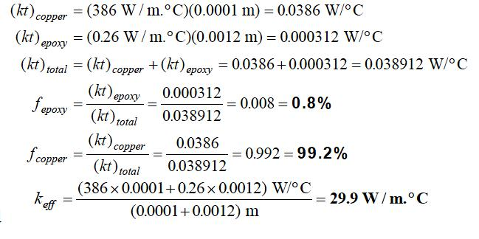

- A1-mm-thick copper plate (k = 386 W/m · °C) is sandwiched between two 5- mm-thick epoxy boards (k = 0.26 W/m · °C) that are 15 cm 20 cm in size. If the thermal contact conductance on both sides of the copper plate is estimated to be 6000 W/m · °C, determine the error involved in the total thermal resistance of the plate if the thermal contact conductance are ignored.

Fatima Michael College of Engineering & Technology15
www.studentsfocus.com

Fatima Michael College of Engineering & Technology

Assumptions 1 Steady operating conditions exist. 2 Heat transfer is one-dimensional since the plate is large. 3 Thermal conductivities are constant.
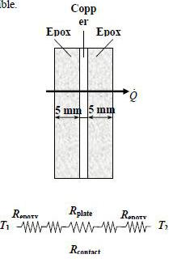
Properties The thermal conductivities are given to be k = 386 W/m.°C for copper plates and k = 0.26 W/m.°C for epoxy boards. The contact conductance at the interface of copper-epoxy layers is given to be hc = 6000 W/m2. °C

Analysis The thermal resistances of different layers for unit surface area of 1 m2 are
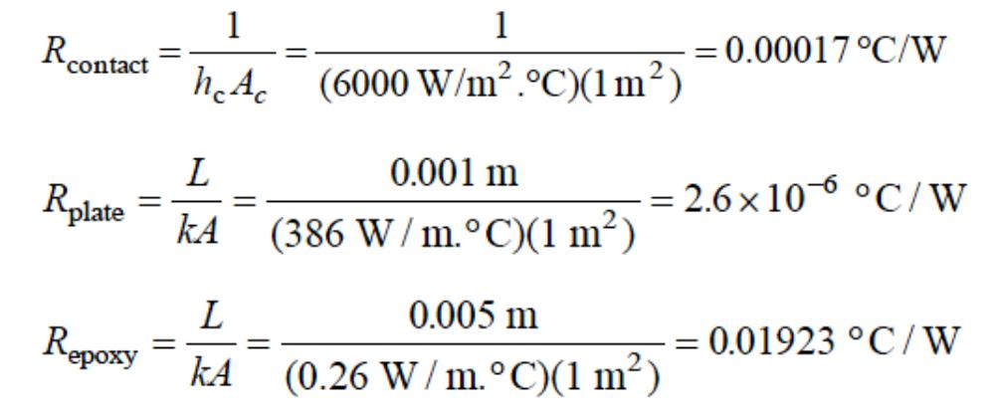

The total thermal resistance is
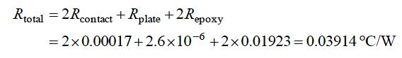

Then the percent error involved in the total thermal resistance of the plate if the thermal contact resistances are ignored is determined to be
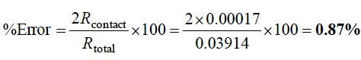

Fatima Michael College of Engineering & Technology16
www.studentsfocus.com

Fatima Michael College of Engineering & Technology

which is negligible.

- A 4-m- high and 6- m-wide wall consists of a long 18-cm 30-cm cross section of horizontal

bricks (k =0.72 W/m · °C) separated by 3-cm-thick plaster layers (k = 0.22 W/m · °C). There are also 2-cm-thick plaster layers on each side of the wall, and a 2-cm-thick rigid foam (k =0.026

W/m · °C) on the inner side of the wall. The indoor and the outdoor temperatures are 22°C and =4°C, and the convection heat transfer coefficients on the inner and the outer sides are h1 = 10 W/m2 · °C and h2 =20 W/m2 · °C, respectively. Assuming one-dimensional heat transfer and disregarding radiation, determine the rate of heat transfer through the wall.

Assumptions 1 Heat transfer is steady since there is no indication of change with time. 2 Heat transfer through the wall is one-dimensional. 3 Thermal conductivities are constant. 4 Heat transfer by radiation is disregarded.

Properties The thermal conductivities are given to be k = 0.72 W/m °C for bricks, k = 0.22 W/m °C for plaster layers, and k = 0.026 W/m °C for the rigid foam.

Analysis We consider 1 m deep and 0.33 m high portion of wall which is representative of the entire wall. The thermal resistance network and individual resistances are
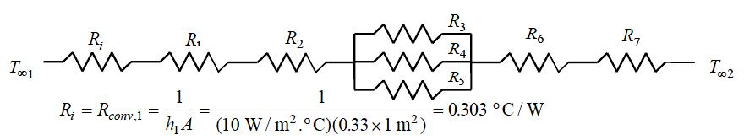

Fatima Michael College of Engineering & Technology17
www.studentsfocus.com

Fatima Michael College of Engineering & Technology
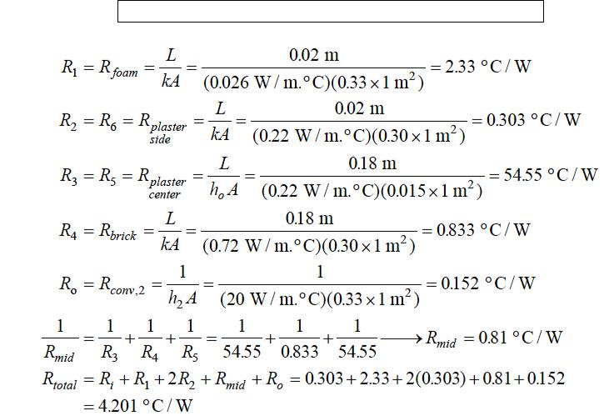

The steady rate of heat transfer through the wall per is 0.33 m²
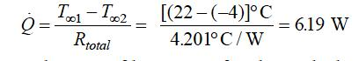

Then steady rate of heat transfer through the entire wall becomes
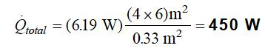

7. A50-m- long section of a steam pipe whose outer diameter is 10 cm passes through an open space at 15°C. The average temperature of the outer surface of the pipe is measured to be 150°C. If the combined heat transfer coefficient on the outer surface of the pipe is 20 W/m2.°C, determine (a) the rate of heat loss from the steam pipe, (c) the thickness of fiberglass insulation (k =0.035 W/m · °C) needed in order to save 90 percent of the heat lost. Assume the pipe

Temperature to remain constant at 150°C.

Fatima Michael College of Engineering & Technology18
www.studentsfocus.com

Fatima Michael College of Engineering & Technology

Assumptions 1 Heat transfer is steady since there is no indication of any change with time. 2 Heat transfer is one-dimensional since there is thermal symmetry about the center line and no variation in the axial direction. 3 Thermal conductivity is constant. 4 The thermal contact resistance at the interface is negligible. 5 The pipe temperature remains constant at about 150 C with or without insulation. 6 The combined heat transfer coefficient on the outer surface remains constant even after the pipe is insulated.

Properties The thermal conductivity of fiberglass insulation is given to be k = 0.035 W/m.°C.
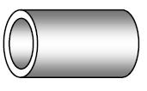

Analysis (a) The rate of heat loss from the steam pipe is
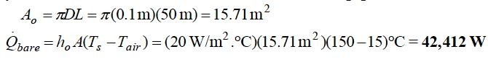

(c) In order to save 90% of the heat loss and thus to reduce it to 0.1 42,412 = 4241 W, the thickness of insulation needed is determined from
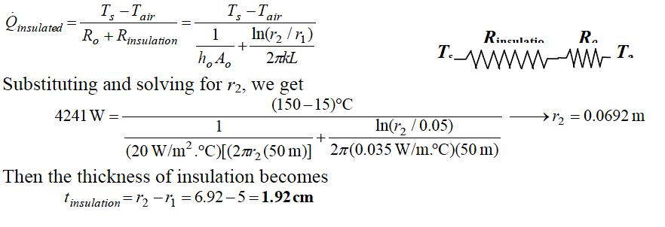

- Consider a 2-m- high electric hot water heater that has a diameter of 40 cm and maintains the hot water at 55°C. The tank is located in a small room whose average temperature i 27°C, and the heat transfer coefficients on the inner and outer surfaces of the heater are 50 and 12 W/m2 ·

°C, respectively. The tank is placed in another 46-cm-diameter sheet metal tank of negligible thickness, and the space between the two tanks is filled with foam insulation (k =0.03 W/m · °C). The thermal resistances of the water tank and the outer thin sheet metal shell are very small and

Fatima Michael College of Engineering & Technology19
www.studentsfocus.com

Fatima Michael College of Engineering & Technology

can be neglected. The price of electricity is $0.08/kWh, and the home owner pays $280 a year for water heating. Determine the fraction of the hot water energy cost of this household that is due to the heat loss from the tank. Hot water tank insulation kits consisting of 3-cm-thick fiberglass insulation (k = 0.035 W/m · °C) large enough to wrap the entire tank are available in the market for about $30. If such an insulation is installed on this water tank by the home owner himself, how long will it take for this additional insulation to pay for itself? Assumptions 1 Heat transfer is steady since there is no indication of any change with time. 2 Heat transfer is one-dimensional since there is thermal symmetry about the centerline and no variation in the axial direction. 3 Thermal properties are constant. 4 The thermal contact resistance at the interface is negligible. 5 Heat transfer coefficient accounts for the radiation effects, if any.

Properties The thermal conductivity of plastic cover is given to be k = 0.15 W/m.°C. Analysis In steady operation, the rate of heat transfer from the wire is equal to the heat generated within the wire,
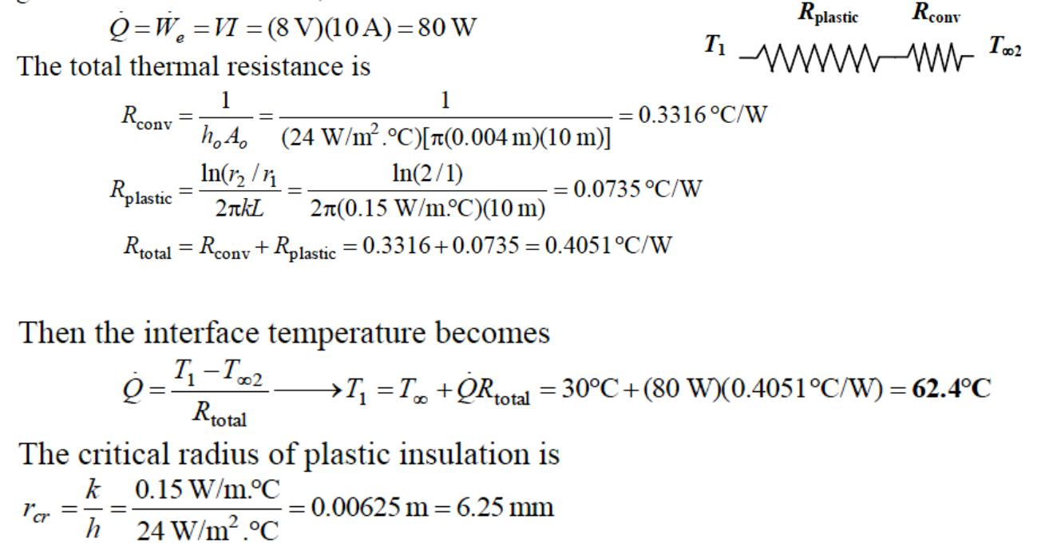

Doubling the thickness of the plastic cover will increase the outer radius of the wire to 3 mm, which is less than the critical radius of insulation. Therefore, doubling the thickness of plastic cover will increase the rate of heat loss and decrease the interface temperature.

Fatima Michael College of Engineering & Technology20
www.studentsfocus.com

Fatima Michael College of Engineering & Technology

- Obtain a relation for the fin efficiency for a fin of constant cross-sectional area Ac, perimeter

p, length L, and thermal conductivity k exposed to convection to a medium at T with a heat transfer coefficient h. Assume the fins are sufficiently long so that the temperature of the fin at the tip is nearly T. Take the temperature of the fin at the base to be Tb and neglect heat transfer from the fin tips. Simplify the relation for (a) a circular fin of diameter D and (b) rectangular fins of thickness t..

Assumptions 1 The fins are sufficiently long so that the temperature of the fin at the tip is nearly . 2 Heat transfer from the fin tips is negligible
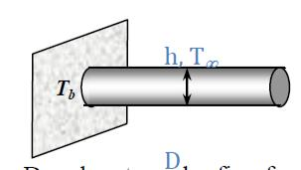
Analysis Taking the temperature of the fin at the base to be and using the heat transfer relation for a long fin, fin efficiency for long fins can be expressed as Tb
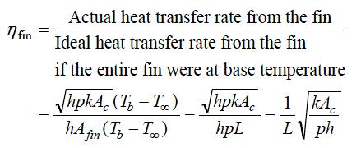

This relation can be simplified for a circular fin of diameter D and rectangular fin of thickness t and width w to be
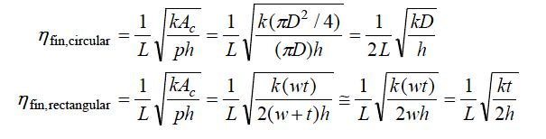

- A hot plate is to be cooled by attaching aluminum pin fins on one side. The rate of heat transfer from the 1 m by 1 m section of the plate and the effectiveness of the fins are to be determined.

Fatima Michael College of Engineering & Technology21
www.studentsfocus.com

Fatima Michael College of Engineering & Technology

Assumptions 1 Steady operating conditions exist. 2 The temperature along the fins varies in one direction only (normal to the plate). 3 Heat transfer from the fin tips is negligible. 4 The heat transfer coefficient is constant and uniform over the entire fin surface. 5 The thermal properties of the fins are constant. 6 The heat transfer coefficient accounts for the effect of radiation from the fins.
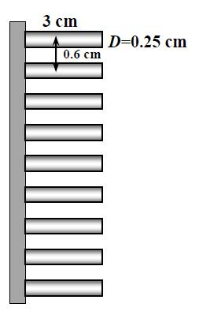

Properties The thermal conductivity of the aluminium plate and fins is given to be k = 237 W/m.°C.

Analysis Noting that the cross-sectional areas of the fins are constant, the efficiency of the circular fins can be determined to be
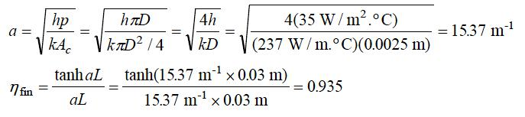

The number of fins, finned and unfinned surface areas, and heat tra nsfer rates from those areas are
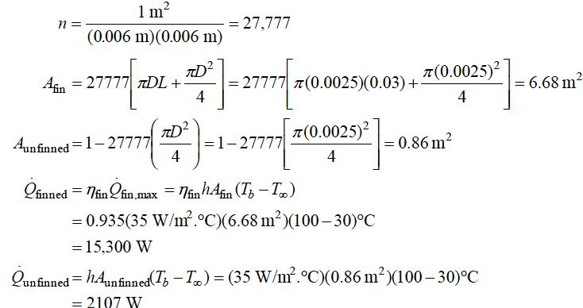

Fatima Michael College of Engineering & Technology22
www.studentsfocus.com

Fatima Michael College of Engineering & Technology
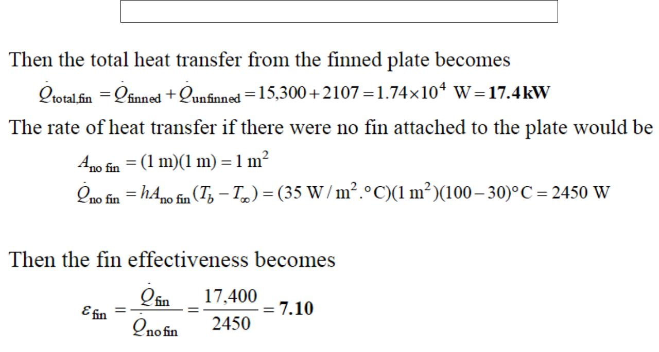

Fatima Michael College of Engineering & Technology23
www.studentsfocus.com

Fatima Michael College of Engineering & Technology

UNIT II – CONVECTION

INTRODUCTION

The preceding unit have considered the mechanism and calculation of conduction heat transfer. Convection was considered only insofar as it related to the boundary conditions imposed on a conduction problem. We now wish to examine the methods of calculating convection heat transfer and, in particular, the ways of predicting the value of the convection heat-transfer coefficient h. The subject of convection heat transfer requires an energy balance long with an analysis of the fluid dynamics of the problems concerned. Our discussion in this chapter will first consider some of the simple relations of fluid dynamics and boundary layer analysis that are important for a basic understanding of convection heat transfer. Next, we shall impose an energy balance on the flow system and determine the influence of the flow on the temperature gradients in the fluid. Finally, having obtained a knowledge of the temperature distribution, the heat-transfer rate from a heated surface to a fluid that is forced over it may be determined.

The process of heat transfer between a surface and a fluid flowing in contact with it is

called convection. If the flow is caused by an external device like a pump or blower, it is termed as forced convection. If the flow is caused by the buoyant forces generated by heating or cooling of the fluid the process is called as natural or free convection.
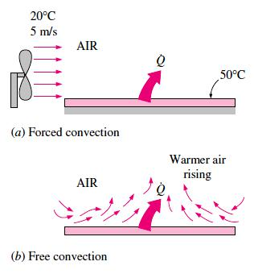

Fatima Michael College of Engineering & Technology24
www.studentsfocus.com

Fatima Michael College of Engineering & Technology
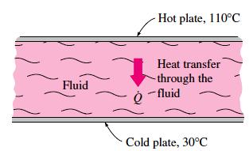

Fig. 1. Heat transfer through a fluid sandwiched between two parallel plates.

MECHANISM OF CONVECTION

In conduction, energy is transferred as heat either due to free electron flux or lattice vibration. There is no movement of mass in the direction of energy flow. In convection, energy flow occurs at the surface purely by conduction. But in the next layers both conduction and diffusion- mass movement in the molecular level or macroscopic level occurs. Due to the mass movement the rate the rate of energy transfer is higher. Higher the rate of mass movement, higher w ill be the heat flow rate.

Consider the cooling of a hot iron block with a fan blowing air over its top surface, as shown in Figure 2. We know that heat will be transferred from the hot block to the surrounding cooler air, and the block will eventually cool. We also know that the block will cool faster if the fan is switched to a higher speed. Replacing air by water will enhance the convection heat transfer even more.
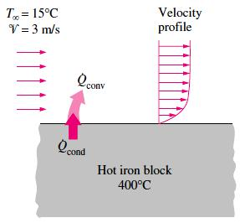

Fig. 2. The cooling of a hot block by forced convection.

Fatima Michael College of Engineering & Technology25
www.studentsfocus.com

Fatima Michael College of Engineering & Technology

Experience shows that convection heat transfer strongly depends on the fluid properties dynamic viscosity, thermal conductivity k, density, and specific heat Cp, as well as the fluid velocity. It also depends on the geometry and the roughness of the solid surface, in addition to the type of fluid flow (such as being streamlined or turbulent). Thus, we expect the convection heat transfer relations to be rather complex because of the dependence of convection on so many variables. This is not surprising, since convection is the most complex mechanism of heat transfer.
Despite the complexity of convection, the rate of convection heat transfer is observed to be proportional to the temperature difference and is conveniently expressed by Ne wton’s law of cooling as
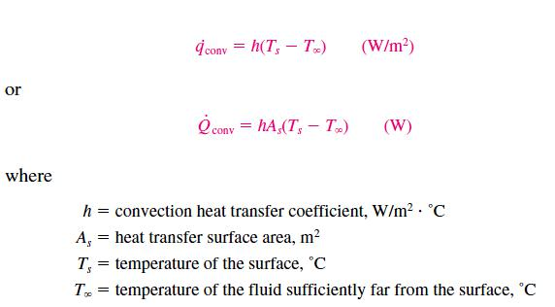

Judging from its units, the convection heat transfer coefficient h can be defined as the rate of

heat transfer between a solid surface and a fluid per unit surface area per unit temperature

difference.

CLASSIFICATION OF FLUID FLOWS

Convection heat transfer is closely tied with fluid mechanics, which is the science that deals with the behavior of fluids at rest or in motion, and the interaction of fluids with solids or other fluids at the boundaries. There are a wide variety of fluid flow problems encountered in practice, and it is usually convenient to classify them on the basis of some common characteristics to make it feasible to study them in groups. There are many ways to classify the fluid flow problems, and below we present some general categories.

Fatima Michael College of Engineering & Technology26
www.studentsfocus.com

Fatima Michael College of Engineering & Technology

Viscous versus Inviscid Flow

When two fluid layers move relative to each other, a friction force develops between them and the slower layer tries to slow down the faster layer. This internal resistance to flow is called the viscosity, which is a measure of internal stickiness of the fluid. Viscosity is caused by cohesive forces between the molecules in liquids, and by the molecular collisions in gases. There is no fluid with zero viscosity, and thus all fluid flows involve viscous effects to some degree. Flows in which the effects of viscosity are significant are called viscous flows. The effects of viscosity are very small in some flows, and neglecting

those effects greatly simplifies the analysis without much loss in accuracy. Such idealized flows of zero-viscosity fluids are called frictionless or inviscid flows.

Internal versus External Flow

A fluid flow is classified as being internal and external, depending on whether the fluid is forced to flow in a confined channel or over a surface. The flow of an unbounded fluid over a surface such as a plate, a wire, or a pipe is external flow. The flow in a pipe or duct is internal flow if the fluid is completely bounded by solid surfaces. Water flow in a pipe, for example, is internal flow, and air flow over an exposed pipe during a windy day is external flow (Fig. 3). The flow of liquids in a pipe is called open-channel flow if the pipe is partially filled with the liquid and there is a free surface. The flow of water in rivers and irrigation ditches are examples of such flows.
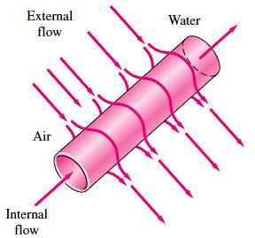

Fig. 3. Internal flow of water in a pipe and the external flow of air over the same pipe.

Fatima Michael College of Engineering & Technology27
www.studentsfocus.com

Fatima Michael College of Engineering & Technology

Compressible versus Incompressible Flow

A fluid flow is classified as being compressible or incompressible, depending on the density variation of the fluid during flow. The densities of liquids are essentially constant, and thus the flow of liquids is typically incompressible. Therefore, liquids are usually classified as incompressible substances. A pressure of 210 atm, for example, will cause the density of liquid water at 1 atm to change by just 1 percent. Gases, on the other hand, are highly compressible. A pressure change of just 0.01 atm, for example, will cause a change of 1 percent in the density of atmospheric air. However, gas flows can be treated as incompressible if the density changes are under about 5 percent, which is usually the case when the flow velocity is less than 30 percent of the velocity of sound in that gas (i.e., the Mach number of flow is less than 0.3). The velocity of sound in air at room temperature is 346 m/s. Therefore, the compressibility effects of air can be neglected at speeds under 100 m/s. Note that the flow of a gas is not necessarily a compressible flow.

Laminar versus Turbulent Flow

Some flows are smooth and orderly while others are rather c haotic. The highly ordered fluid motion characterized by smooth streamlines is called laminar. The flow of high- viscosity fluids such as oils at low velocities is typically laminar. The highly disordered fluid motion that typically occurs at high velocities characterized by velocity fluctuations is called turbulent. The flow of low-viscosity fluids such as air at high velocities is typically turbulent. The flow regime greatly influences the heat transfer rates and the required power for pumping.

Natural (or Unforced) versus Forced Flow

A fluid flow is said to be natural or forced, depending on how the fluid motion is initiated. In forced flow, a fluid is forced to flow over a surface or in a pipe by external means such as a pump or a fan. In natural flows, any fluid motion is due to a natural means such as the buoyancy effect, which manifests itself as the rise of the warmer (and thus lighter) fluid and the fall of cooler (and thus denser) fluid. This thermosiphoning effect is commonly used to replace pumps in solar water heating systems by placing the water tank sufficiently above the solar collectors (Fig. 4).

Fatima Michael College of Engineering & Technology28
www.studentsfocus.com

Fatima Michael College of Engineering & Technology
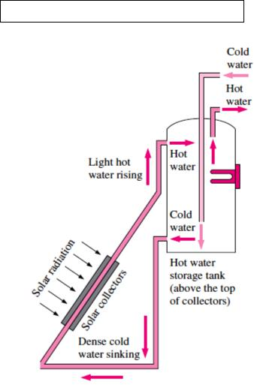

Fig. 4. Natural circulation of water in a solar water heater by thermosiphoning.

The Convection Boundary Layer

The concept of boundary layers is central to the understanding of convection heat transfer between a surface and a fluid flowing past it. In this section, velocity and thermal boundary layers are described, and their relationships to the friction coefficient and convection heat transfer coefficient are introduced.

6.1.1 The Velocity Boundary Layer

To introduce the concept of a boundary layer, consider flow over the flat plate of Figure 5. When fluid particles make contact with the surface, their velocity is reduced significantly relative to the fluid velocity upstream of the plate, and for most situations it is valid to assume that the particle velocity is zero at the wall.1 These particles then act to retard the motion of particles in the adjoining fluid layer, which act to retard the motio n of particles in the next layer, and so on until, at a distance y _ _ from the surface, the effect becomes negligible. This retardation of fluid motion is associated with shear stresses _ acting in planes that are parallel to the fluid velocity (Figure 5). With increasing distance y from the surface, the x velocity component of the fluid, u, must then increase until it approaches the free stream value u_. The subscript _ is used to designate conditions in the free stream outside the boundary layer.

Fatima Michael College of Engineering & Technology29
www.studentsfocus.com

Fatima Michael College of Engineering & Technology
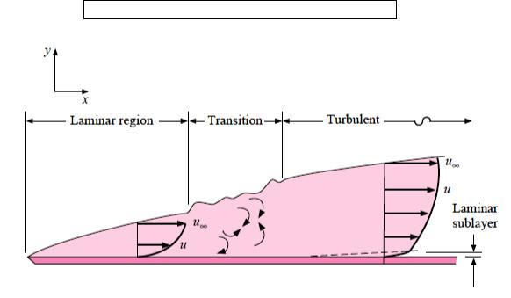

Fig. 5. Laminar velocity profile on a flat plate.
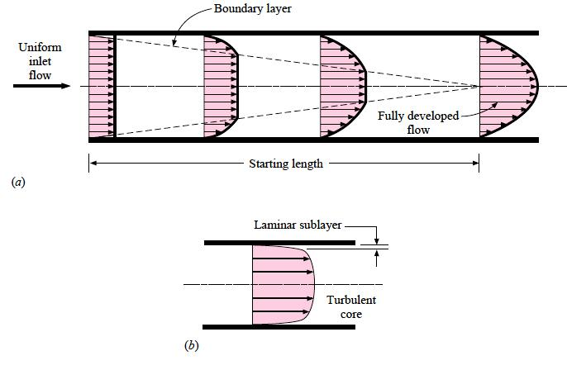

Fig. 6. Velocity profile for (a) laminar flow in a tube and (b) turbulent tube flow.

THERMAL BOUNDARY LAYER

Just as a velocity boundary layer develops when there is fluid flow over a surface, a thermal boundary layer must develop if the fluid free stream and surface temperatures differ. Consider

Fatima Michael College of Engineering & Technology30
www.studentsfocus.com

Fatima Michael College of Engineering & Technology

flow over an isothermal flat plate. At the leading edge the temperature profile is uniform, with T(y) = T.
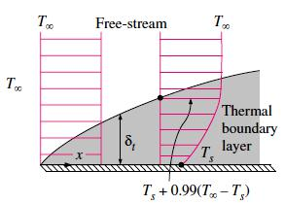

However, fluid particles that come into contact with the plate achieve thermal equilibrium at the plate‘s surface temperature.2 In turn, these particles exchange energy with those in the adjoining fluid layer, and temperature gradients develop in the fluid. The region of the fluid in which these temperature gradients exist is the thermal boundary layer, and its thickness _t is typically defined as the value of y for which the ratio [(Ts _ T )/(Ts _ T_)] _ 0.99. With increasing distance from the leading edge, the effects of heat transfer penetrate farther into the free stream and the thermal boundary layer grows. The relation between conditions in this boundary layer and the convection heat transfer coefficient may readily be demonstrated. At any distance x from the leading edge, the local surface heat flux may be obtained by applying Fourier‘s law to the fluid at y = 0.

- Hot engine oil flows over a flat plate. The temperature and velocity of the oil are 30 degree C&3 m/s respectively. The temperature of the plate is 30 degree C. compute the total drag force and the rate of heat transfer per unit width of the plate.

Assumptions 1 Steady operating condition exists. 2 The critical Reynolds number is Recr = 5*105. 3 Radiation effects are negligible.

Properties The properties of engine oil at the film temperature o f (Ts + T )/2 = (80+30)/2 =55 C = 328 K are

Fatima Michael College of Engineering & Technology31
www.studentsfocus.com

Fatima Michael College of Engineering & Technology
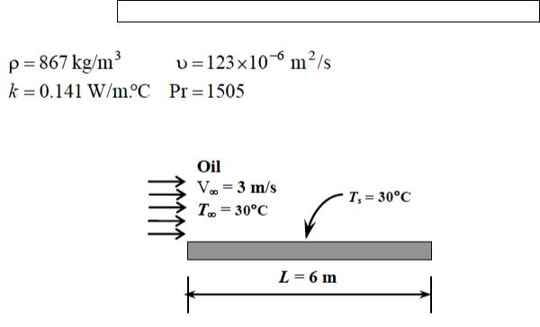

Analysis Noting that L = 6 m, the Reynolds number at the end of the plate is
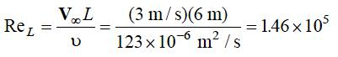
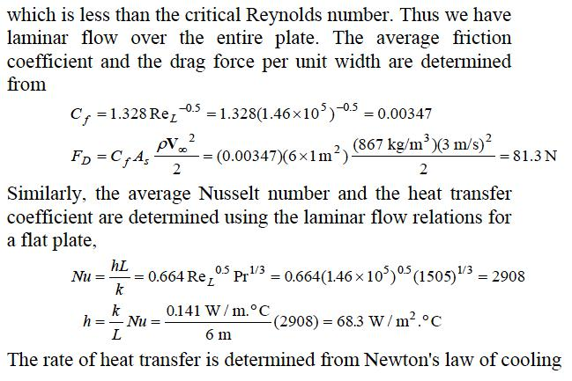

Fatima Michael College of Engineering & Technology32
www.studentsfocus.com

Fatima Michael College of Engineering & Technology

- Wind is blowing parallel to the wall of a house. The temperature and velocity of the air is 5oC& 55 km/hr. Calculate the rate of heat loss from the wall.
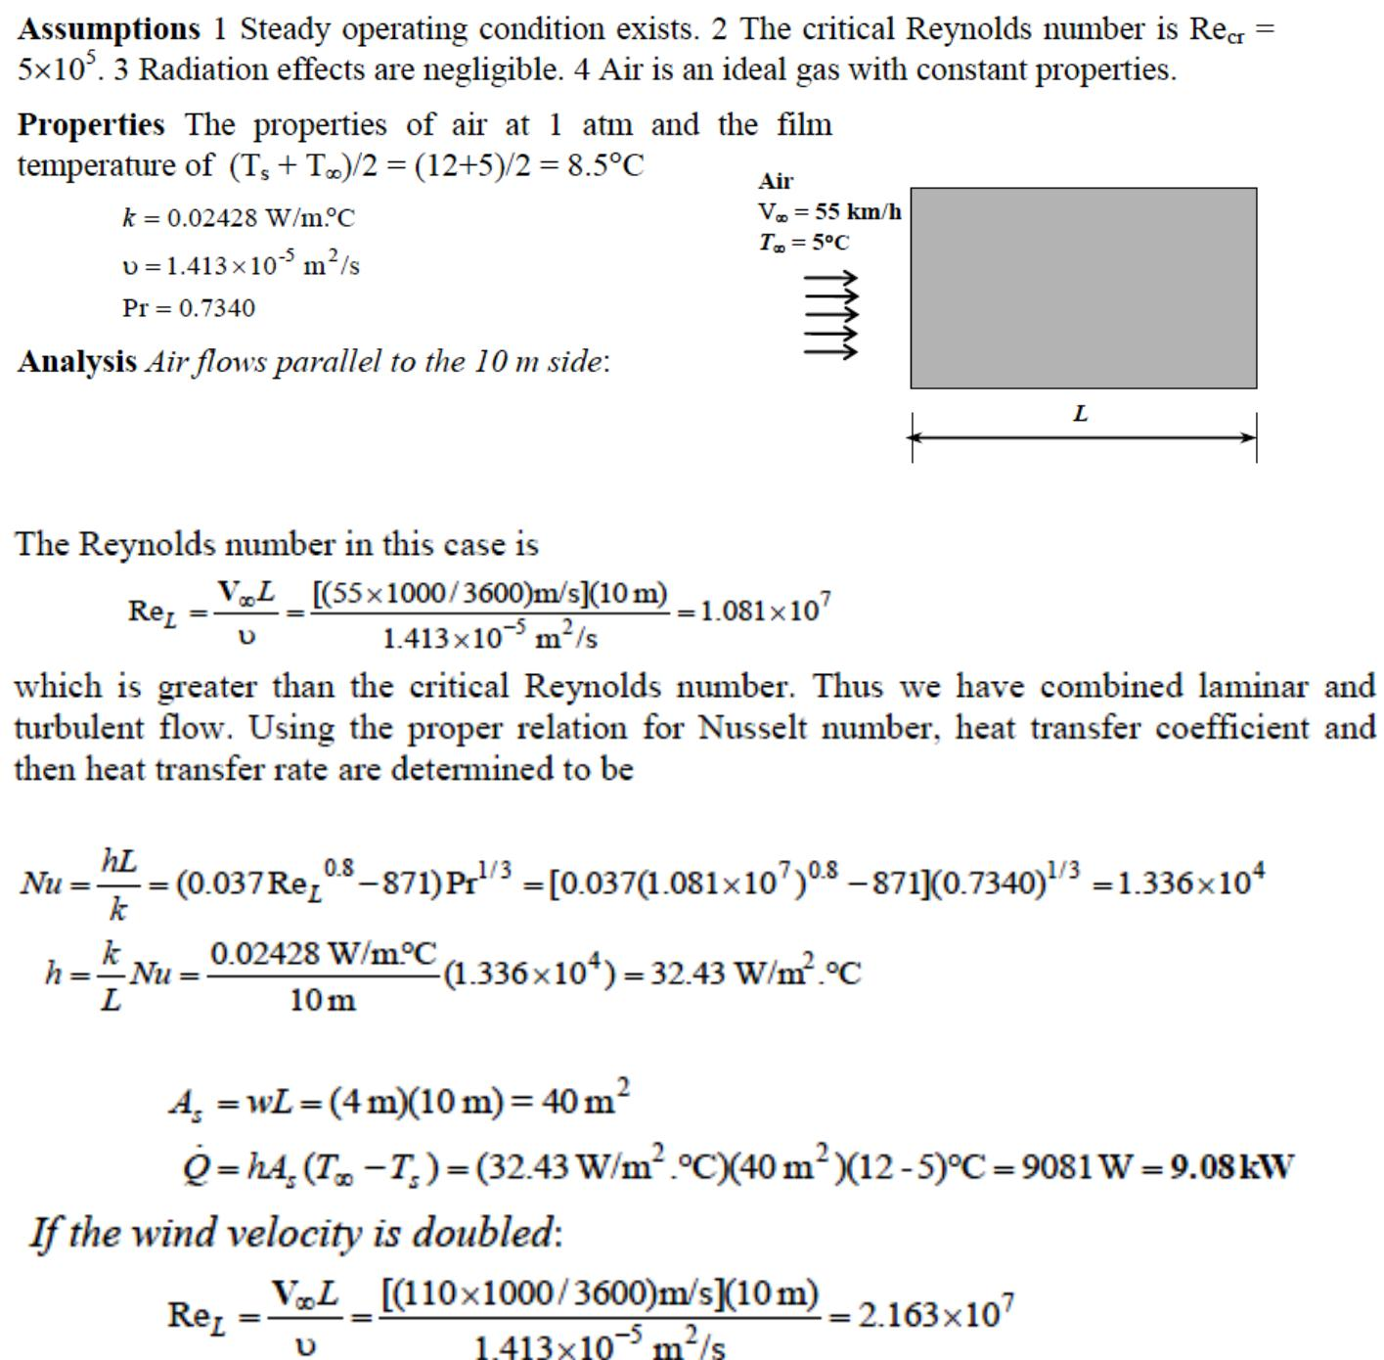

which is greater than the critical Reynolds number. Thus we have combined laminar and turbulent flow. Using the proper relation for Nusselt number, the average heat transfer coefficient and the heat transfer rate are determined to be

Fatima Michael College of Engineering & Technology33
www.studentsfocus.com

Fatima Michael College of Engineering & Technology
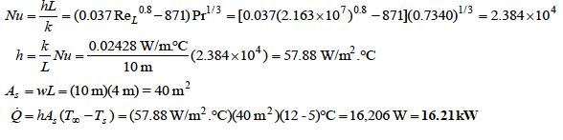

- Air is flowing over the steam pipe having steam temperature of 90 oC .The velocity and temperature of the air are 7 degree C and 50 km/ hr respectively. Calculate rate of heat loss by the air on the steam pipe

Assumptions 1 Steady operating conditions exist. 2 Radiation effects are negligible. 3 Air is an ideal gas with constant properties.
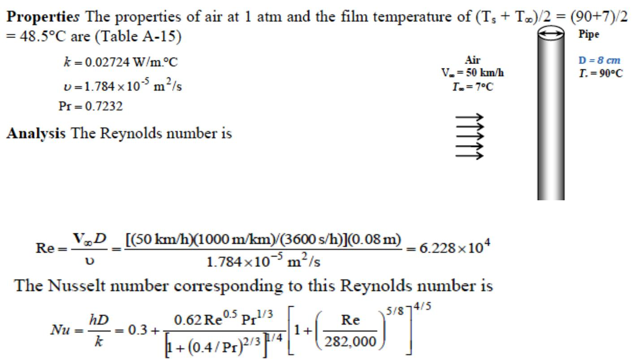

Fatima Michael College of Engineering & Technology34
www.studentsfocus.com

Fatima Michael College of Engineering & Technology
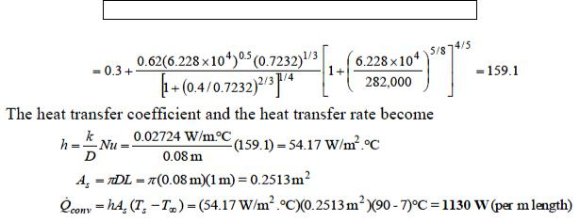

- The components of an electronic system located in a horizontal square duct (20cm×20 cm) is cooled by air flowing over the duct. The velocity and temperature of the air are 200 m/min & 30degree C. Determine the total power rating of the electronic device.
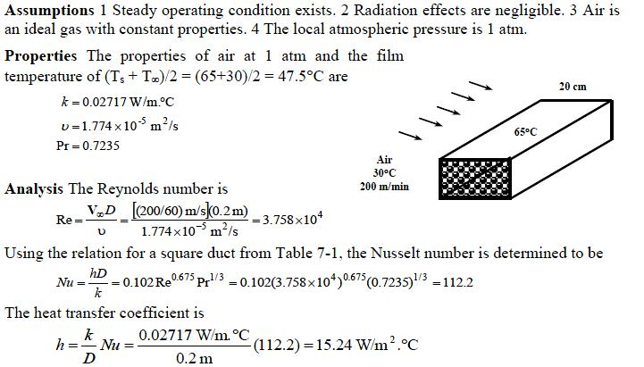

- Water at 15ºC is to be heated to 65ºC by passing it over a bundle of 4-m- long 1-cm-diameter resistance heater rods maintained at 90ºC. Water approaches the heater rod bundle in normal direction at a mean velocity of 0.8 m/s. The rods arc arranged in- line with longitudinal and

Fatima Michael College of Engineering & Technology35
www.studentsfocus.com

Fatima Michael College of Engineering & Technology

transverse pitches of SL = 4 cm and ST = 3 cm. Determine the number of tube rows NL in the flow direction needed to achieve the indicated temperature rise.

Assumptions 1 steady operating condition exists. 2 The surface temperature of the rods is constant.

Properties The properties of water at the mean temperature of (15ºC +65ºC)/2=40ºC
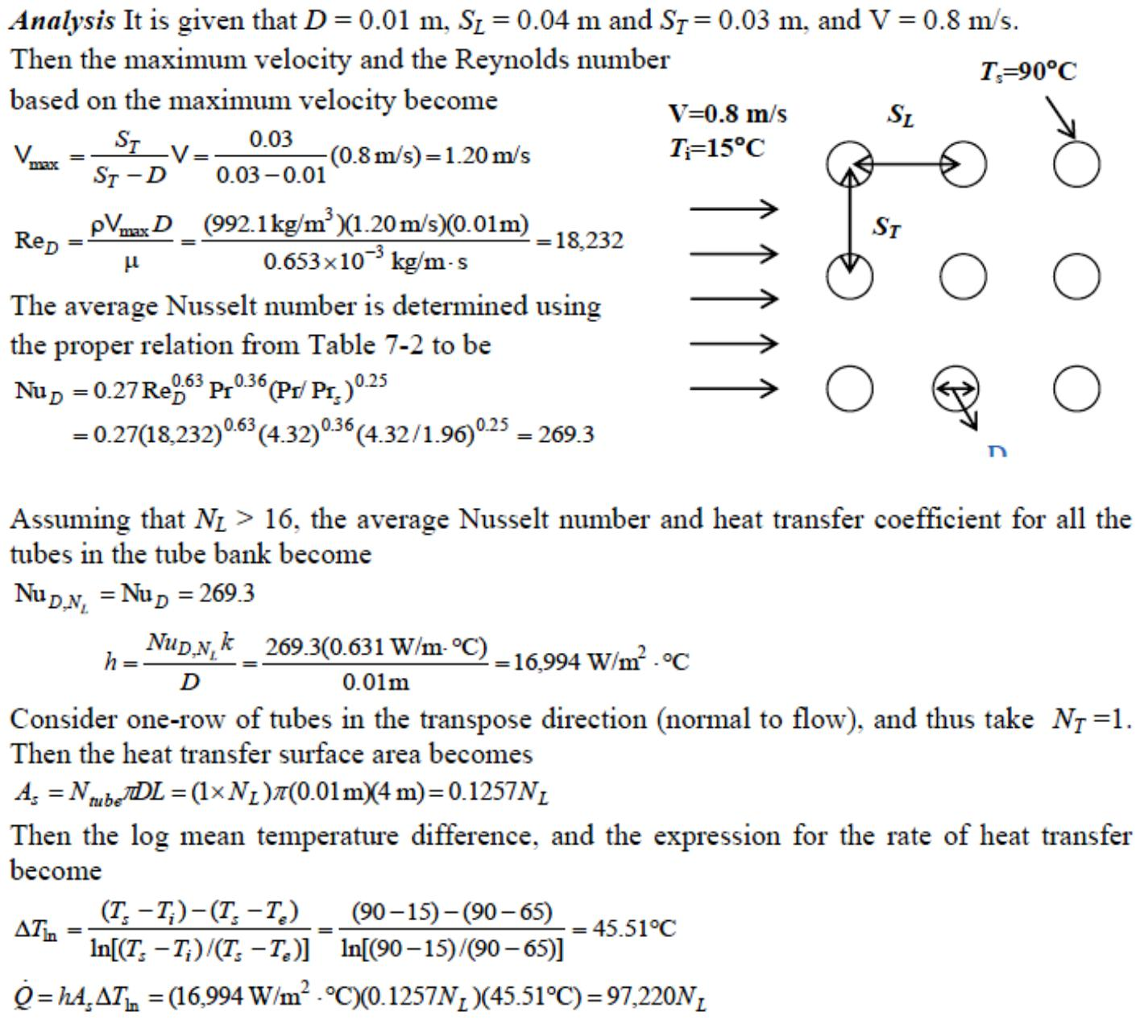

Fatima Michael College of Engineering & Technology36
www.studentsfocus.com

Fatima Michael College of Engineering & Technology
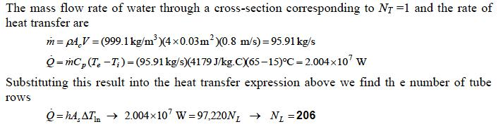

- Cooling water available at 10°C is used to condense steam at 30°C in the condenser of a power plant at a rate of 0.15 kg/s by circulating the cooling water through a bank of 5- m-long 1.2-cm- internal-diameter thin copper tubes. Water enters the tubes at a mean velocity of 4 m/s, and leaves at a temperature of 24°C. The tubes are nearly isothermal at 30°C.Determine the average heat transfer coefficient between the water and the tubes, and the number of tubes needed to achieve the indicated heat transfer rate in the condenser.
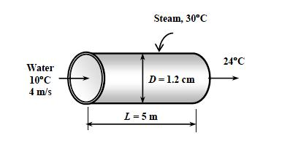

Assumptions 1 Steady operating conditions exist. 2 The surface temperature of the pipe is constant. 3 The thermal resistance of the pipe is negligible.

Properties The properties of water at the average temperature of (10+24)/2=17 C are

Fatima Michael College of Engineering & Technology37
www.studentsfocus.com

Fatima Michael College of Engineering & Technology
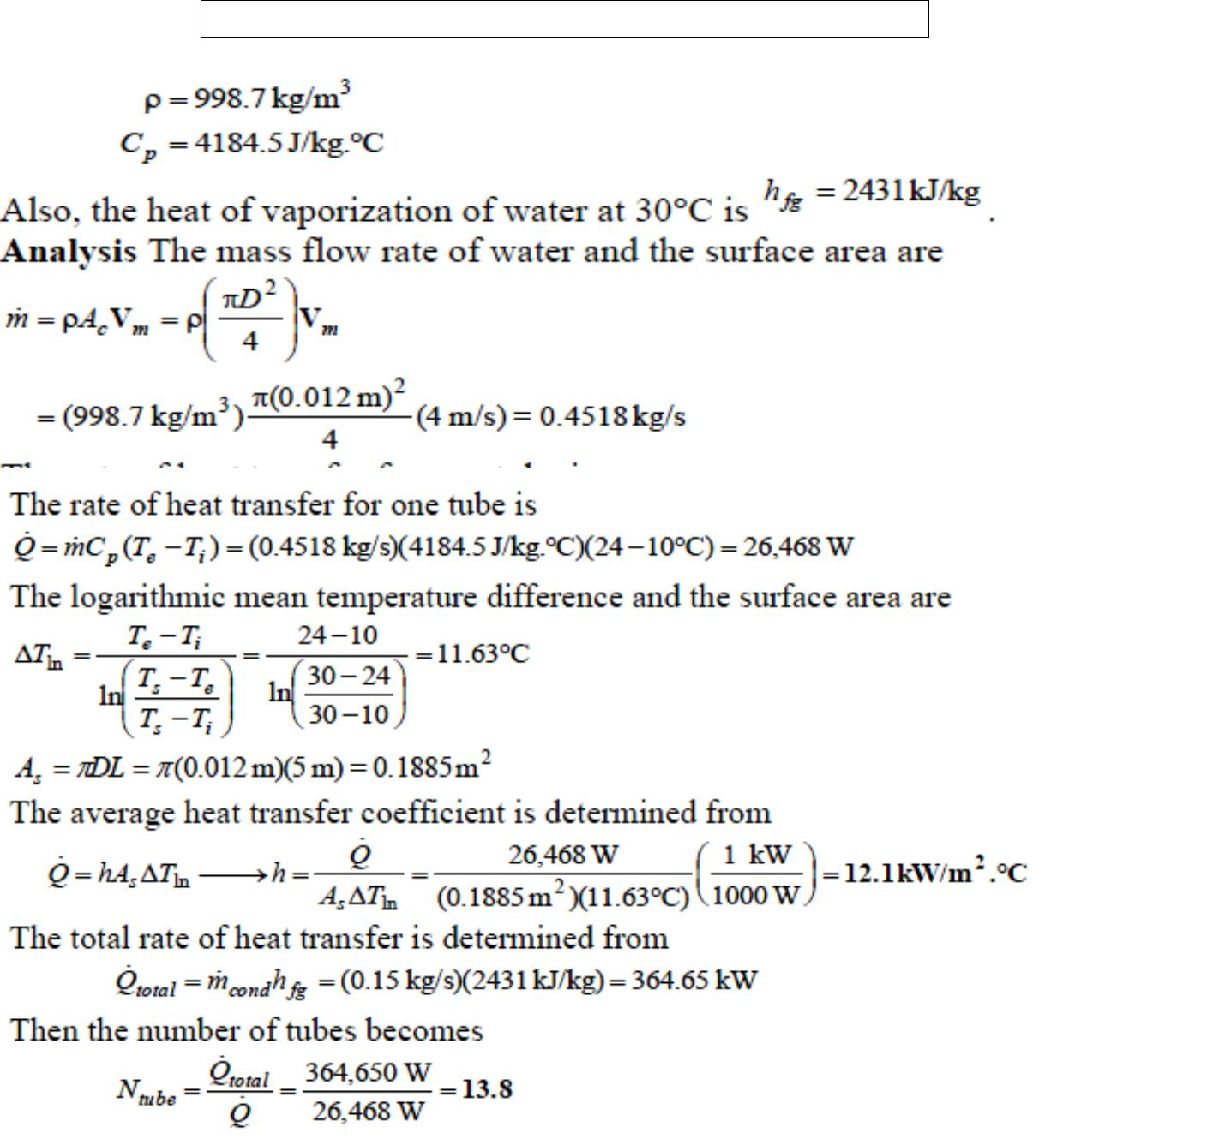

- Water is to be heated from 10°C to 80°C as it flows through a 2-cm-internal-diameter, 7- m-long tube. The tube is equipped with an electric resistance heater, which provides uniform heating throughout the surface of the tube. The outer surface of the heater is well insulated, so that in steady operation all the heat generated in the heater is transferred to the water in the tube. If the system is to provide hot water at a rate of 8 L/min, determine the power rating of the resistance heater. Also, estimate the inner surface temperature of the pipe at the exit.

Fatima Michael College of Engineering & Technology38
www.studentsfocus.com

Fatima Michael College of Engineering & Technology
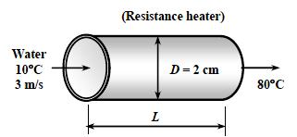

Assumptions 1 Steady flow conditions exist. 2 The surface heat flux is uniform. 3 The inner surfaces of the tube are smooth.

Properties The properties of water at the average temperature of (80+10) / 2 = 45 deg C are
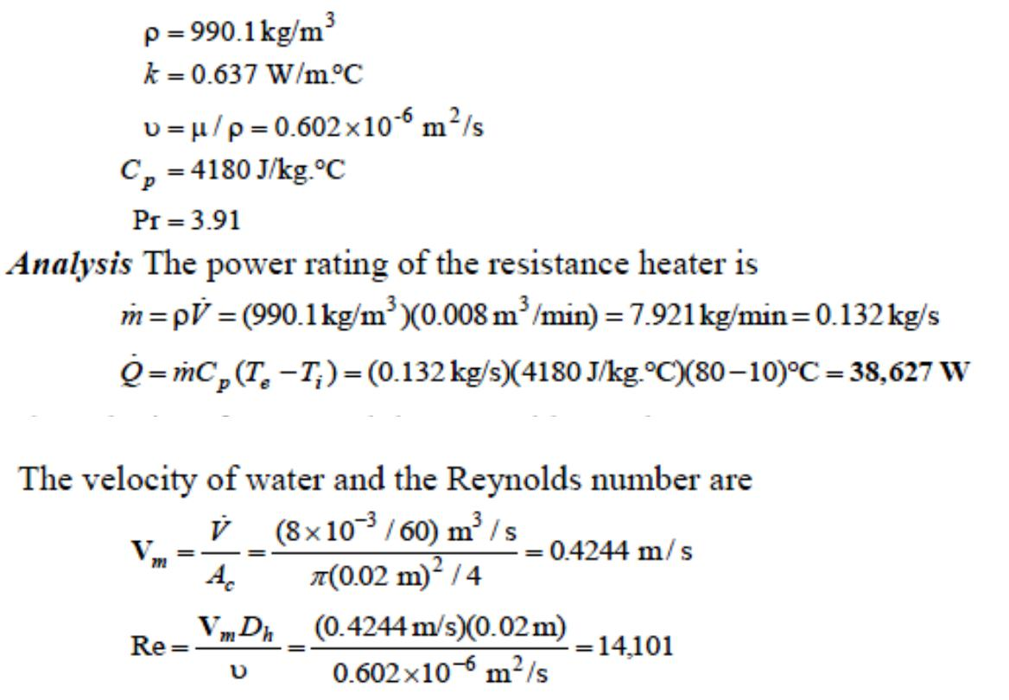

which is greater than 10,000. Therefore, the flow is turbulent and the entry lengths in this case are roughly

Fatima Michael College of Engineering & Technology39
www.studentsfocus.com

Fatima Michael College of Engineering & Technology
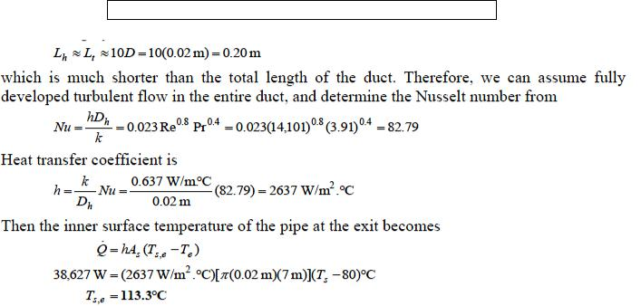

- Water is boiling in a 12-cm-deep pan with an outer diameter of 25 cm that is placed on top of a stove. The ambient air and the surrounding surfaces are at a temperature of 25°C, and the emissivity of the outer surface of the pan is 0.95. Assuming the entire pan to be at an average temperature of 98°C, determine the rate of heat loss from the cylindrical side surface of the pan to the surroundings by (a) natural convection and (b) radiation. (c) If water is boiling at a rate of
- kg/h at 100°C, determine the ratio of the heat lost from the side surfaces of the pan to that by evaporation of water. The heat of vaporization of water at 100°C is 2257 kJ/kg.
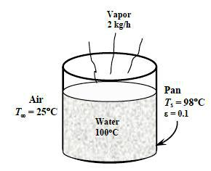

Assumptions 1 Steady operating conditions exist. 2 Air is an ideal gas with constant properties.

3 The local atmospheric pressure is 1 atm.

Fatima Michael College of Engineering & Technology40
www.studentsfocus.com

Fatima Michael College of Engineering & Technology

Properties The properties of air at 1 atm and the film temperature of (Ts+T )/2 = (98+25)/2 = 61.5 deg C are
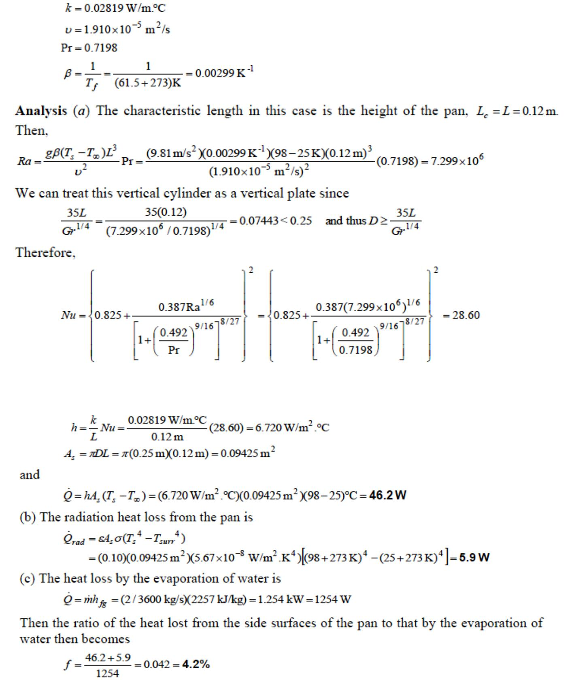

Fatima Michael College of Engineering & Technology41
www.studentsfocus.com

Fatima Michael College of Engineering & Technology

- Consider a 1.2- m-high and 2- m-wide glass window with a thickness of 6 mm, thermal conductivity k =0.78 W/m °C, and emissivity 0.9. The room and the walls that face the window are maintained at 25°C, and the average temperature of the inner surface of the window is

measured to be 5°C. If the temperature of the outdoors is 5°C, determine (a) the convection heat transfer coefficient on the inner surface of the window, (b) the rate of total heat transfer through the window, and (c) the combined natural convection and radiation heat transfer coefficient on the outer surface of the window. Is it reasonable to neglect the thermal resistance of the glass in this case?
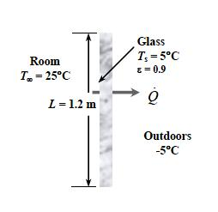

Assumptions 1 Steady operating conditions exist. 2 Air is an ideal gas with constant properties.

3 The local atmospheric pressure is 1 atm.

Properties The properties of air at 1 atm and the film temperature of (Ts+T )/2 = (5+25)/2 = 15deg C are

Fatima Michael College of Engineering & Technology42
www.studentsfocus.com

Fatima Michael College of Engineering & Technology
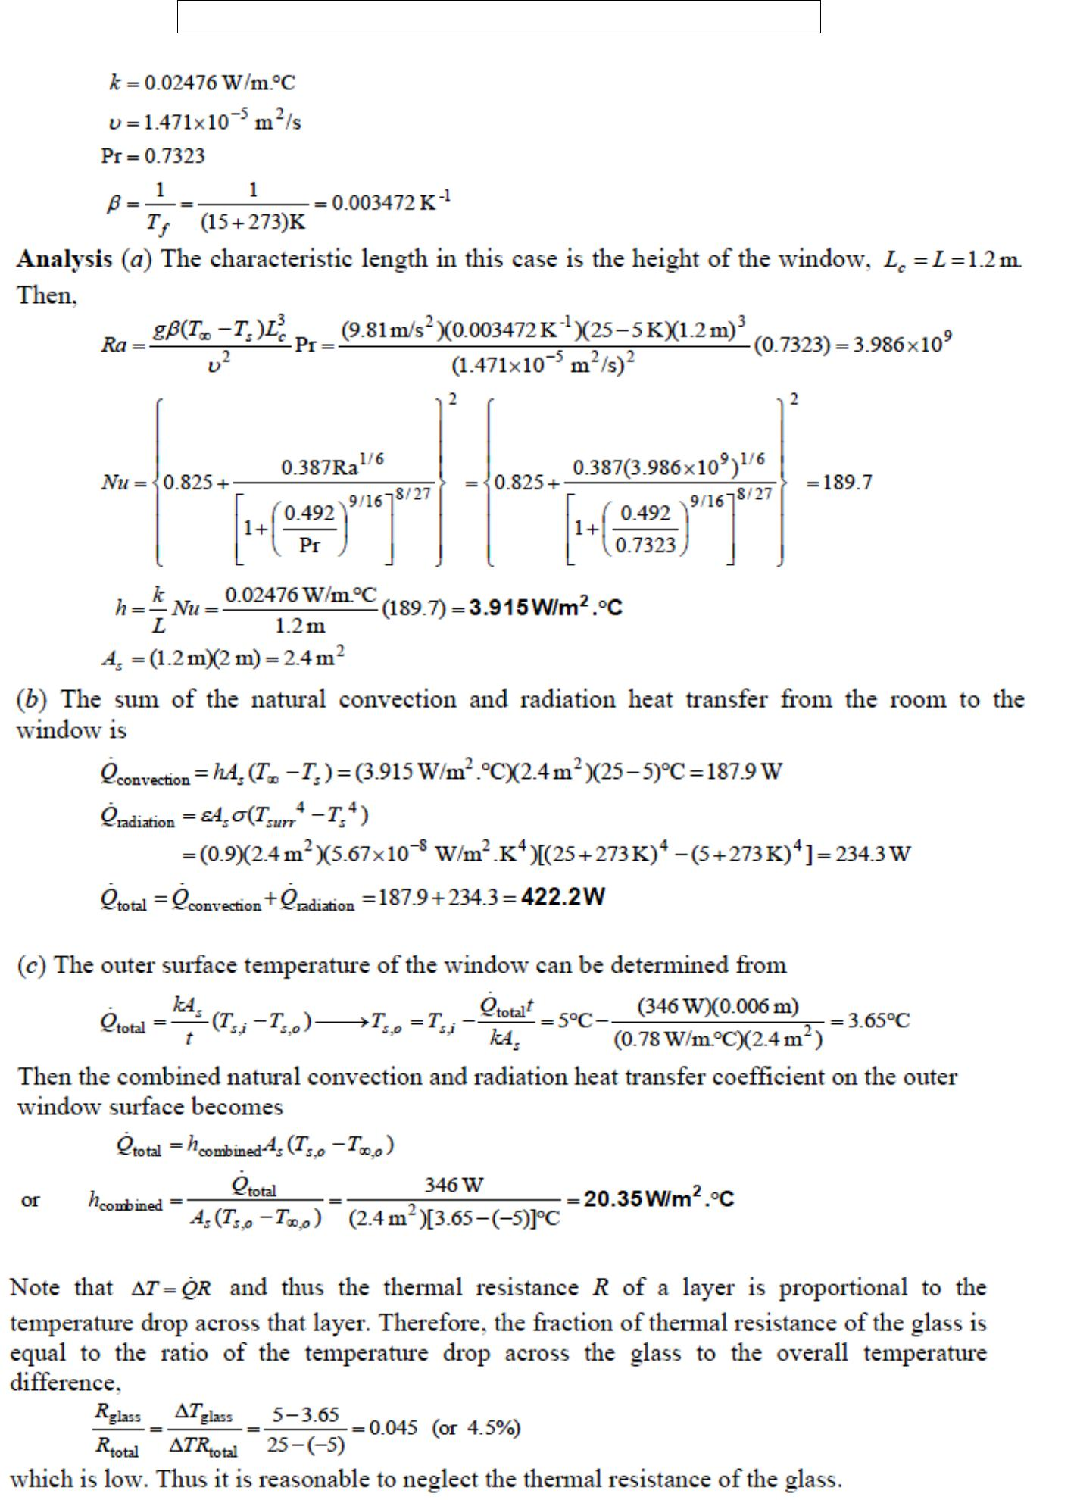

Fatima Michael College of Engineering & Technology43
www.studentsfocus.com

Fatima Michael College of Engineering & Technology

- Nitrogen at a pressure of 0.1 atm flows over a flat plate with a free stream velocity of 8 m/s.

The temperature of the gas is – 20°C. The plate temperature is 20°C. Determine the length for

the flow to turn turbulent. Assume 5 × 10 ⁵ as critical Reynolds number. Also determine the thickness of thermal and velocity boundary layers and the average convection coefficient for a plate length of 0.3 m.
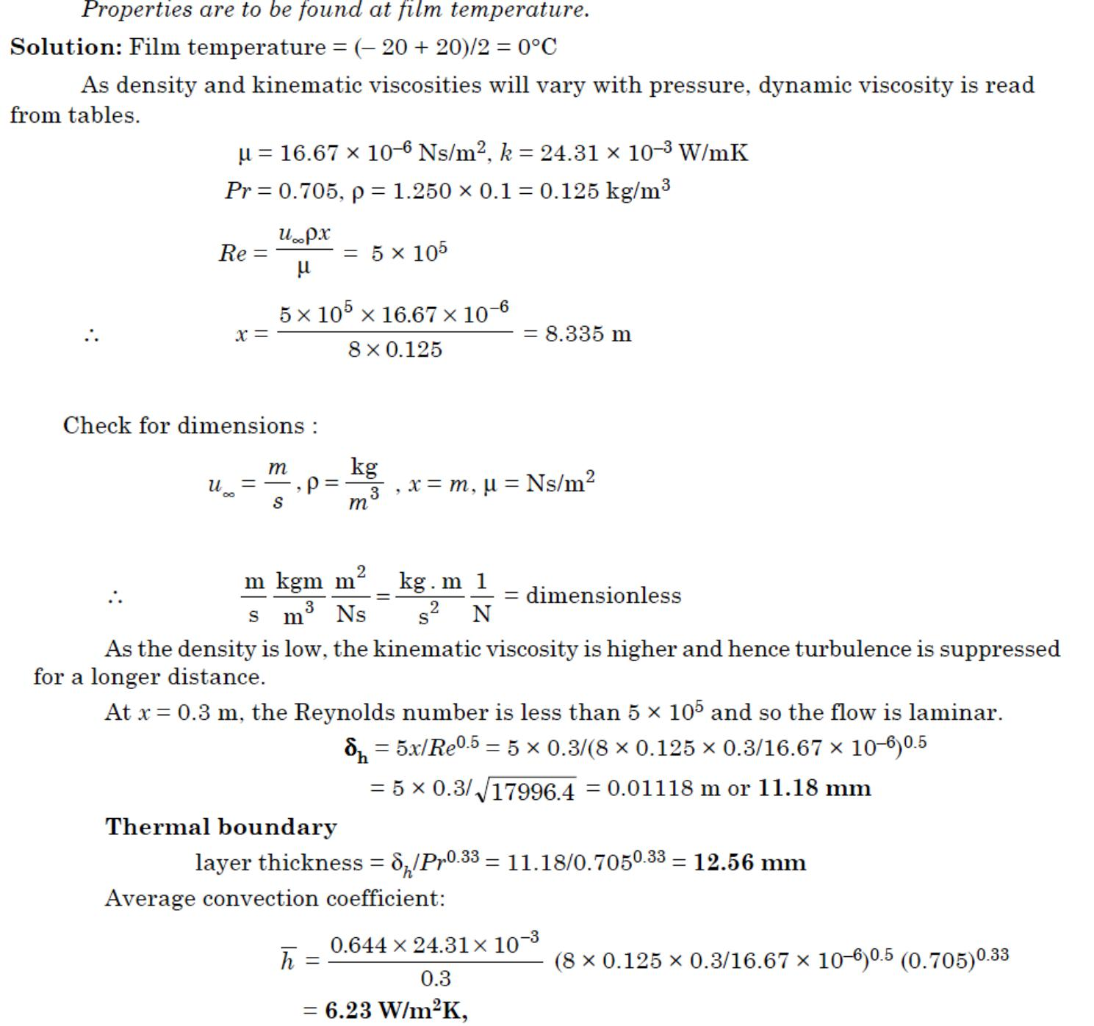

Fatima Michael College of Engineering & Technology44
www.studentsfocus.com

Fatima Michael College of Engineering & Technology
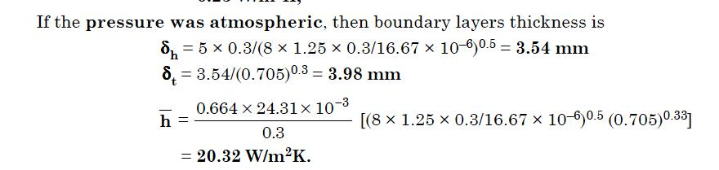

Fatima Michael College of Engineering & Technology45
www.studentsfocus.com

Fatima Michael College of Engineering & Technology

UNIT III - PHASE CHANGE HEAT TRANSFER

AND HEAT EXCHANGERS

BOILING AND CONDENSATION

We know from thermodynamics that when the temperature of a liquid at a specified pressure is raised to the saturation temperature Tsat at that pressure, boiling occurs. Likewise, when the temperature of a vapor is lowered to Tsat, condensation occurs. In this chapter we study the rates of heat transfer during such liquid-to-vapor and vapor-to-liquid phase transformations.

Although boiling and condensation exhibit some unique features, they are considered to be forms of convection heat transfer since they involve fluid motion (such as the rise of the bubbles to the top and the flow of condensate to the bottom). Boiling and condensation differ from other forms of convection in that they depend on the latent heat of vaporization hfg of the fluid and the surface tension _ at the liquid–vapor interface, in addition to the properties of the fluid in each phase. Noting that under equilibrium conditions the temperature remains constant during a phase-change process at a fixed pressure, large amounts of heat (due to the large latent heat of vaporization released or absorbed) can be transferred during boiling and condensation essentially at constant temperature. In practice, however, it is necessary to maintain some difference between the surface temperature Ts and Tsat for effective heat transfer. Heat transfer coefficients h associated with boiling and condensation are typically much higher than those encountered in other forms of convection processes that involve a single phase.

BOILING HEAT TRANSFER

Many familiar engineering applications involve condensation and boiling heat transfer. In a household refrigerator, for example, the refrigerant absorbs heat from the refrigerated space by boiling in the evaporator section and rejects heat to the kitchen air by condensing in the condenser section (the long coils behind the refrigerator). Also, in steam power plants, heat is transferred to the steam in the boiler where water is vaporized, and the waste heat is rejected from the steam in the condenser where the steam is condensed. Some electronic components are cooled by boiling by immersing them in a fluid with an

Fatima Michael College of Engineering & Technology46
www.studentsfocus.com

Fatima Michael College of Engineering & Technology

appropriate boiling temperature. Boiling is a liquid-to-vapor phase change process just like evaporation, but there are significant differences between the two. Evaporation occurs at the liquid–vapor interface when the vapor pressure is less than the saturation pressure of the liquid at a given temperature. Water in a lake at 20°C, for example, will evaporate to air at 20°C and 60 percent relative humidity since the saturation pressure of water at 20°C is 2.3 kPa and the vapor pressure of air at 20°C and 60 percent relative humidity is 1.4 kPa. Other examples of evaporation are the drying of clothes, fruits, and vegetables; the evaporation of sweat to cool the human body; and the rejection of waste heat in wet cooling towers. Note that evaporation involves no bubble formation or bubble motion.
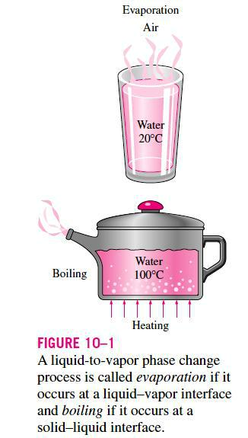

Boiling, on the other hand, occurs at the solid–liquid interface when a liquid is brought into contact with a surface maintained at a temperature Ts sufficiently above the saturation

Fatima Michael College of Engineering & Technology47
www.studentsfocus.com

Fatima Michael College of Engineering & Technology

temperature Tsat of the liquid (Fig. 10–2). At 1 atm, for example, liquid water in contact with a solid surface at 110°C will boil since the saturation temperature of water at 1 atm is 100°C. The boiling process is characterized by the rapid formation of vapor bubbles at the solid–liquid interface that detach from the surface when they reach a certain size and attempt to rise to the free surface of the liquid. When cooking, we do not say water is boiling until we see the bubbles rising to the top. Boiling is a complicated phenomenon because of the large number of variables involved in the process and the complex fluid motion patterns caused by the bubble formatio n and growth.

As a form of convection heat transfer, the boiling heat flux from a solid surface to the fluid is expressed from Newton‘s law of cooling as
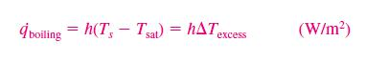
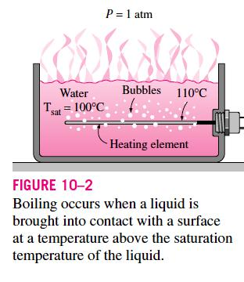

Fatima Michael College of Engineering & Technology48
www.studentsfocus.com

Fatima Michael College of Engineering & Technology

Boiling is classified as pool boiling or flow boiling, depending on the presence of bulk fluid motion (Fig. 10–3). Boiling is called pool boiling in the absence of bulk fluid flow and flow boiling (or forced convection boiling) in the presence of it. In pool boiling, the fluid is stationary, and any motion of the fluid is due to natural convection currents and the motion of the bubbles under the influence of buoyancy. The boiling of water in a pan on top of a stove is an example of pool boiling. Pool boiling of a fluid can also be achieved by placing a heating coil in the fluid. In flow boiling, the fluid is forced to move in a heated pipe or over a surface by external means such as a pump. Therefore, flow boiling is always accompanied by other convection effects.
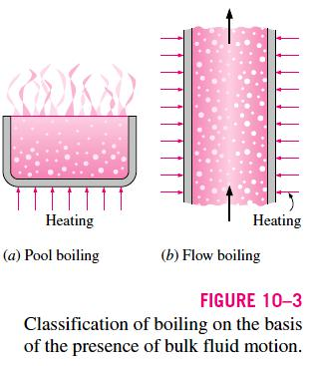

Pool and flow boiling are further classified as subcooled boiling or saturated boiling, depending on the bulk liquid temperature (Fig. 10–4). Boiling is said to be subcooled (or local) when the temperature of the main body of the liquid is below the saturation temperature Tsat (i.e., the bulk of the liquid is subcooled) and saturated (or bulk) when the temperature of the liquid is equal to Tsat (i.e., the bulk of the liquid is saturated). At the early stages of boiling, the bubbles are confined to a narrow region near the hot surface. This is because the liquid adjacent to the hot surface vaporizes as a result of being heated above its saturation temperature. But these bubbles disappear soon after they move away from the hot surface as a result of heat transfer from the bubbles to the cooler liquid surrounding them. This happens when the bulk of the liquid is at a lower temperature than the saturation temperature. The bubbles serve as ―energy movers‖ from the hot surface into the liquid body by absorbing heat from the hot surface and releasing it into

Fatima Michael College of Engineering & Technology49
www.studentsfocus.com

Fatima Michael College of Engineering & Technology

the liquid as they condense and collapse. Boiling in this case is confined to a region in the locality of the hot surface and is appropriately called local or subcooled boiling. When the entire liquid body reaches the saturation temperature, the bubbles start rising to the top. We can see bubbles throughout the bulk of the liquid,
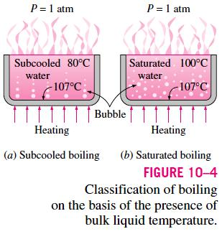

POOL BOILING CURVE
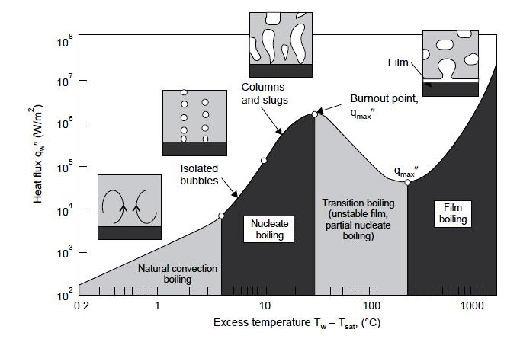

Fatima Michael College of Engineering & Technology50
www.studentsfocus.com

Fatima Michael College of Engineering & Technology
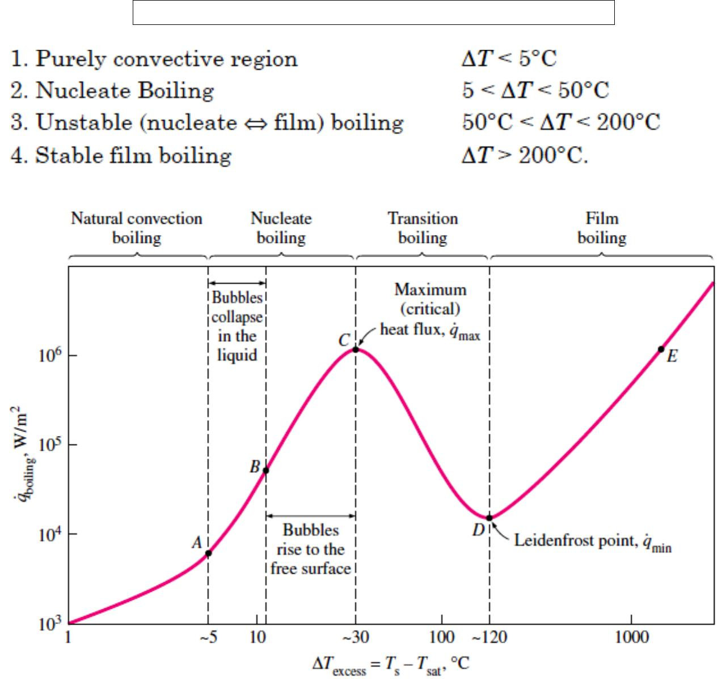

THE CORRELATIONS OBTAINED FOR NUCLEATE POOL BOILING IS GIVEN BY ROHSENOW (1952).
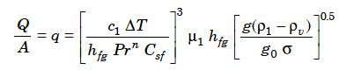

suffix l denotes liquid properties and v denotes vapour properties.

Where c1 — Specific heat of liquid J/kgK

T — excess temperature °C or K, (difference)

hfg — specific enthalpy of evaporation J/kg

Fatima Michael College of Engineering & Technology51
www.studentsfocus.com

Fatima Michael College of Engineering & Technology Pr — Prandtl number of liquid
n — constant equal to 1 for water and 1.7 for other fluids

Csf — surface factor shown in tabulation 11.1 and taken as 0.013 for other cases μ1 — dynamic viscosity of the liquid kg/ms or Ns m2 ρ1 — density of the liquid kg/m3

ρv — density of vapour kg/m3

- — surface tension- liquid-vapour interface N/m

g — gravitational acceleration m/s2

g0 — force conversion factor kgm/Ns2 = 1 in SI units.

This correlation is the result of a log plot of experimental results with parameters
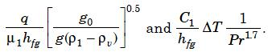

- Water at atmospheric pressure (saturation temperature = 100°C) is boiling on a brass surface heated from below. If the surface is at 108°C, determine the heat flux and compare the same with critical heat flux.
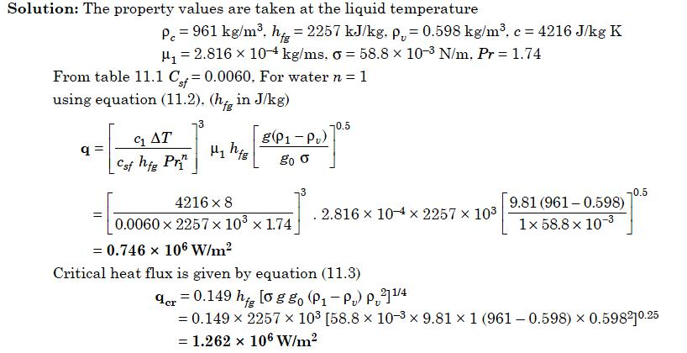

Fatima Michael College of Engineering & Technology52
www.studentsfocus.com

Fatima Michael College of Engineering & Technology
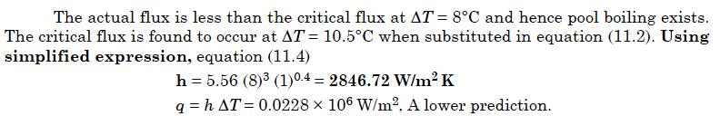

- Water is to be boiled at atmospheric pressure in a mechanically polished stainless steel pan

placed on top of a heating unit. The inner surface of the bottom of the pan is maintained at 108°C. If the diameter of the bottom of the pan is 30 cm, determine (a) the rate of heat transfer to the water and (b) the rate of evaporation of water.

SOLUTION Water is boiled at 1 atm pressure on a stainless steel surface. The rate of heat transfer to the water and the rate of evaporation of water are to be determined.

Assumptions 1 Steady operating conditions exist. 2 Heat losses from the heater and the pan are negligible

Properties The properties of water at the saturation temperature of 100°C are surface tension-0.0589 N/m
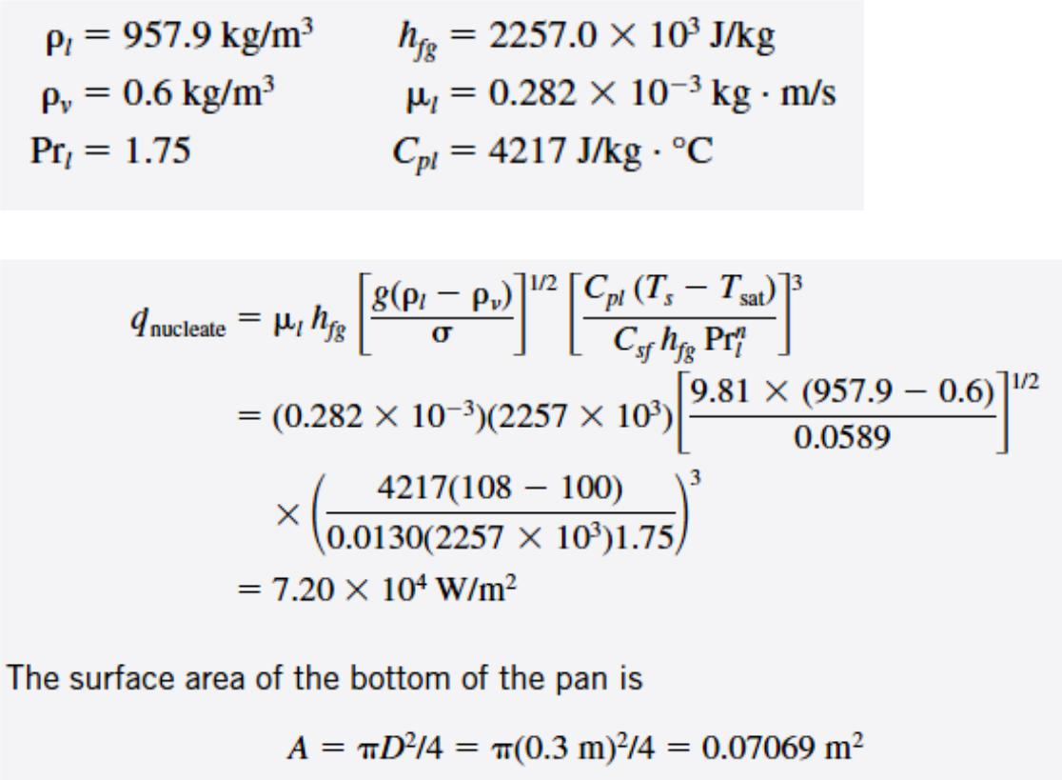

Fatima Michael College of Engineering & Technology53
www.studentsfocus.com

Fatima Michael College of Engineering & Technology
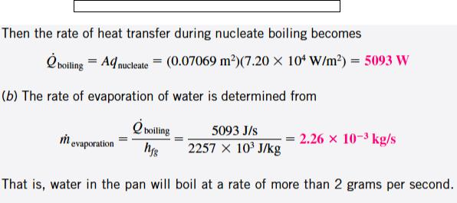

CONDENSATION HEAT TRANSFER

When saturated vapour comes in contact with a cooler surface, the vapour condenses into liquid. The surface temperature should be lower in this case as compared to the temperature of the vapour. The condensate generally moves down by gravity. If the liquid wets the surface a thin layer of liquids forms over the surface and the film thickness increases along the downward direction. This type of condensation is known as filmwise condensation and this is the type encountered in most practical situations. The film introduces a resistance to heat flow between the surface and the vapour. The heat transfer rate is reduced because of this resistance. If the

surface is nonwetting, then droplets form on the surface and these roll down individually.

The vapour is in direct contact with the surface over most of the area and heat transfer rates are much higher as there is very little resistance for heat flow between the vapour and the surface. This type is known as dropwise condensation. In practice no surface is found to continue as nonwetting over any length of time. So using the value of heat transfer coefficients assuming dropwise condensation for design purposes is not advisable.

Fatima Michael College of Engineering & Technology54
www.studentsfocus.com

Fatima Michael College of Engineering & Technology
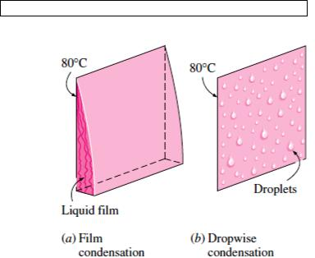

Saturated steam at a temperature of 65°C condenses on a vertical surface at 55°C. Determine the thickness of the condensate film at locations 0.2, 0.4, 0.6, 0.8, 1 m from the top. Also determine the condensate flow, the film Reynolds number, the local and average values of convective heat transfer coefficients at these locations. Also calculate the condensation numbers.

Solution: The property values for liquid should be taken at the film temperature = (55 + 65)/2 = 60°C. The liquid property values at 60°C are
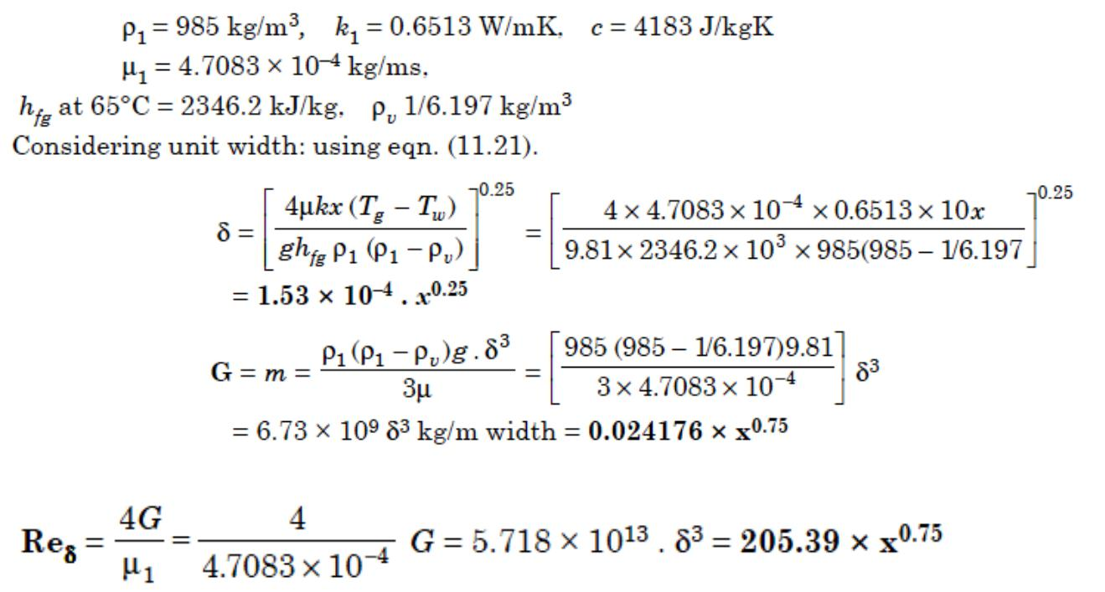

Fatima Michael College of Engineering & Technology55
www.studentsfocus.com

Fatima Michael College of Engineering & Technology
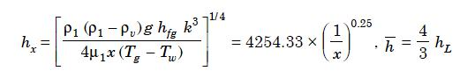

These values at various locations are tabulated below:
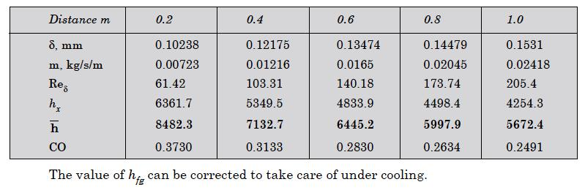

HEAT EXCHANGER

The process of heat exchange between two fluids that are at different temperatures and separated by a solid wall occurs in many engineering applications. The device used to implement this exchange is termed a heat exchanger, and specific applications may be found in space heating and air-conditioning, power production, waste heat recovery, and chemical processing. In this chapter our objectives are to introduce performance parameters for assessing the efficacy of a heat exchanger and to develop methodologies for designing a heat exchanger or for predicting the performance of an existing exchanger operating under prescribed conditions.

Heat Exchanger Types

Heat exchangers are typically classified according to The simplest heat exchanger is one for which the

flow arrangement and type of construction. hot and cold fluids move in the same or

Fatima Michael College of Engineering & Technology56
www.studentsfocus.com

Fatima Michael College of Engineering & Technology

opposite directions in a concentric tube (or double-pipe) construction. In the parallel-flow arrangement of Figure 11.1a, the hot and cold fluids enter at the same end, flow in the same direction, and leave at the same end. In the counterflow arrangement of Figure 11.1b, the fluids enter at opposite ends, flow in opposite directions, and leave at opposite ends. Alternatively, the fluids may move in cross flow (perpendicular to each other), as shown by the finned and unfinned tubular heat exchangers of Figure 11.2. The two configurations are typically differentiated by an idealization that treats fluid motion over the tubes as unmixed or mixed. In Figure 11.2a, the cross- flowing fluid is said to be unmixed because the fins inhibit motion in a direction (y) that is transverse to the main- flow direction (x). In this case the cross- flowing fluid temperature varies with x and y. In contrast, for the unfinned tube bundle of Figure 11.2b, fluid motion, hence mixing, in the transverse direction is possible, and temperature variations are primarily in the main- flow direction. Since the tube flow is unmixed in either heat exchanger, both fluids are unmixed in the finned exchanger, while the cross-flowing fluid is mixed and the tube fluid is unmixed in the unfinned exchanger. The nature of the mixing condition influences heat exchanger performance. Another common configuration is the shell-and-tube heat exchanger [1]. Specific forms differ according to the number of shell-and-tube passes, and the simplest form, which involves single tube and shell passes, is shown in Figure 11.3. Baffles are usually installed to increase the convection coefficient of the shell-side fluid by inducing turbulence and a cross- flow velocity component relative to the tubes. In addition, the baffles physically support the tubes, reducing flow- induced tube vibration. Baffled heat exchangers with one shell pass and two tube passes and with two shell passes and four tube passes are shown in Figures 11.4a and 11.4b, respectively.
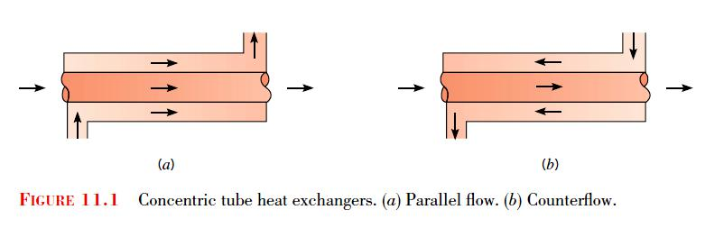

Fatima Michael College of Engineering & Technology57
www.studentsfocus.com

Fatima Michael College of Engineering & Technology
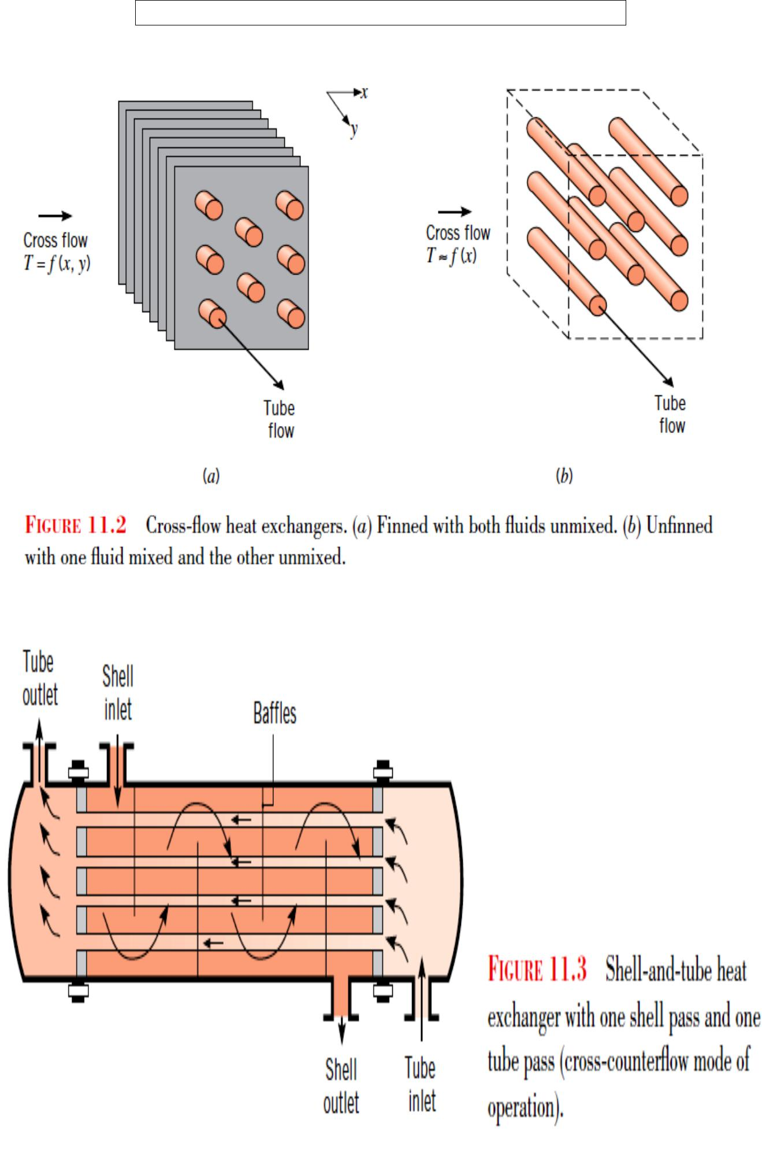

Fatima Michael College of Engineering & Technology58
www.studentsfocus.com

Fatima Michael College of Engineering & Technology
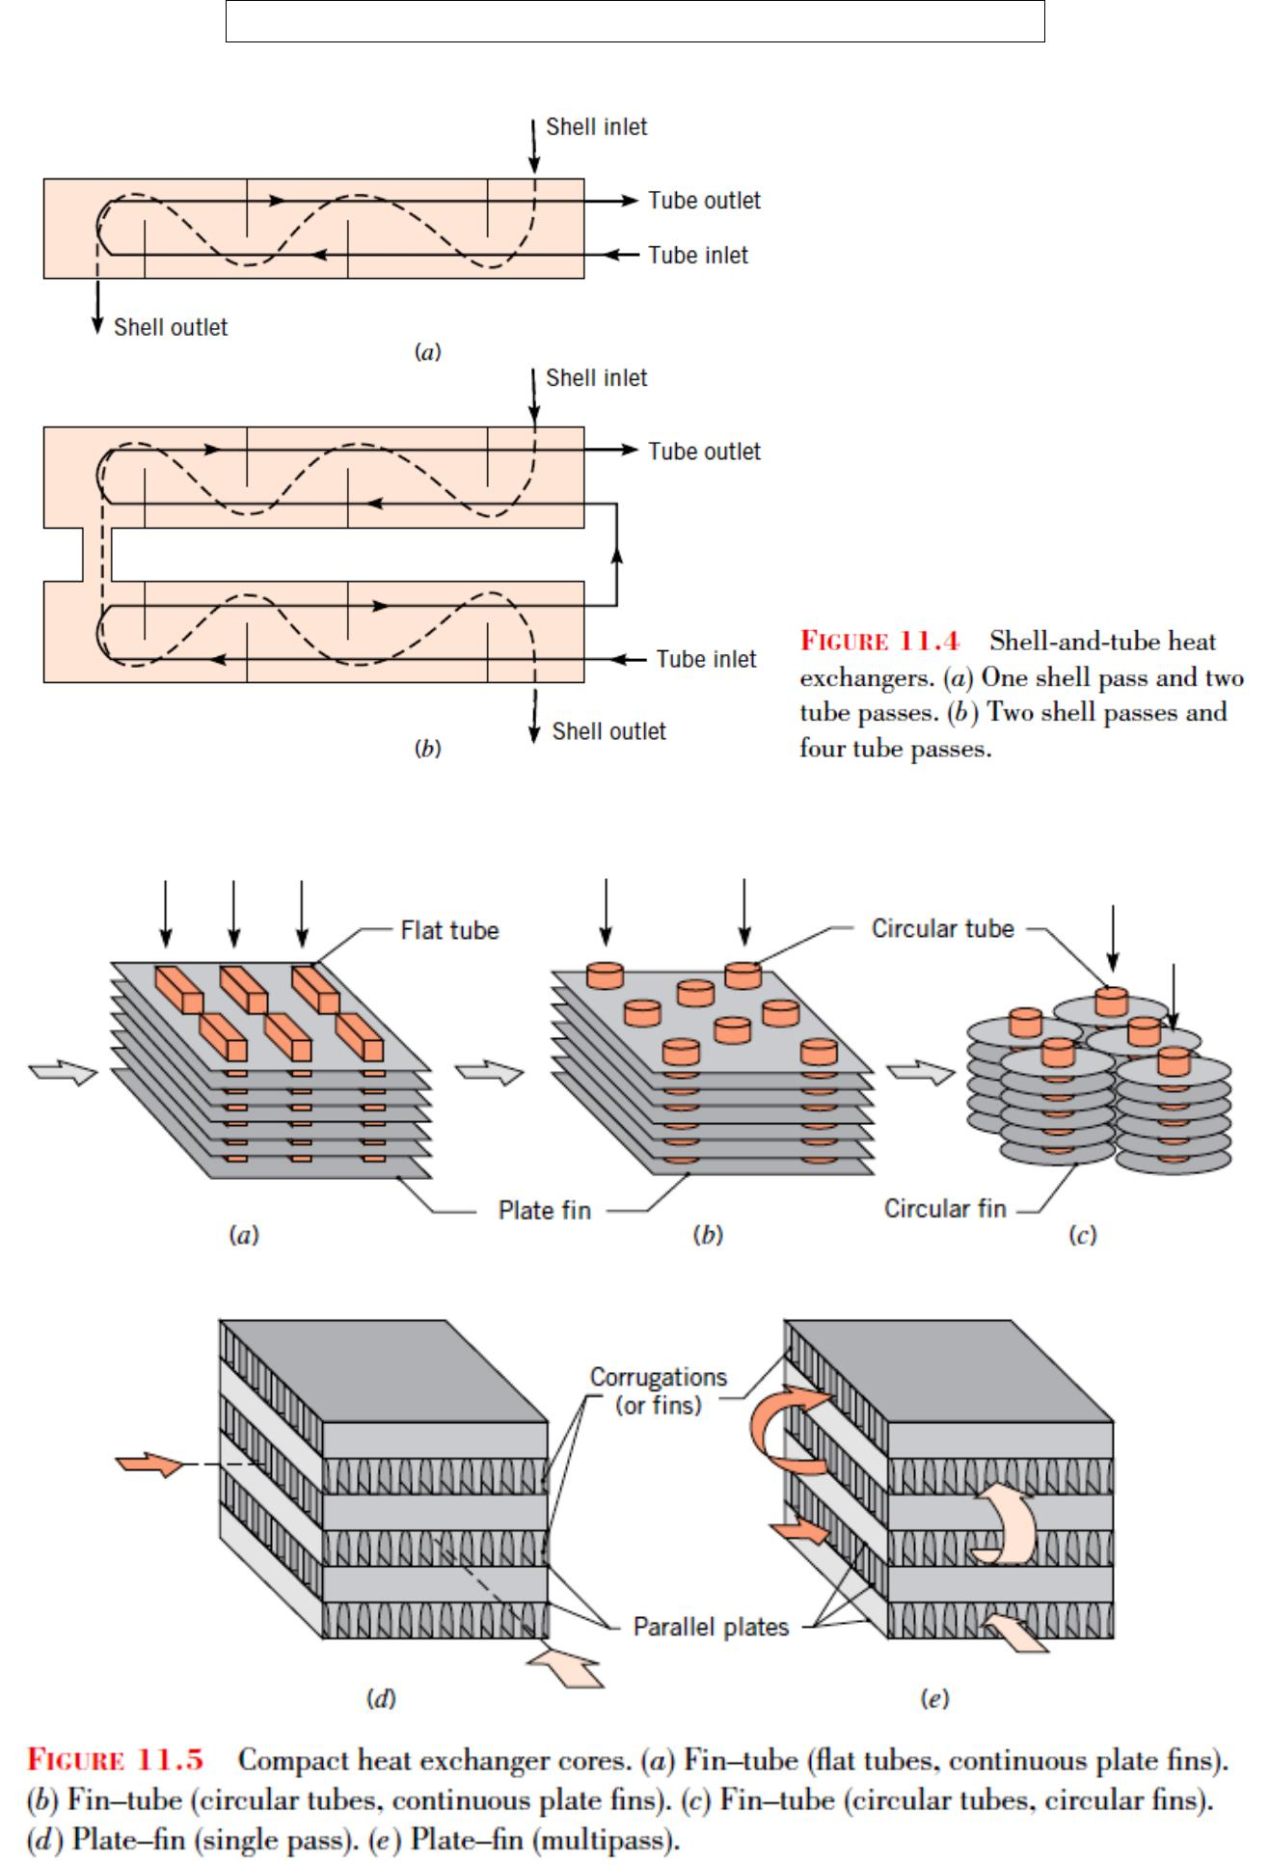

Fatima Michael College of Engineering & Technology59
www.studentsfocus.com

Fatima Michael College of Engineering & Technology

Determine the area required in parallel flow heat exchanger to cool oil from 60°C to 30°C using water available at 20°C. The outlet temperature of the water is 26°C. The rate of flow of oil is 10 kg/s. The specific heat of the oil is 2200 J/kg K. The overall heat transfer coefficient U = 300 W/m2 K. Compare the area required for a counter flow exchager.

Solution: The temperature variation for parallel flow is shown in Fig. 12.4 (a).
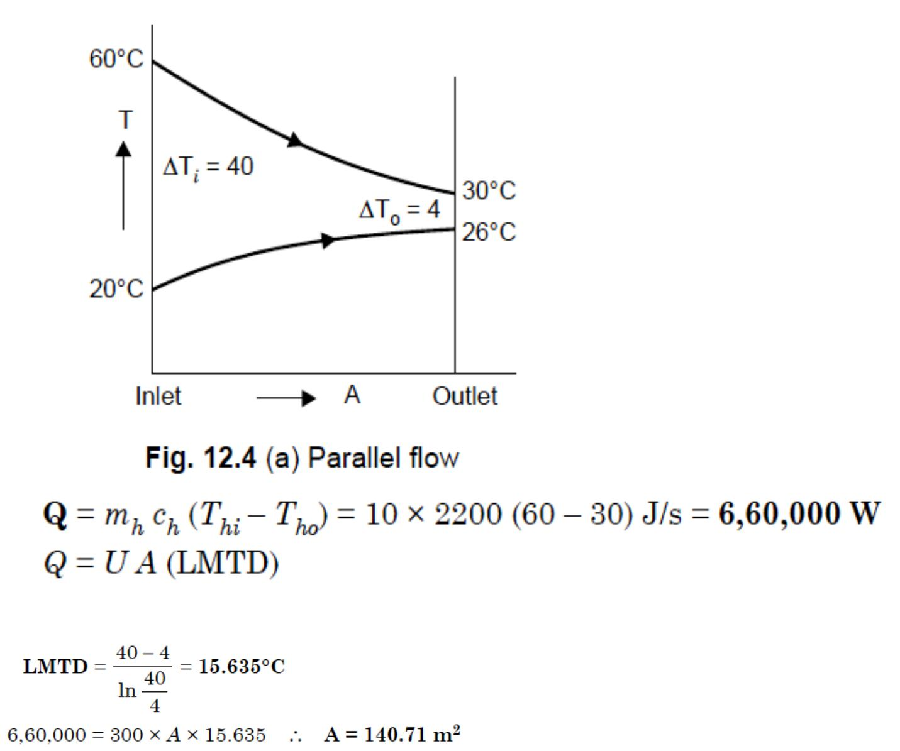

Fatima Michael College of Engineering & Technology60
www.studentsfocus.com

Fatima Michael College of Engineering & Technology
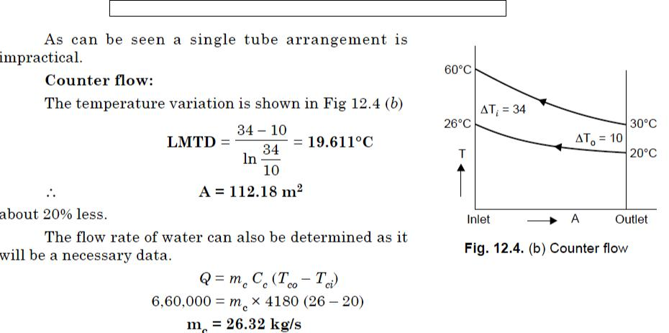

The counter flow arrangement provides more uniform temperature difference along the flow and hence a better rate of heat flow. The counter flow type can also be used to cool or heat over a wider range of temperatures. In the above case by increasing the area or by reducing flow the hot oil can in the limit be cooled to 20°C. Manipulation in the opposite direction can get the water heated to 60°C. This is not possible in the parallel flow where the exit temperature has to lie somewhere in between the two inlet temperatures. As far as possible counter flow is always used in heat exchanger designs.

An economiser in a boiler has flow of water inside the pipes and hot gases on the outside flowing across the pipes. The flow rate of gases is 2,000 tons/hr and the gases are cooled from 390°C to 200°C. The specific heat of the gas is 1005 J/kg K. Water is heated (under pressure) from 100°C to 220°C. Assuming an overall heat transfer coefficient of 35 W/m2 K, determine the area required. Assume that the air flow is mixed.

Fatima Michael College of Engineering & Technology61
www.studentsfocus.com

Fatima Michael College of Engineering & Technology
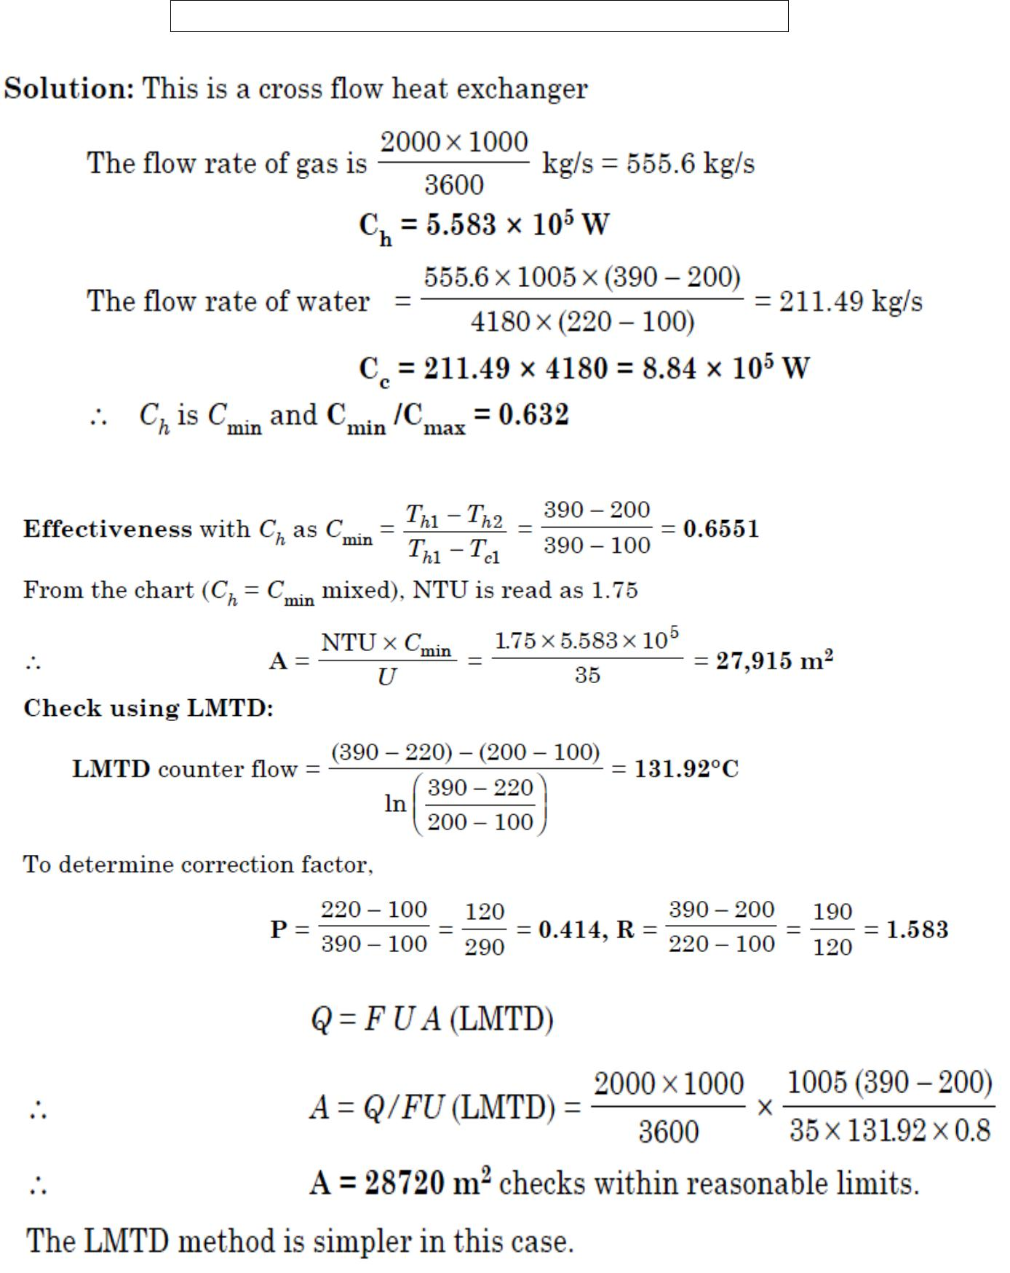

Fatima Michael College of Engineering & Technology62
www.studentsfocus.com

Fatima Michael College of Engineering & Technology

UNIT – IV - Thermal Radiation

Introduction

This mode of heat transfer defers from the other two modes in that radiation does not require the presence of material medium.

Ex: Heat transfer through a vacuum, from Sun to earth, a hot body inside a vacuum.

Thermal radiation is that electro magnetic radiation emitted by a body as a result of its temperature which is propagated at the speed of light (3 10⁸ m/s). It is called as the ―Stefan-Boltzmann Law‖. The total energy emitted by an ideal radiator or black body per unit time per unit area, E_{b} can be written as


 |  | ^{E}b | Black body radiation or emissive power (W/m²)
E_{b} | T | 4 | Stefan Boltzman Constant (5.67 10⁻⁸ W/m²K⁴)
E_{b} | T | T | Temperature in K
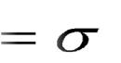


Black body

A body at a temperature above absolute zero emits radiation in all directions over a wide range of wave lengths. The amount of radiation emitted from a surface at a given wave length depends on the material surface condition and temperature. Therefore different bodies may emit different amount of radiation (Per unit surface area) even when they are at the same temperature. A black body is an ideal surface having the following properties

- It absorbs all the incident radiation regardless of wave length and direction.

- No surface can emit more energy than a black body for a given temperature and wave length

- Radiation emitted by a black body is a function of both wave length and temperature but independent of direction

Fatima Michael College of Engineering & Technology63
www.studentsfocus.com

Fatima Michael College of Engineering & Technology

Properties of radiation

When radiant energy strikes a material surface, part of the radiation is reflected, part is absorbed

and a part is transmitted. If | is the fraction reflected, | is the fraction absorbed and | is the
fraction transmitted |  | Reflected radiation ( | )
Incident radiation
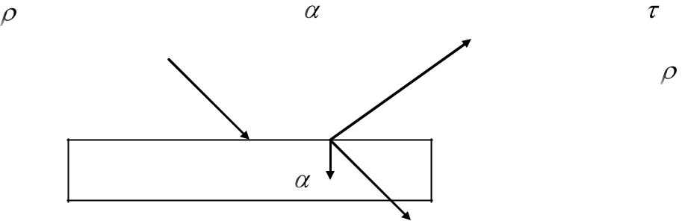

- +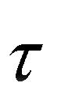= 1



But for most solid bodies = 0

Emissivity

Absorbed radiation ( )

Transmitted radiation ()

The ratio of the emissing power of a body to the emissive power of the black body at the same temperature is equal to absorptivity of the body.

E
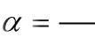

E_{b}

The ratio is defined as the emissivity of the body

E
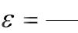

E_{b}
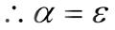

is a function of body temperature and wave length but a grey body is defined as for which absorptivity and emmisivity are independent of wave length.

Radiation exchange between surfaces
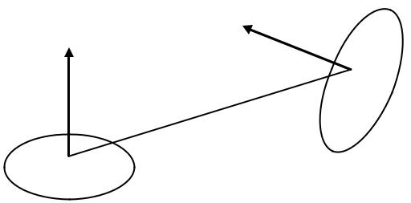

A₂

A₁

Fatima Michael College of Engineering & Technology64
www.studentsfocus.com

Fatima Michael College of Engineering & Technology

Shape factor is defined as the fraction of energy leaving one surface, which reaches the other surface. The figure shows two black surfaces, with areas A₁ and A₂.

If F₁₂ is the fraction of energy leaving surface 1, which reaches surface 2, and if F₂₁ is the fraction of energy leaving surface 2 which reaches surface 1

The energy leaving surface 1 and reaching surface 2 = E_{b1}A₁F₁₂

The energy leaving surface 2 and reaching surface 2 = E_{b2}A₂F₂₁

The net energy exchange Q₁₋₂ = E_{b1}A₁F₁₂ - E_{b2}A₂F₂₁

For same temperature

Q₁₋₂ = 0 therefore

Eb1A1F12 = Eb2A2F21

A1F12 = A2F21

In general A_{i}F_{ij} = A_{j}F_{ji}

f_{ij`} Geometric factor for surface i to surface j

Heat exchange between non-black bodies

The calculation of radiation heat transfer between black surfaces is relatively easy since all the radiant energy which strikes a surface is absorbed. The main problem is to find out the shape factors, but once this accomplished, the calculation of heat exchange is very simple.

When non-black bodies are involved, the situation is much more complex and for all the energy striking a surface will not be absorbed; part will be reflected back to another heat transfer surface, and part will be reflected back to another heat transfer surface and part may be reflected out of the system entirely.

To cope with the situation let us assume the surfaces considered in our analysis are diffusive and uniform in temperature and the reflective and emissive properties are constant over all the surfaces.

Fatima Michael College of Engineering & Technology65
www.studentsfocus.com

 |  | Fatima Michael College of Engineering & Technology
J_{i} | radiosity, total radiation leaving a surface i per unit time and per unit area.
G_{i} | irradiation, total energy incident upon surface i per unit time per unit area.
E_{i} | emission, total radiation generated by surface i per unit time per unit area.

When no energy transmitted, the radiosity is,

J= E_{b} 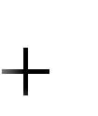 G



When trasmitivity is assumed zero,

 1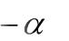 1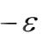
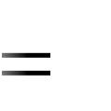
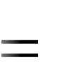

So that

 | J |  | ^{E}b | (1 |  |  | )G ……………………………………………(1)
The net energy leaving the surface
 | q |  | J | G |  |  | E_{b} (1 | )G GE_{b} G ………………(2)
 | A
Solving (1) and (2) |  |  |  |  |  |  |  | 1 |  |  | A
 |  |  |  |  |  |  |  | q
q |  |  | A |  | (E_{b} |  | J ) |  |  |  |  | J
 |  |  | A |  |  |  | J ) |  | E_{b}
 |  | 1
q |  |  | ^{E}b |  | J
 |  | 1 |  |  | A
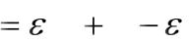
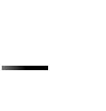
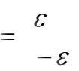
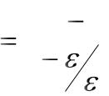
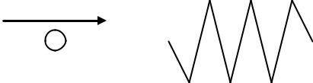

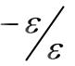

Element representing ―Surface resistant‖ in radiation network method

Now consider he exchange of radiant energy by two surfaces A₁ and A₂, of that total radiation leaving A₁ and reaches A₂

J1A1F12

Fatima Michael College of Engineering & Technology66
www.studentsfocus.com

Fatima Michael College of Engineering & Technology

And of that total radiation leaving A₂ and reaches A₁ is

J2A2F21

The net interchange between the two surfaces is

q1-2 = J1A1F12 - J2A2F21

But A₁F₁₂ = A₂F₂₁

Therefore

q₁₋₂ = (J₁ – J₂) A₁F₁₂

q1-2= | (J₁ J₂ )
q1-2= | 1
 | ^{A}1^{F}12
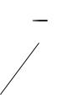
We may construct the network elements

q1-2

J₁
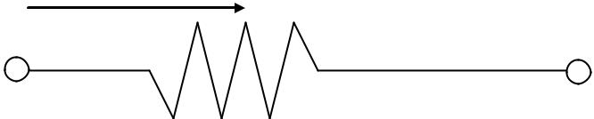
J₂

1

^{A}1^{F}12

Element representing ―Space resistant‖ in radiation network method

Ex: Two surfaces of area A₁ and A₂ of emissivities other and nothing else, would be represented by the

₁ and ₂ which exchangeheat with each following circuit diagram.
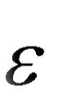
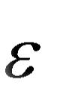

A₂
A₁
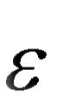

2
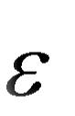

1

Fatima Michael College of Engineering & Technology67
www.studentsfocus.com

Fatima Michael College of Engineering & Technology

Eb1

Eb1

 |  | q1-2
 |  | J₁ | J₂ | Eb2
1 |  | 1 | 1
1 | 1 | ^{A}1^{F}12 | 1 | 2
 | 1 ^{A}1 | ^{A}1^{F}12 |  | 2 ^{A}2
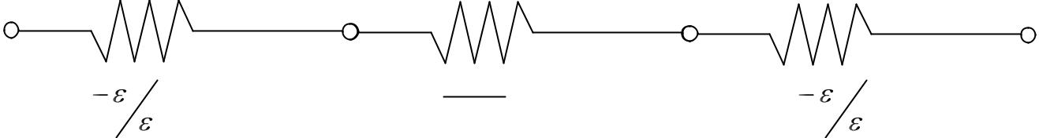

A radiation network for three surfaces which see each other and nothing else is

1 | 1 | 1
 | 1 ^{A}1 | ^{A}1^{F}12
 |  | 1 |  | 2
 | J₁ |  | J₂ | 2 ^{A}2
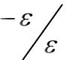
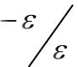
Eb2
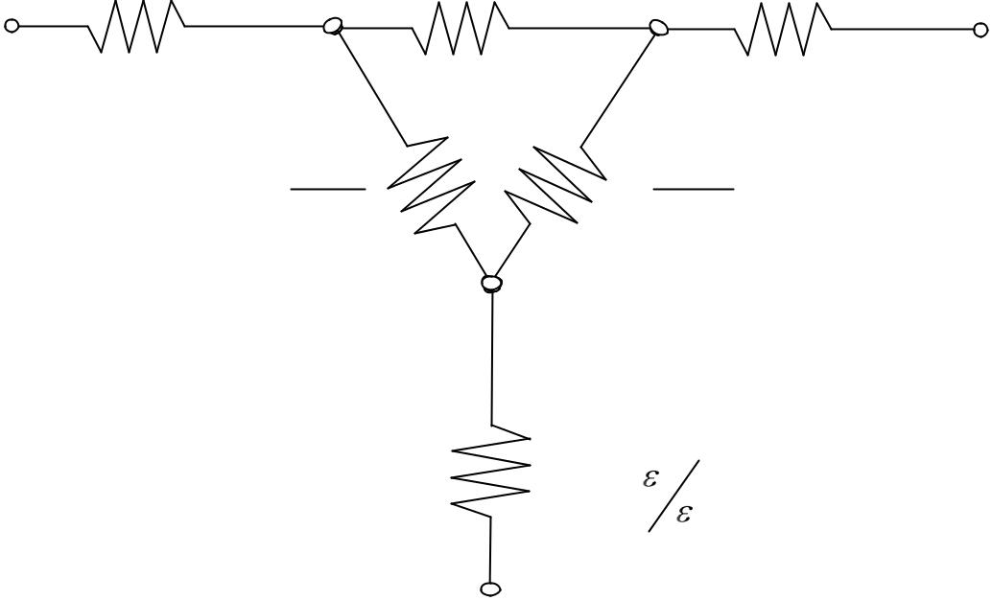

1 | 1
^{A}1^{F}13 | ^{A}2 ^{F}23
 | J₃

1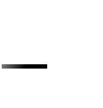₃
3 ^{A}3

Eb3

Fatima Michael College of Engineering & Technology68
www.studentsfocus.com

Fatima Michael College of Engineering & Technology
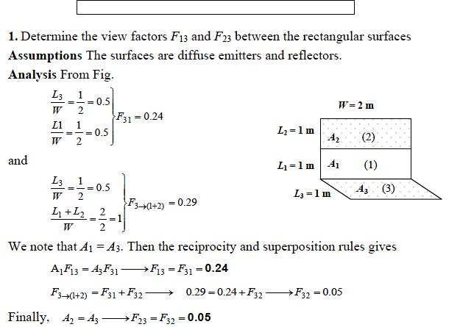

- 2. Consider a 4-m × 4- m × 4- m cubical furnace whose floor and ceiling are black and whose side surfaces are reradiating. The floor and the ceiling of the furnace are maintained at temperatures of 550 K and 1100 K, respectively. Determine the net rate of radiation heat transfer between the floor and the ceiling of the furnace.

Assumptions 1 Steady operating condition exist 2 The surfaces are opaque, diffuse, and gray. 3 Convection heat transfer is not considered.

Properties The emissivities of all surfaces are = 1 since they are black or reradiating.

Analysis We consider the ceiling to be surface 1, the floor to be surface 2 and the side surfaces to be surface 3. The furnace can be considered to be three-surface enclosure with a radiation network shown in the figure. We assume that steady-state conditions exist. Since the side surfaces are reradiating, there is no heat transfer through them, and the entire heat lost by the ceiling must be gained by the floor. The view factor from the ceiling to the floor of the furnace is . Then the rate of heat loss from the ceiling can be determined from

Fatima Michael College of Engineering & Technology69
www.studentsfocus.com

Fatima Michael College of Engineering & Technology
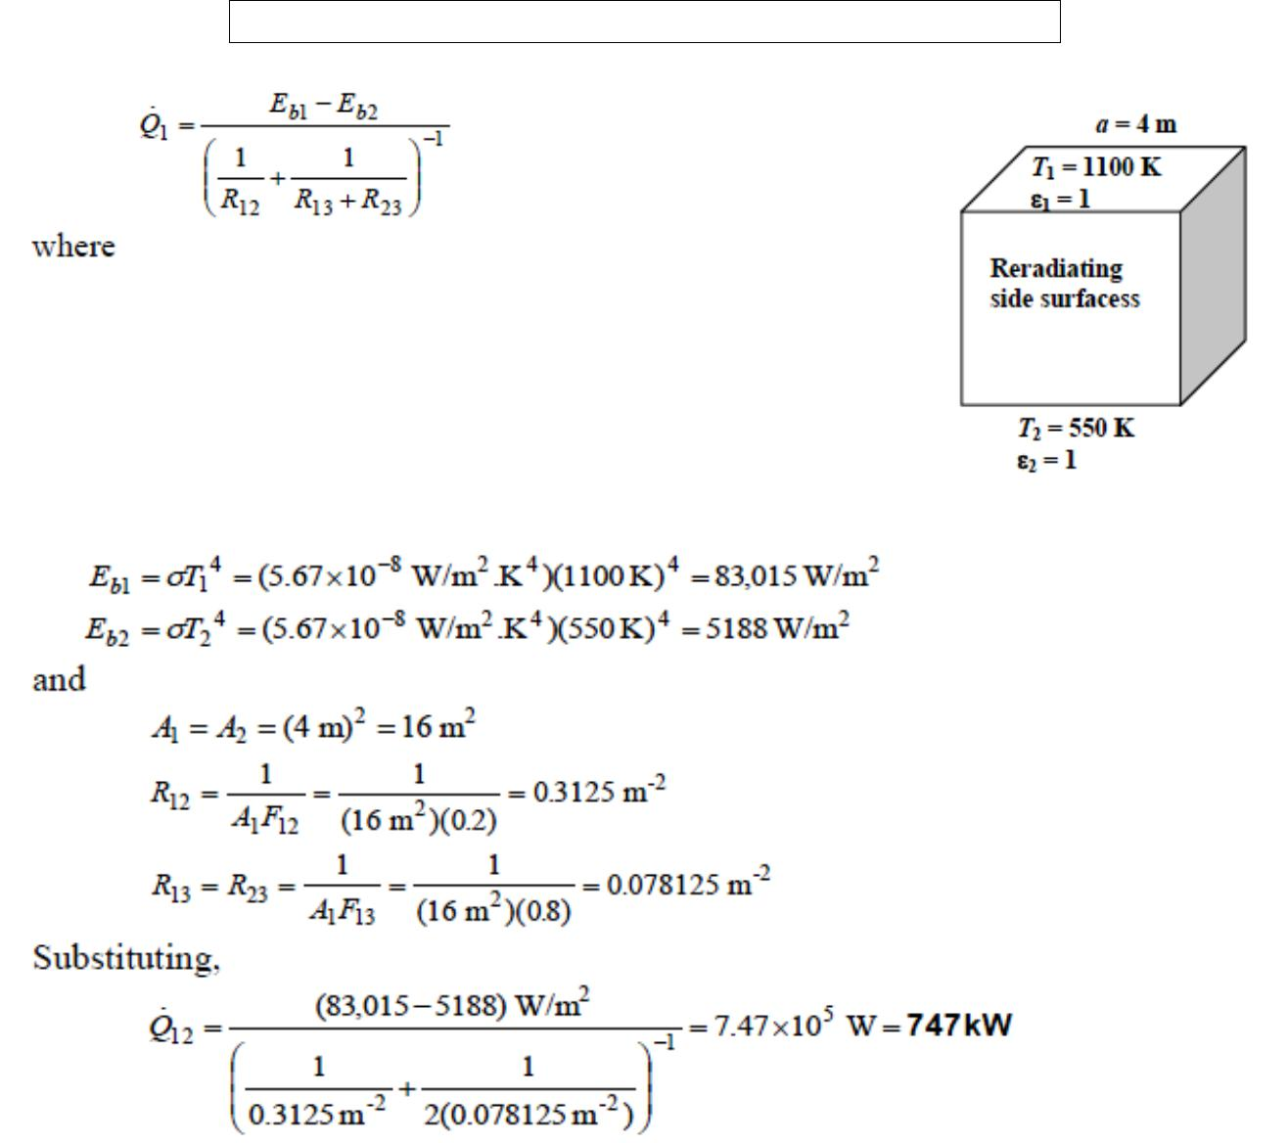

3. A thin aluminum sheet with an emissivity of 0.15 on both sides is placed between two very large parallel plates, which are maintained at uniform temperatures T1 =900 K and T2 =650 K and have emissivities 0.5 and 2 ,0.8, respectively. Determine the net rate of radiation heat transfer between the two plates per unit surface area of the plates and Compare the result with that without the shield.

Assumptions 1 Steady operating conditions exist 2 The surfaces are opaque, diffuse, and gray. 3 Convection heat transfer is not considered.

Properties The emissivities of surfaces are given to be emm1 = 0.5, emm2 = 0.8, and emm3 = 0.15.

Analysis The net rate of radiation heat transfer with a thin aluminum shield per unit area of the plates is

Fatima Michael College of Engineering & Technology70
www.studentsfocus.com

Fatima Michael College of Engineering & Technology
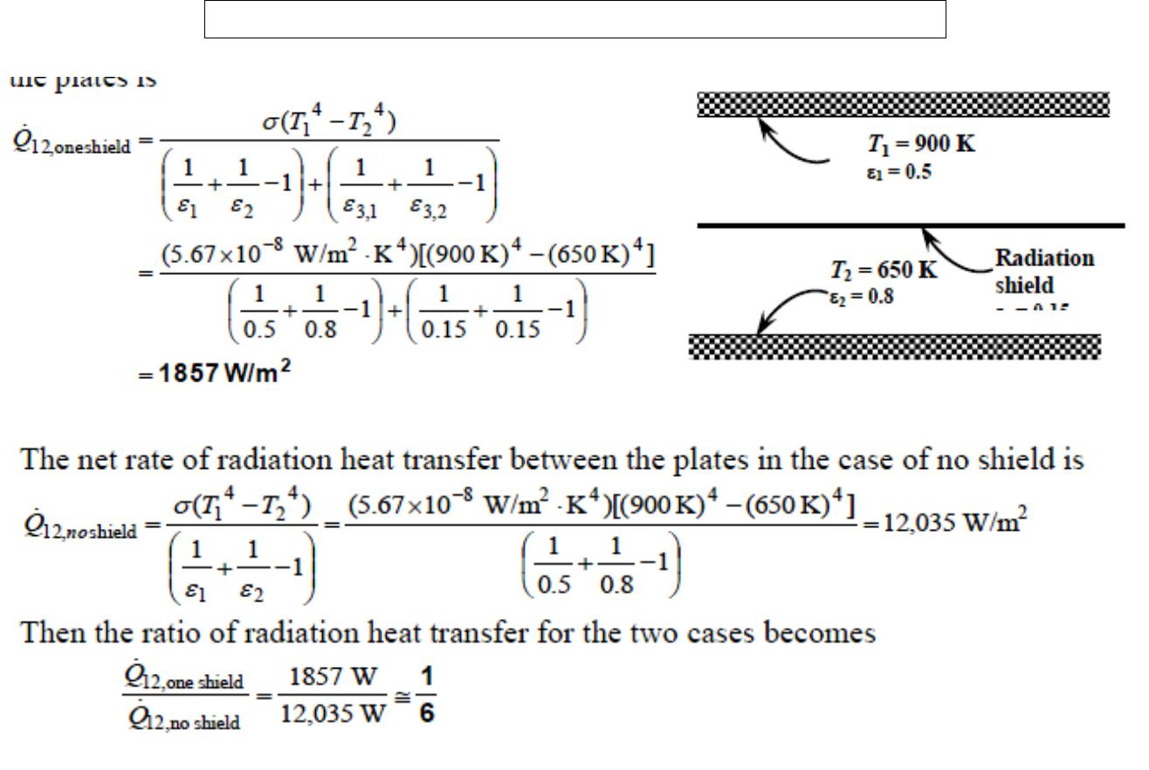

- Two very large parallel plates are maintained at uniform temperatures of T1=1000 K and T2 =

- K and have emissivities of 1 ,2 and 0.2, respectively. It is desired to reduce the net rate of radiation heat transfer between the two plates to one- fifth by placing thin aluminum sheets with anemissivity of 0.15 on both sides between the plates. Determine the number of sheets that need to be inserted.
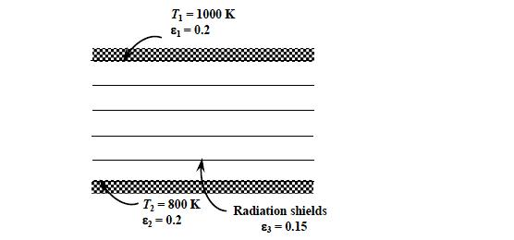

Assumptions 1 Steady operating conditions exist 2 The surfaces are opaque, diffuse, and gray. 3 Convection heat transfer is not considered.

Fatima Michael College of Engineering & Technology71
www.studentsfocus.com

Fatima Michael College of Engineering & Technology
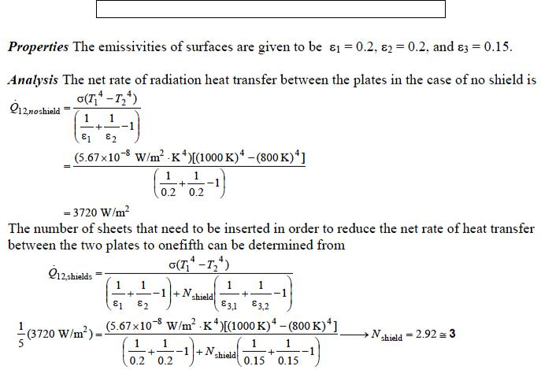

- T2 = 800 K

emm2 = 0.2

T1 = 1000 K

emm1 = 0.2

Radiation shields

emm3 = 0.15

A2-m- internal-diameter double-walled spherical tank is used to store iced water at 0°C. Each wall is 0.5 cm thick, and the 1.5-cm-thick air space between the two walls of the tank is evacuated in order to minimize heat transfer. The surfaces surrounding the evacuated space are polished so that each surface has an emissivity of 0.15. The temperature of the outer wall of the tank is measured to be 20°C. Assuming the inner wall of the steel tank to be at 0°C, determine (a) the rate of heat transfer to the iced water in the tank and (b) the amount of ice at 0°C that melts during a 24-h period.

Assumptions 1 Steady operating conditions exist 2 The surfaces are opaque, diffuse, and gray.

Fatima Michael College of Engineering & Technology72
www.studentsfocus.com

Fatima Michael College of Engineering & Technology

Analysis (a) Assuming the conduction resistance s of the walls to be negligible, the rate of heat transfer to the iced water in the tank is determined to be
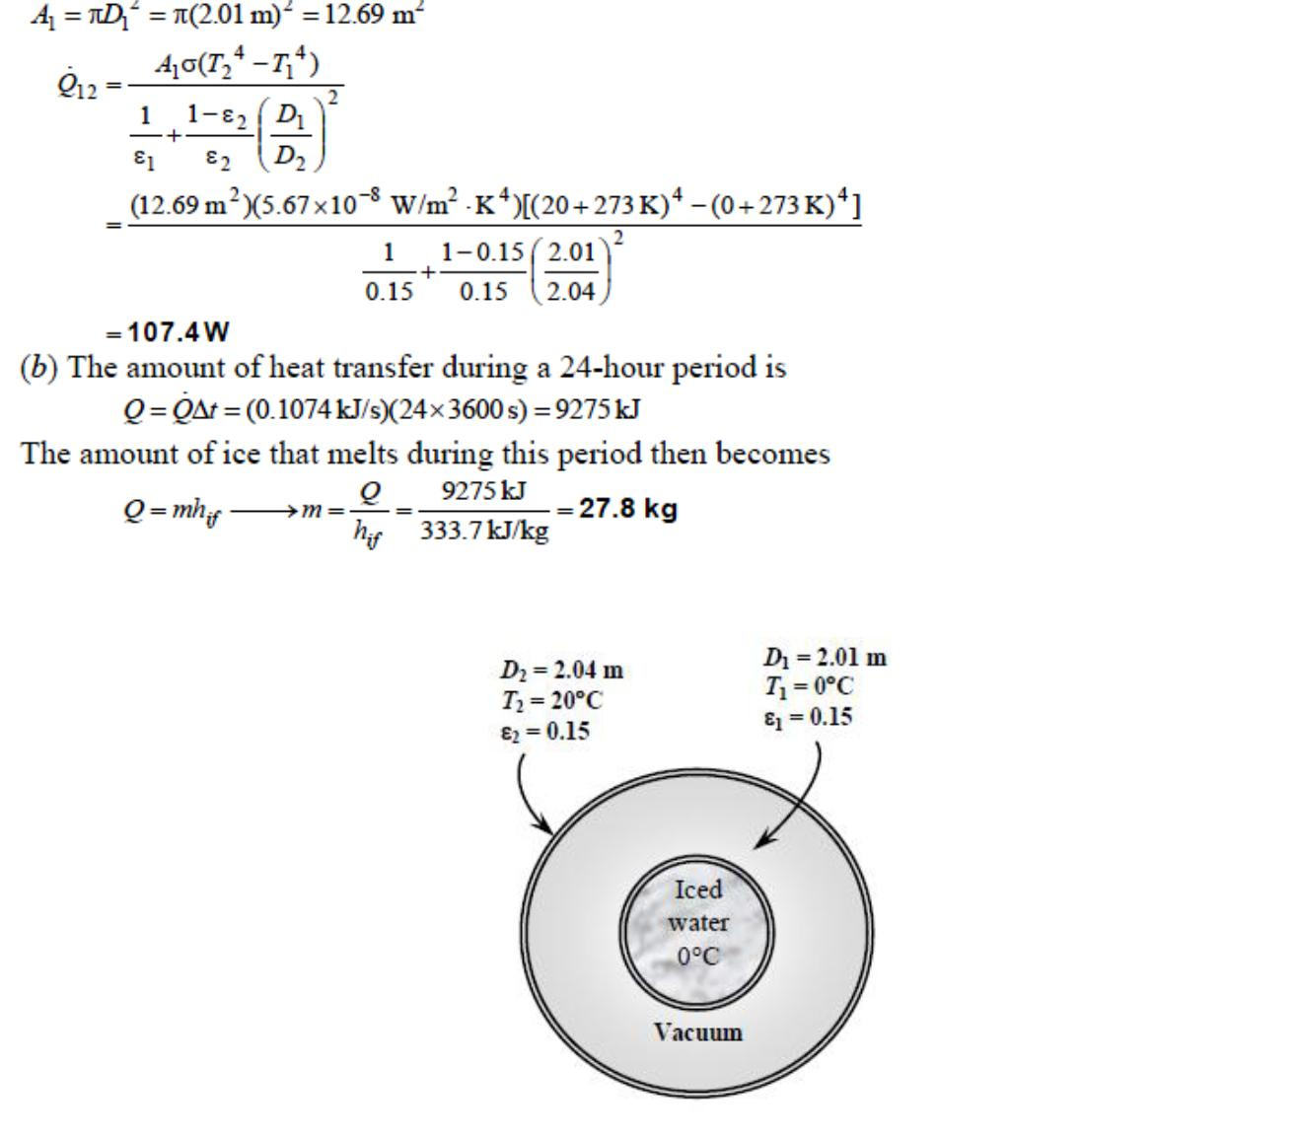

Fatima Michael College of Engineering & Technology73
www.studentsfocus.com

Fatima Michael College of Engineering & Technology

UNIT- V- MASS TRANSFER

Introduction

Mass transfer can result from several different phenomena. There is a mass transfer associated with convection in that mass is transported from one place to another in the flow system. This type of mass transfer occurs on a macroscopic level and is usually treated in the subject of fluid mechanics. When a mixture of gases or liquids is contained such that there exists a concentration gradient of one or more of the constituents across the system, there will be a mass transfer on a microscopic level as the result of diffusion from regions of high concentration to regions of low concentration. In this chapter we are primarily concerned with some of the simple relations that may be used to calculate mass diffusion and their relation to heat transfer. Nevertheless, one must remember that the general subject of mass transfer encompasses both mass diffusion on a molecular scale and the bulk mass transport that may result from a convection process.

Not only may mass diffusion occur on a molecular basis, but accelerated diffusion rates will also occur in turbulent- flow systems as a result of the rapid-eddy mixing processes, just as these mixing processes created increased heat transfer and viscous action in turb ulent flow.

Although beyond the scope of our discussion, it is well to mention that mass diffusion may also result from a temperature gradient in a system; this is called thermal diffusion. Similarly, a concentration gradient can give rise to a temperature gradient and a consequent heat transfer. These two effects are termed coupled phenomena and may be treated by the methods of irreversible thermodynamics.
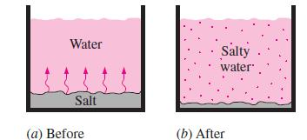

Whenever there is concentration difference of a physical quantity in a medium, nature tends to equalize things by forcing a flow from the high to the low concentration region.

Fatima Michael College of Engineering & Technology74
www.studentsfocus.com

Fatima Michael College of Engineering & Technology

ANALOGY BETWEEN HEAT AND MASS TRANSFER

We have spent a considerable amount of time studying heat transfer, and we could spend just as much time (perhaps more) studying mass transfer. However, the mechanisms of heat and mass transfer are analogous to each other, and thus we can develop an understanding of mass transfer in a short time with little effort by simply drawing parallels between heat and mass transfer. Establishing those ―bridges‖ between the two seemingly unrelated areas will make it possible to use our heat transfer knowledge to solve mass transfer problems. Alternately, gaining a working knowledge of mass transfer will help us to better understand the heat transfer processes by thinking of heat as a massless substance as they did in the nineteenth century. The short- lived caloric theory of heat is the origin of most heat transfer terminology used today and served its purpose well until it was replaced by the kinetic theory. Mass is, in essence, energy since mass and energy can be converted to each other according to Einstein‘s formula E = mc², where c is the speed of light. Therefore, we can look at mass and heat as two different forms of energy and exploit this to advantage without going overboard.

PROPERTIES OF MIXTURE

In a mixture consisting of two or more materials the mass per unit volume of any component is called mass concentration of that component. If there are two components A and B, then the mass concentration of A is
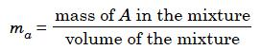

and concentration of B,
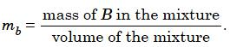

The total mass concentration is ma + mb, which is also the density of the mixture. Mass concentration can also be expressed in terms of individual and total densities of the mixture i.e.,
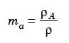

Fatima Michael College of Engineering & Technology75
www.studentsfocus.com

Fatima Michael College of Engineering & Technology

where ρa is the density of A in the mixture and ρ is the density of the mixture. It is more convenient to express the concentration in terms of the molecular weight of the component.

Mole fraction Na can be expressed as
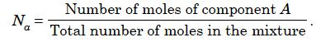

Nu mber of Mo le = mass/molecular weight
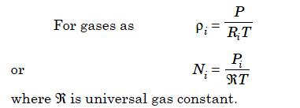

At the temperature T of the mixture then
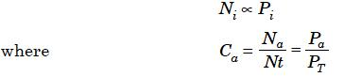

where P_{a} is the partial pressure of A in the mixture and P_{T} is the total pressure of the mixture. C_{a} is the mole concentration of A in the mixture.

Also C_{a} + C_{b} = 1 for a two component mixture.

DIFFUSION MASS TRANSFER

Diffusion mass transfer occurs without macroscopic mass motion or mixing. A lump of sugar dropped into a cup of tea will dissolve by diffusion even if left unstirred. But it will take a long time for the sugar to reach all of the volume in the cup. However it will diffuse into the volume by and by. Consider a chamber in which two different gases at the same pressure and temperature are kept separated by a thin barrier. When the barrier is removed, the gases will begin to diffuse into each others volume. After some time a steady condition of uniform mixture would be reached. This type of diffusion can occur in solids also. The rate in solids will be extremely slow. Diffusion in these situations occurs at the molecular level and the governing

Fatima Michael College of Engineering & Technology76
www.studentsfocus.com

Fatima Michael College of Engineering & Technology

equations are similar to those in heat conduction where energy transfer occurs at the molecular level.

The basic law governing mass transfer at the molecular diffusion level is known as Fick’s law. This is similar to the Fourier heat conduction law. In Mass transfer, molal quantities are more convenient to use as compared to mass units, because mass transfer is due to the movement of molecules as discrete quantities. Hence it is convenient to use number of moles, or molar concentration instead of density etc.

FICK’S LAW OF DIFFUSION

The Fick‘s law can be stated as

…….1
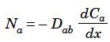

Where N_{a}— > number of moles of ‗a‘ diffusing perpendicular to area A, moles/m² sec

D_{ab}— > Diffusion coefficient or mass diffusivity, m²/s, a into b

Ca — > mole concentration of ‗a‘ moles/m³

- — > diffusion direction

The diffusion coefficient is similar to thermal diffusivity, α and momentum diffusivity v.

Number of moles multiplied by the molecular mass (or more popularly known as molecular weight) will provide the value of mass transfer in kg/s. Equation 1 can also be written as
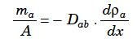

……2

but this form is not as popular as the more convenient equation (1). The conduction equation similar to this is
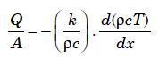

…..3

Fatima Michael College of Engineering & Technology77
www.studentsfocus.com

Fatima Michael College of Engineering & Technology

k/ρc is thermal diffusivity α and ρ c is the heat capacity (energy density) for unit volume.

The derivation of the general mass diffusion equation is similar to that of the general heat conduction equation with C_{a} replacing T and D replacing k/ρc.

The general mass diffusion equation for the species A under steady state condition is given by equation (4)
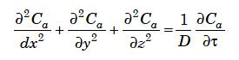

….. 4

Generation of mass of the species ‗A‘ by chemical reaction is not considered in the equation. However an additive term N_{a}/D on the LHS will take care of this similar to heat generation term q/k.

The solutions for this equation are also similar to the solutions of the general conduction equation. However there exist some differences. These are

(i) While heat flow is in one direction, the mass of one species flows opposite to the flow of the other component of the mixture. (here two component mixture is considered).

(ii) Even while one component alone diffuses under certain circumstances, a bulk flow has to be generated as otherwise a density gradient will be created spontaneously, which is not possible. For example when water evaporates into an air body over water surface, an equal quantity of air cannot enter the water phase. The density gradient created is dispersed by some mixture moving away from the surface maintaining a balance. This is termed as bulk flow.

The value of Dab for certain combinations of components are available in literature. It can be proved that Dab= Dba. When one molecule of ‗A‘ moves in the x direction, one molecule of ‗B‘ has to move in the opposite direction. Otherwise a macroscopic density gradient will develop, which is not sustainable, (A is area)

Fatima Michael College of Engineering & Technology78
www.studentsfocus.com

Fatima Michael College of Engineering & Technology
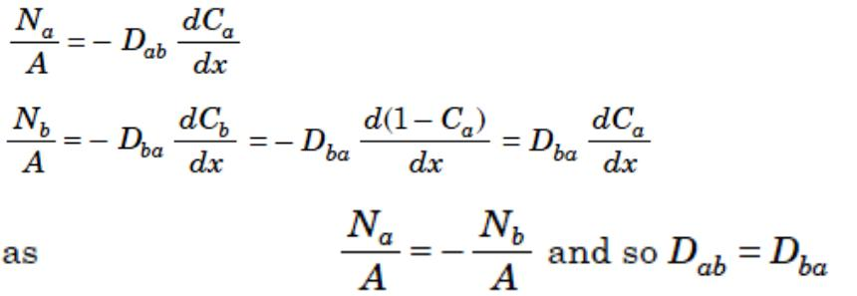

EQUIMOLAL COUNTER DIFFUSION

The total pressure is constant all through the mixture. Hence the difference in partial pressures will be equal. The Fick‘s equation when integrated for a larger plane volume of thickness L will give
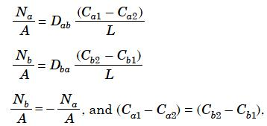

Dab equals Dba

Where Ca1 and Cb1 are the mole concentrations at face 1 and Ca2 and Cb2 are mole concentrations at face 2 which is at a distance L from the first face.

When applied to gases,
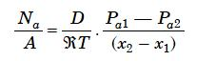

Where Pa1 and Pa2 are partial pressures of component ‗A‘ at x1 and x2 and ℜ is the universal gas constant in J/kg mol K. T is the temperature in absolute units. The distance should be expressed in metre.

Fatima Michael College of Engineering & Technology79
www.studentsfocus.com

Fatima Michael College of Engineering & Technology

The partial pressure variation and diffusion directions are shown in Fig 1.
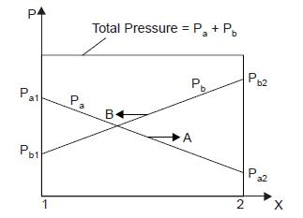

Fig. 1. Partial Pressure variation of components in equimolal counter diffusion.

- In order to avoid pressure build up ammonia gas at atmospheric pressure in a pipe is vented to atmosphere through a pipe of 3 mm dia and 20 m length. Determine the mass of ammonia diffusing out and mass of air diffusing in per hour. Assume D = 0.28 × 10–4 m2/s, M = 17 kg/kg mole

Solution: P_{NH3} in pipe = 1 atm

P_{NH3} at the outlet = 0
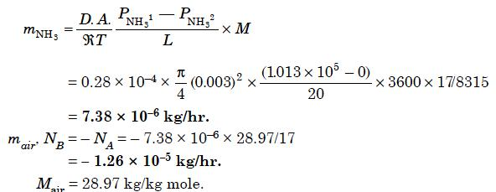

Fatima Michael College of Engineering & Technology80
www.studentsfocus.com

Fatima Michael College of Engineering & Technology

STATIONARY MEDIA WITH SPECIFIED SURFACE CONCENTRATION

In the diffusion of gas from containers, there is diffusion of gas from inside to the outs ide without the metal molecules diffusing into the gas. In these cases the concentration of gas at the surfaces should be known. The solubility of the gas in the surface determines the concentration at the surface.

These cases are similar to conduction through the medium. In these cases the temperature potential in conduction is replaced by concentration potential (Ca1 – Ca2) for component A. The flow rate can be obtained as in the case of conduction.

Na = (Ca1 – Ca2)/R.

Where R is the resistance of diffusion. The resistance in the case of plane wall is
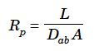

For hollow cylindrical configuration.
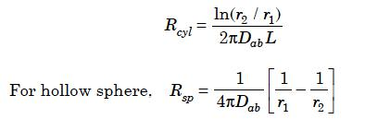

These equations can be derived from the general equation in Cartesian, cylindrical and spherical coordinate systems.

2. Hydrogen stored in a vessel diffuses through the steel wall of 20 mm thickness. The molar concentration at the inner surface is 2 kg mol/m³. At the other surface it is zero. Assuming plane wall condition and Dab = 0.26 × 10–12 m²/s, determine the mass of hydrogen diffused per 1 m².

Fatima Michael College of Engineering & Technology81
www.studentsfocus.com

Fatima Michael College of Engineering & Technology
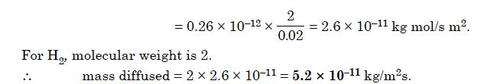

DIFFUSION OF ONE COMPONENT INTO A STATIONARYCOMPONENT OR UNIDIRECTIONAL DIFFUSION

In this case one of the components diffuses while the other is stationary. For steady conditions the mass diffused should be absorbed continuously at the boundary. In certain cases this is not possible. The popular example is water evaporating into air. In this case, as mentioned earlier, a bulk motion replaces the air tending to accumulate at the interface without being absorbed, causing an increase in the diffusion rate. The diffusion eq uation for gases can be derived as (with ‗a‘ as the diffusing medium and P = total pressure)
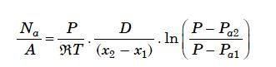

For liquids (considering ‗a‘ as diffusing medium)
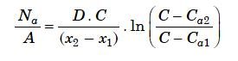

- Oxygen is diffusing in a mixture of oxygen-nitrogen at 1 std atm, 25 C. Concentration of oxygen at planes 2 mm apart are 10 and 20 volume % respectively. Nitrogen is non-diffusing.

  - Derive the appropriate expression to calculate the flux oxygen. Define units of each term clearly.

  - Calculate the flux of oxygen. Diffusivity of oxygen in nitrogen = 1.89 * 10 ^{–5} m²/sec.


Fatima Michael College of Engineering & Technology82
www.studentsfocus.com

Fatima Michael College of Engineering & Technology

Solution:

Given:

D _{AB} = 1.89 * 10 ^{–5} m²/sec

P _{t} = 1 atm = 1.01325 * 10 ⁵ N/m ²

T = 25 C = 273 + 25 = 298 K


z = 2 mm = 0.002 m

P _{A1} = 0.2 * 1 = 0.2 atm (From Ideal gas law and additive pressure rule)

P _{A2} = 0.1 * 1 = 0.1 atm

Substituting these in equation (6)

N _{A} | 1.89 * 10 | ⁵ 1.01325 * |  | 10 ⁵ | ln |  | 1 | 0.1
N _{A} | 8314 | 298 | 0.002 |  | ln | 1 |  | 0.2



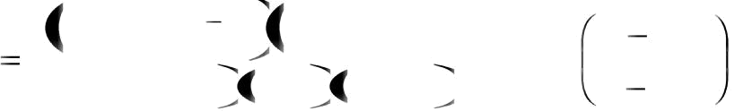

  - 4.55 * 10 ^{–5} kmol/m ².sec

- A vertical glass tube 3 mm in diameter is filled with liquid toluene to a depth of 20mm from the top openend. After 275 hrs at 39.4 C and a total pressure of 760 mm Hg the level has dropped to 80 mm from the top. Calculate the value of diffusivity.

Given Data:

vapor pressure of toluene at 39.4 C = 7.64 kN / m²,

density of liquid toluene = 850 kg/m³

Molecular weight of toluene = 92

 |  |  | (C ₆ H₆ CH₃)
C | P |  | 1.01325 * 10 ⁵
C | R T | 8314 * 273 39.4

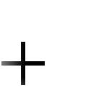
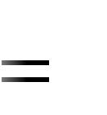

Fatima Michael College of Engineering & Technology83
www.studentsfocus.com

Fatima Michael College of Engineering & Technology

= 0.039 k mol /m³

Therefore

^{D} AB | 850 * 0.9618 |  | 0.08 ² 0.02 ²
^{D} AB | 92 * 0.039 * 0.0754 0 * 275 * 3600 | 2

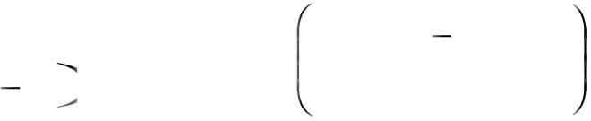
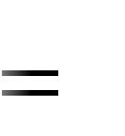

  - 1.5262 * 10 ^{–3} (0.08 ² – 0.02 ²)

  - 9.1572 * 10⁻⁶ m²/sec.

- Methane diffuses at steady state through a tube containing helium. At point 1 the partial pressure of methane is p _{A1} = 55 kPa and at point 2, 0.03 m apart P _{A2} = 15 KPa. The total pressure is 101.32 kPa, and the temperature is 298 K. At this pressure and temperature, the value of diffusivity is 6.75 * 10 ^{–5} m ²/sec.

- calculate the flux of CH ₄ at steady state for equimolar counter diffusion.

- Calculate the partial pressure at a point 0.02 m apart from point 1.

Calculation:

For steady state equimolar counter diffusion, molar flux is given by

Therefore;

N _{A} | 6.75 * 10 | 5 |  | 55 | 15 | kmol
N _{A} | 8.314 * 298 * 0.03 |  |  | 55 | 15 | m | ². sec
 | 3.633 * 10 | 5 | kmol
 | 3.633 * 10 | 5 | m ² sec



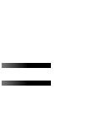
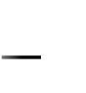
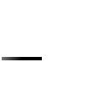
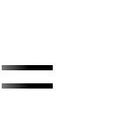

And from (1), partial pressure at 0.02 m from point 1 is:

3.633 * 10 | 5 | 6.75 * 10 | 5 | 55 p _{A}
3.633 * 10 | 5 | 8.314 * 298 * 0.02 |  | 55 p _{A}



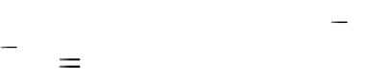

Fatima Michael College of Engineering & Technology84
www.studentsfocus.com

Fatima Michael College of Engineering & Technology

p _{A} = 28.33 kPa.

- In a gas mixture of hydrogen and oxygen, steady state equimolar counter diffusion is occurring at a total pressure of 100 kPa and temperature of 20 C. If the partial pressures of oxygen at two planes 0.01 m apart, and perpendicular to the direction of diffusion are 15 kPa and
5 kPa, respectively and the mass diffusion flux of oxygen in the mixture is 1.6 * 10 ^{–5} kmol/m

².sec, calculate the molecular diffusivity for the system.

Solution:

For equimolar counter current diffusion:

^{N} A | ^{D} AB | ^{p} A1 | ^{p} A2
^{N} A | RTz | ^{p} A1 | ^{p} A2 | (1)
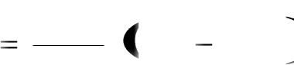

N _{A} = molar flux of A (1.6 * 10 ^{–5} kmol/m ².sec):

D _{AB} = molecular diffusivity of A in B

R = Universal gas constant (8.314 kJ/kmol.k)

T = Temperature in absolute scale (273 + 20 = 293 K)

z = distance between two measurement planes 1 and 2 (0.01 m)

P _{A1} = partial pressure of A at plane 1 (15 kPa); and

P _{A2} = partial pressure of A at plane 2 (5 kPa)

Substituting these in equation (1)

1.6 * 10 | 5 |  | ^{D} AB |  | 15 5
1.6 * 10 | 8.314 |  | 293 | 0.01 | 15 5


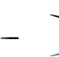
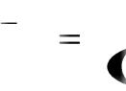

Therefore, D _{AB} = 3.898 * 10 ^{–5} m ²/sec

- A tube 1 cm in inside diameter that is 20 cm long is filled with Co₂ and H₂ at a total pressure of 2 atm at 0 C. The diffusion coefficient of the Co₂ – H₂ system under these conditions is 0.275

Fatima Michael College of Engineering & Technology85
www.studentsfocus.com

Fatima Michael College of Engineering & Technology

cm²/sec. If the partial pressure of Co₂ is 1.5 atm at one end of the tube and 0.5 atm at the other end, find the rate of diffusion for:

- steady state equimolar counter diffusion (N _{A} = - N _{B})

- steady state counter diffusion where N _{B} = -0.75 N _{A}, and

- steady state diffusion of Co₂ through stagnant H₂ (N_{B} = 0)

Given: D _{AB} = 0.275 cm ²/sec = 0.275 * 10 ^{–4} m ² /sec ; T = 0 C = 273 k
^{N} A | 0.275 * 10 | 4 |  | 1.5 * 1.01325 * 10 |  | 5 | 0.5 * 1.01325 * 10 | 5
^{N} A | 8314 * 273 * 0.2
 | 6.138 * 10 | 6 | k mol
 | 6.138 * 10 | 6 | m ² sec



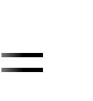
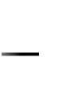
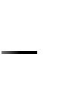
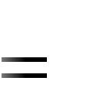

Rate of diffusion = N _{A} S

Where S is surface area

Therefore rate of diffusion = 6.138 * 10⁻⁶ * r ²
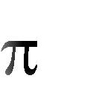

= 6.138 * 10 ^{–6} * (0.5 * 10 ^{–2}) ²

- 4.821 * 10

- 1.735 * 10

–10

–3

- mol/sec

mol/hr.

ii) N _{A} | C D _{AB} | d y _{A} |  | y _{A} N _{A} |  |  | N _{B}
ii) N _{A} | C D _{AB} | d z |  |  |  |  | N _{B}
given: N _{B} = - 0.75 N _{A}
Therefore | N _{A} | C D _{AB} |  |  | d y _{A} |  | y _{A} N _{A} 0.75 N _{A}
Therefore | N _{A} |  |  |  | d z |  | y _{A} N _{A} 0.75 N _{A}


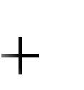
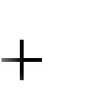
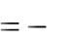


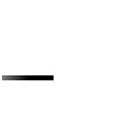
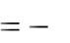

Fatima Michael College of Engineering & Technology86
www.studentsfocus.com

Fatima Michael College of Engineering & Technology

^{C D} A B | d y _{A} |  | 0.25 y _{A} N _{A}
^{C D} A B | d z
N _{A} 0.25 y _{A} N _{A} |  |  | C D _{AB} |  | d y _{A}
 |  |  |  |  | d z
N _{A} d zC D _{AB} |  |  | d y _{A}
 |  |  | 0.25 y _{A}
 | 1
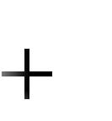
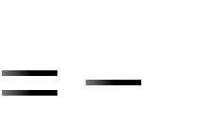
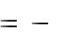


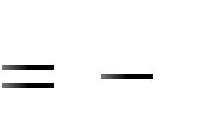

for constant N _{A} and C

Z ₂ | ^{y} A2
N _{A} d z | CD _{AB}
^{Z} 1 | ^{y} A1


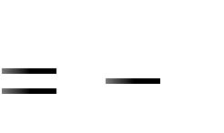

d y _{A}
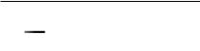

1 0.25 y _{A}

 |  |  |  |  |  |  |  | d x |  |  | 1 | ln a b x
 |  |  |  |  |  |  |  | a b x b
N _{A} z | C D _{AB} |  |  |  | 1 | ln 1 0.25 y _{A} |  |  | ^{y} A2
N _{A} z |  |  | 0.25 |  |  |  |  |  | ^{y} A1
N _{A} | 4 CD _{AB} | ln | 1 |  | 0.25 y _{A} ₂
N _{A} | z | ln |  | 1 | 0.25 y _{A} ₁ |  | ---------------------------------- (2)
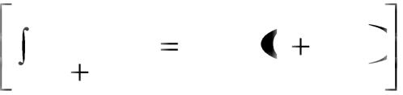
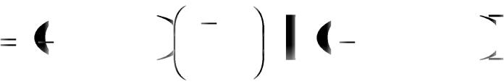
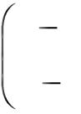
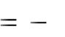

Given:

C | p |  | 2 * 1.01325 * 10 ⁵ | 0.0893 K mol m ³
C | R T | 8314 * 273 |  | 0.0893 K mol m ³
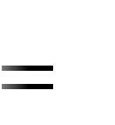
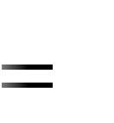

y

y

A1 | ^{p} A1 |  |  | 1.5 |  |  |  | 0.75
A1 |  | P |  |  | 2 |  |  | 0.75
A 2 |  | ^{p} A 2 |  | 0.5 |  |  |  | 0.25
A 2 |  | P |  |  |  | 2 |  | 0.25
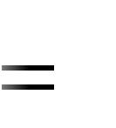
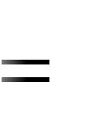

Fatima Michael College of Engineering & Technology87
www.studentsfocus.com

Fatima Michael College of Engineering & Technology

Substituting these in equation (2),
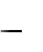

N _{A} | 4 * 0.0893 * 0.275 *10 ⁴ | ln | 1 |  | 0.25 * 0.25
N _{A} | 0.2 | ln | 1 |  | 0.25 * 0.75
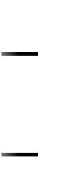
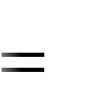

_{7.028 * 10} 6 ^{kmol}
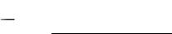
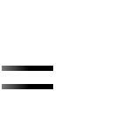
m ² sec

Rate of diffusion = N _{A} S = 7.028 * 10 ^{–6} * * (0.5 * 10 ^{–2}) ²
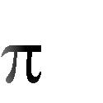

- 5.52 * 10 ^{–10} kmol/sec

- 1.987 * 10 ^{–3} mol/hr.

^{N} A | ^{CD} AB |  |  | d y _{A} |  |  |  |  |  |  |  |  | ^{y} A ^{N} A |  |  |  |  |  | ^{N} B
^{N} A |  |  |  | d z
iii)
Given: N _{B} = 0
 | ^{N} A |  | ^{CD} AB |  |  |  | d y _{A} |  |  |  |  |  |  |  | ^{y} A |  |  |  | ^{N} A
 | ^{N} A |  |  |  |  |  |  |  |  | d z |  |  |  |  |  |  |  |  | ^{N} A
Therefore
Z ₂ |  |  |  |  |  | ^{y} A2 |  |  |  |  |  |  | d y _{A}
N _{A} | d z |  | CD _{AB}
 |  |  |  |  |  | y _{A1} ¹ ^{y} A
^{Z} 1
 |  | ^{CD} AB |  |  |  | ln |  |  |  | 1 |  |  |  | ^{y} A2
 |  |  | Z |  |  |  |  |  |  |  | 1 |  |  | ^{y} A1
 |  |  | 0.0893 * 0.275 * 10 ⁴ |  |  |  |  |  |  |  |  |  |  |  |  |  |  |  | ln | 1 |  | 0.25
 |  |  |  |  |  | 0.2 |  |  |  |  |  |  |  |  |  |  |  |  | ln | 1 |  | 0.75
 |  | 1.349 * 10 |  |  |  |  |  |  |  | 5 |  |  |  |  | kmol
 |  |  |  |  |  |  |  |  |  |  |  |  |  | m ². sec
Rate of diffusion = 1.349 8 10 ^{–5} * |  |  |  |  |  |  |  |  |  |  |  |  | * (0.5 * 10 ^{–2}) ²


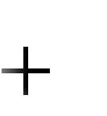
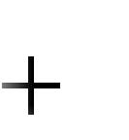
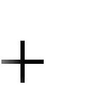
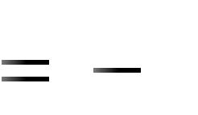
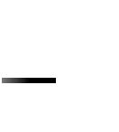
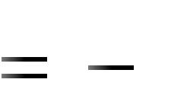
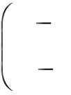
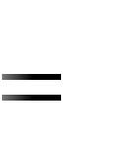

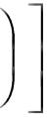
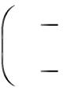
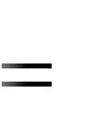
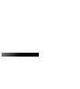
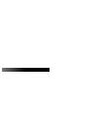
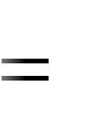

Fatima Michael College of Engineering & Technology88
www.studentsfocus.com

Fatima Michael College of Engineering & Technology

= 1.059 Kmol / sec = 3.814 mol/hr

CONVECTIVE MASS TRANSFER

In the study of convective heat transfer, the heat flux is connected to heat transfer coefficient as

^{Q Aq h t s t m} -------------------- | (4.1)
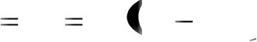

The analogous situation in mass transfer is handled by an equation of the form

^{N} ^{Ak c C As C A} -------------------- | (4.2)


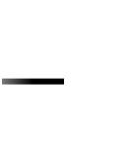
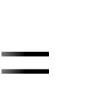
The molar flux N _{A} is measured relative to a set of axes fixed in space. The driving force is the difference between the concentration at the phase boundary, C _{AS} (a solid surface or a fluid interface) and the concentration at some arbitrarily defined point in the fluid medium, C _{A} . The convective mass transfer coefficient k_{C} is a function of geometry of the system and the velocity and properties of the fluid similar to the heat transfer coefficient, h.

Significant Parameters in Convective Mass Transfer

Dimensionless parameters are often used to correlate convective transfer data. In momentum transfer Reynolds number and friction factor play a major role. In the correlation of convective heat transfer data, Prandtl and Nusselt numbers are important. Some of the same parameters, along with some newly defined dimensionless numbers, will be useful in the correlation of convective mass-transfer data.

The molecular diffusivities of the three transport process (momentum, heat and mass) have been defined as:
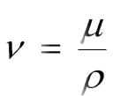

Momentum diffusivity

 | ----------------------------- | (4.3)
Thermal diffusivity | k
Thermal diffusivity | C _{p} | --------------------------- (4.4)
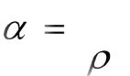

and

Fatima Michael College of Engineering & Technology89
www.studentsfocus.com

Fatima Michael College of Engineering & Technology

^{Mass diffusivity} ^{D} AB ₋₋₋₋₋₋₋₋₋₋₋₋₋₋₋₋₋₋₋₋₋₋₋₋₋₋₋ | (4.5)

It can be shown that each of the diffusivities has the dimensions of L² / t, hence, a ratio of any of the two of these must be dimensionless.

The ratio of the molecular diffusivity of momentum to the molecular diffusivity of heat (thermal diffusivity) is designated as the Prandtl Number
Momentum diffusivity |  |  | Pr |  |  | ^{C}p
 | Thermal diffusivity |  | Pr |  |  |  |  | K |  | ------------------------ |  | (4.6)
The analogous number in mass transfer is Schmidt number given as
 | Momentum diffusivity |  | Sc
 | Mass diffusivity |  |  |  | ^{D} AB |  |  |  |  | ^{D} AB |  | (4.7)
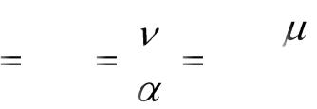
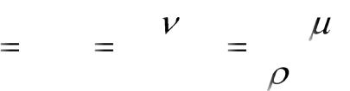

The ratio of the molecular diffusivity of heat to the molecular diffusivity of mass is designated the Lewis Number, and is given by

Thermal diffusivity | Le |  |  | k
Mass diffusivity | Le | ^{D} AB |  | ^{C} ^{p} ^{D} ^{AB} ------------- (4.8)
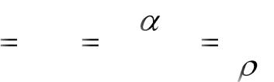

Lewis number is encountered in processes involving simultaneous convective transfer of mass and energy.

Let us consider the mass transfer of solute A from a solid to a fluid flowing past the surface of the solid. For such a case, the mass transfer between the solid surface and the fluid may be written as

^{N} ^{Ak c C As C A} ---------------------- | (4.1 a)
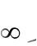

Since the mass transfer at the surface is by molecular diffusion, the mass transfer may also described by

Fatima Michael College of Engineering & Technology90
www.studentsfocus.com

Fatima Michael College of Engineering & Technology

N _{A} | ^{D} AB | d C _{A}
N _{A} | ^{D} AB | d y |  | y | 0 | (4.9)
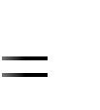
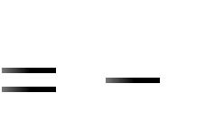

When the boundary concentration, C_{As} is constant, equation (4.9) may be written as




N _{A} | ^{D} AB | d C _{A} C _{A s}
N _{A} | ^{D} AB | d y |  | y | 0 | (4.10)

Equation (4.1a) and (4.10) may be equated, since the y define the same flux of component A leaving the surface and entering the fluid




^{k} c ^{C} A s ^{C} A | ^{D} AB | d | C _{A} | ^{C} A s
^{k} c ^{C} A s ^{C} A | ^{D} AB | d y | C _{A} | ^{C} A s | ^{y} ⁰ ------------- (4.11)
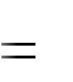
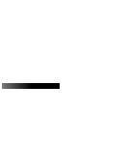
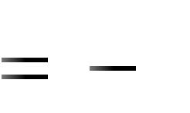

This relation may be rearranged into the following form:

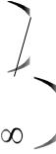
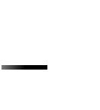

k _{c} |  | d C _{A} | C _{A s} d y
^{D} AB |  | C _{A} | C _{A} |  | y | 0 | (4.12)
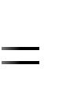
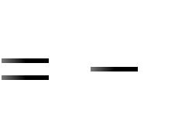

Multiplying both sides of equation(4.12) by a characteristic length, L we obtain the following dimensionless expression:




k _{c} L |  | d C _{A} C _{A s} d y |  | y 0
^{D} AB |  | C _{A S} C _{A} L |  |  | ----------------- (4.13)


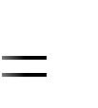

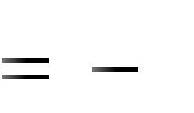

The right hand side of equation (4.13) is the ratio of the concentration gradient at the surface to an overall or reference concentration gradient; accordingly, it may be considered as the ratio of molecular mass-transport resistance to the convective mass-transport resistance of the fluid. This ratio is generally known as the Sherwood number, Sh and analogous to the Nusselt number Nu, in heat transfer.

Fatima Michael College of Engineering & Technology91
www.studentsfocus.com

Fatima Michael College of Engineering & Technology

Application of Dimensionless Analysis to Mass Transfer

One of the method of obtaining equations for predicting mass-transfer coefficients is the use of dimensionless analysis. Dimensional analysis predicts the various dimensionless parameters which are helpful in correlating experimental data.

There are two important mass transfer processes, which we shall consider, the transfer of mass into a steam flowing under forced convection and the transfer of mass into a phase which is moving as the result of natural convection associated with density gradients.

- A stream of air at 100 kPa pressure and 300 K is flowing on the top surface of a thin flat sheet of solid naphthalene of length 0.2 m with a velocity of 20 m/sec. The other data are:

Mass diffusivity of naphthalene vapor in air = 6 * 10 ^{–6} m ²/sec

Kinematic viscosity of air = 1.5 * 10 ^{–5} m ².sc

Concentration of naphthalene at the air-solid naphthalene interface = 1 * 10 ^{–5} kmol/m³

Calculate:

- the overage mass transfer coefficient over the flat plate

- the rate of loss of naphthalene from the surface per unit width

Note: For heat transfer over a flat plate, convective heat transfer coefficient for laminar flow can be calculated by the equation.

Nu 0.664 Re¹_{L} ² Pr ¹ ³
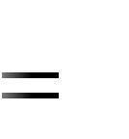

you may use analogy between mass and heat transfer.

Solution:

Given: Correlation for heat transfer

Nu 0.664 Re¹_{L} ² Pr ¹ ³

Fatima Michael College of Engineering & Technology92
www.studentsfocus.com

Fatima Michael College of Engineering & Technology

The analogous relation for mass transfer is

Sh 0.664 Re¹ ² Sc ¹ ³
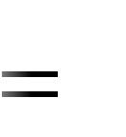
L -----------------------------------------(1)

where

Sh = Sherwood number = kL/D _{AB}

Re _{L} = Reynolds number = L/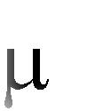


Sc = Schmidt number = / ( D _{AB})
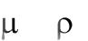

k = overall mass transfer coefficient L = length of sheet

D _{AB} = diffusivity of A in B

  - velocity of air

    - viscosity of air

  - density of air, and

- = kinematic viscosity of air. Substituting for the known quantities in equation (1)



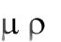
k 0.2 | 0.664 |  | 0.2 20 | 1 2
6 * 10 ⁶ | 0.664 | 1.5 * 10 |  | 5

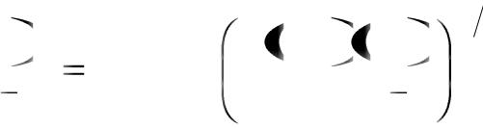

1.5 * 10 | 5 | 1 3
6 * 10 | 6
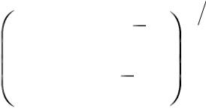

k = 0.014 m/sec

Rate of loss of naphthalene = k (C _{Ai} – C _{A} )


- 0.014 (1 * 10 ^{–5} – 0) = 1.4024 * 10 ^{–7} kmol/m ² sec

Rate of loss per meter width = (1.4024 * 10 ^{–7}) (0.2) = 2.8048 * 10 ^{–8} kmol/m.sec

Fatima Michael College of Engineering & Technology93
www.studentsfocus.com

Fatima Michael College of Engineering & Technology

  - 0.101 gmol/m.hr.

- The mass flux from a 5 cm diameter naphthalene ball placed in stagnant air at 40 C and

atmospheric pressure, is 1.47 * 10 ^{–3} mol/m ². sec. Assume the vapor pressure of naphthalene to be 0.15 atm at 40 C and negligible bulk concentration of naphthalene in air. If air starts blowing across the surface of naphthalene ball at 3 m/s by what factor will the mass transfer rate increase, all other conditions remaining the same?

For spheres :

Sh = 2.0 + 0.6 (Re) ^{0.5} (Sc)^{0.33}

Where Sh is the Sherwood number and Sc is the Schmids number. The viscosity and density of air are 1.8 * 10 ^{–5} kg/m.s and 1.123 kg/m ³, respectively and the gas constant is 82.06 cm ³ . atm/mol.K.

Given:

 |  |  |  |  | 3 |  |  | mol |  |  | ^{K} c
N | 1.47 * 10 |  |  |  | 3 |  |  | mol |  |  |  |  |  |  | p _{A}
N |  |  |  |  |  |  | m ². sec |  |  |  | RT
k _{c} |  | 0.15 |  | 0 |  | 1.47 * 10 |  |  |  | 3 |  | * 10 |  |  | ₄ mol
RT |  | 1 |  | 0 |  |  |  |  |  |  |  |  |  |  |  |  | cm ². sec
^{k} c | 1.47 * 10 |  |  |  |  | 7 |  | * 82.06 * |  | 273 |  |  |  | 40
^{k} c |  |  | 0.15
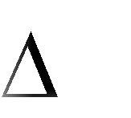
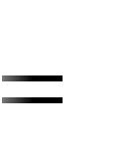
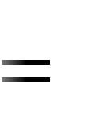
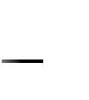
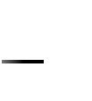
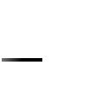
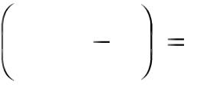


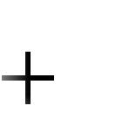
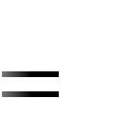
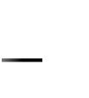

= 0.0252 cm/sec

k _{c} = 2.517 * 10 ^{–4} m/sec ------------------------------(3)

Estimation of D _{AB}:

From (2),


Fatima Michael College of Engineering & Technology94
www.studentsfocus.com


Fatima Michael College of Engineering & Technology

2.517 * 10 ⁴ * 5 * 10 | 2 | 2
^{D} AB |  | 2
^{D} AB |  | (since v = 0)
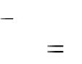
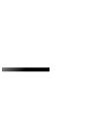
Therefore D _{AB} = 6.2925 * 10 ^{–6} m²/sec.

And

 | k _{c} * 5 * 10 |  | 2 | 2 | 0.6 | 5 * 10 ² | * 3 * 1.123 ^{0.5} |  |  | 1.8 * 10 ⁵ |  | 0.33
 | 6.2925 * 10 |  | 6 | 2 | 0.6 | 1.8 * 10 |  | 5 |  | 1.123 * 6.2925 * 10 |  | 6
7946 k _{c} = 2 |  | + 0.6 * (96.74) * (1.361)
 | k _{c} = | 0.0102 m/sec. |  |  | ----------------------------------------------------- |  |  |  |  | (4)
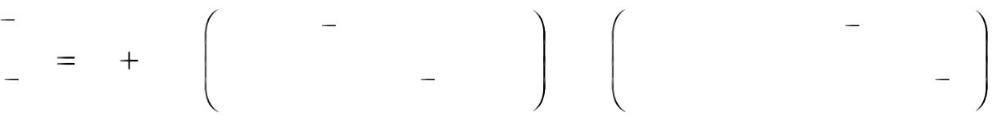

(4) |  | ^{N} A2 |  | 0.0102 | 40.5
(3) |  | ^{N} A1 | 2.517 * 10 ⁴ |  | 40.5
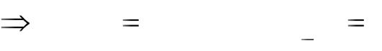
Therefore, rate of mass transfer increases by 40.5 times the initial conditions.

- A solid disc of benzoic acid 3 cm in diameter is spin at 20 rpm and 25 C. Calculate the rate of

dissolution in a large volume of water. Diffusivity of benzoic acid in water is 1.0 * 10 ^{–5} cm ²/sec, and solubility is 0.003 g/cc. The following mass transfer correlation is applicable:

 | Sh = 0.62 Re ^{½} Sc ^{1/3}
 | Re | D ²
Where | Re |  | and is the angular speed in radians/time.
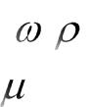
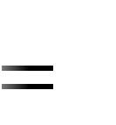
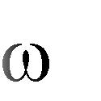

Given:

Sh = 0.62 Re ^{½} Sc ^{1/3}

 | k _{c} D |  | D ² |  | 1 |  |  | 1
 | k _{c} D | 0.62 | D ² |  | 2 |  |  |  | 3
(i.e.) ^{D} ^{AB} |  | 0.62 |  |  |  |  | ^{D} AB | ------------------ (3)


Fatima Michael College of Engineering & Technology95
www.studentsfocus.com


Fatima Michael College of Engineering & Technology

1 rotation = 2 | radian
Therefore 20 rotation per minute = 20 * 2 |  |  |  |  |  |  |  |  | radian/min
 |  |  |  |  |  | 20 |  |  | * 2 radian sec
 | 60
For water = 1 g/cm ³ = 1 centipoise = 0.01 g/cm.sec.
From (3),
 | 1 |  |  |  |  |  |  |  |  |  | 1
 |  |  |  |  |  |  |  |  | 3
 | 2
k _{c} 0.62 | ^{D} AB
k _{c} 0.62 | ^{D} AB |  |  |  |  |  |  |  | ^{D} AB
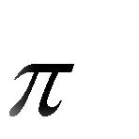

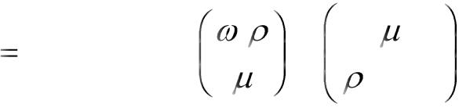

 |  | 40 60 * 1 |  | 1
0.62 * 1.0 * 10 ⁵ | * |  |  | 2
0.62 * 1.0 * 10 ⁵ | * | 0.01



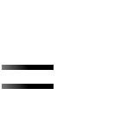
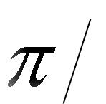

= 8.973 * 10 ^{–4} cm/sec.

From (2),

N _{A} = 8.973 * 10 ^{–4} (0.003 – 0)

= 2.692 * 10 ^{–6} g/cm ².sec

From (1),

N _{A} S = N _{A} * (2 r ²)

= 2.692 * 10 ^{–6} * (2 * 1.5 ²)

- 3.805 * 10 ^{–5} g/sec

- 0.137 g/hr.


1
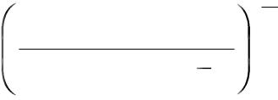

0.01 3

1 * 1.0 * 10 ⁵

Fatima Michael College of Engineering & Technology96
www.studentsfocus.com

