**UNIT-2**

**INTERNAL COMBUSTION ENGINE PLANT**

* **DIESEL POWER PLANT:**

**Introduction:**

**IC Engines:**

An internal combustion engine (ICE) is a heatengine where the combustion of a fuel occurs with an oxidizer (usually air) in a combustion chamber that is an integral part of the working fluid flow circuit.

**IC engine classification:**

1.Based on working cycle

* Four stroke cycle
* Two stroke cycle

2.Based on operating cycle

* [Diesel](https://me-mechanicalengineering.com/diesel-cycle/) (For the Ideal Diesel Engine)
* Dual (For the Actual Diesel Engine)
* [Otto](https://me-mechanicalengineering.com/otto-cycle/) (For the Convectional SI Engine)

3.Based on the position of cylinders

* Horizontal Engine
* Vertical Engine
* Radial Engine
* V-Type Engine

1. According to their uses:

* Stationary Engine
* Portable Engine
* Marine Engine
* Auto mobile Engine
* Aero Engine

5.Based on the fuel used

* Diesel Engine
* Petrol Engine
* Gas Engine
* Kerosene Engine

6. Based on cooling system

* [Air-cooling system](https://me-mechanicalengineering.com/air-cooling-system-reciprocating-engine/)
* [Water-cooling system](https://me-mechanicalengineering.com/liquid-cooling-system-in-reciprocating-engine/)

1. Based on the type of ignition

Spark Ignition Engine (S.I. Engine)

Compression Ignition Engine (C.I. Engine)

**Construction Of A Diesel Power Plant:**

A generating station in which diesel engine is used as the prime mover for the generation of electrical energy is known as diesel power station. In a diesel power station, diesel engine is used as the prime mover. The diesel burns inside the engine and the products of this combustion act as the working fluid to produce mechanical energy. The diesel engine drives alternator which converts mechanical energy into electrical energy. As the generation cost is considerable due to high price of diesel, therefore, such power stations are only used to produce small power. Although steam power stations and hydro-electric plants are invariably used to generate bulk power at cheaper costs, yet diesel power stations are finding favour at places where demand of power is less, sufficient quantity of coal and water is not available and the transportation facilities are inadequate. This plants are also standby sets for continuity of supply to important points such as hospitals, radio stations, cinema houses and telephone exchanges.

**Advantages**

1. The design and layout of the plant are quite simple.
2. It occupies less space as the number and size of the auxiliaries is small.
3. It can be located at any place.
4. It can be started quickly and it can pickup load in a short time.
5. There are no standby losses.
6. It requires less quantity of water for cooling.
7. The overall cost is much less than that of steam power station of same capacity.
8. The thermal efficiency of the plant is higher than that of a steam power station.
9. It requires less operating staff. 120 Power Plant Engineering

**Disadvantages**

1. The plant has high running charges as the fuel (diesel) used is costly.
2. The plant doesn’t work satisfactorily under overload conditions for a longer period.
3. The plant can only generate small power.
4. The cost of lubrication is generally high.
5. The maintenances charges are generally high

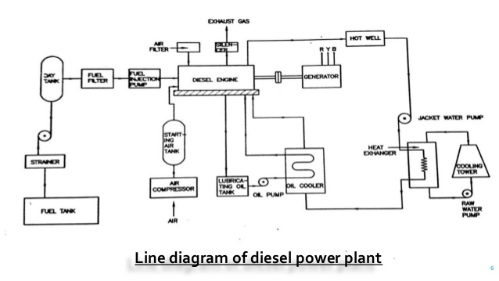

**Diesel power plant auxiliaries:**

1. Fuel supply system.
2. Air starting equipment
3. Lubrication
4. Cooling system

**Fuel supply system.**

It consists of storage tank, strainers, fuel transfer pump and all day fuel tank. The fuel oil is supplied at the plant site by rail or road. The oil is stored in the storage tank. From the storage tank, oil is pumped to smaller all day tank at daily or short intervals. From this tank, fuel oil is passed through strainers to remove suspended impurities. The clean oil is injected into the engine by fuel injection pump.

**Fuel injection**

It is a system for mixing fuel with air in an internal combustion engine. A fuel injection system is designed and calibrated specifically for the type of fuel it will handle. Most fuel injection systems are for diesel applications. With the advent of electronic fuel injection (EFI), the diesel gasoline hardware has become similar. EFI’s programmable firmware has permitted common hardware to be used with different fuels. Carburetors were the predominant method used to meter fuel before the widespread use of fuel injection. A variety of injection systems have existed since the earliest usage of the internal combustion engine. The primary difference between carburetors and fuel injection is that fuel injection atomizes the fuel by forcibly pumping it through a small nozzle under high pressure, while a carburetor relies on low pressure created by intake air rushing through it to add the fuel to the air stream. The fuel injector is only a nozzle and a valve: the power to inject the fuel comes from a pump or a pressure container farther back in the fuel supply.

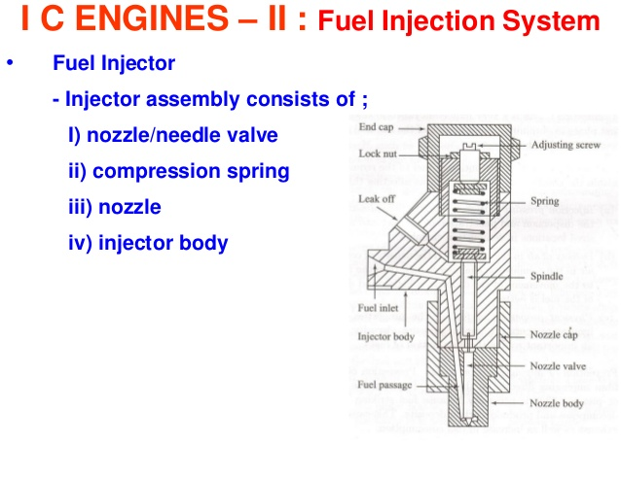

**Air starting equipment:**

This system supplies necessary air to the engine for fuel combustion. It consists of pipes for the supply of fresh air to the engine manifold. Filters are provided to remove dust particles from air which may act as abrasive in the engine cylinder. Because a diesel engine requires close tolerances to achieve its compression ratio, and because most diesel engines are either turbocharged or supercharged, the air entering the engine must be clean, free of debris, and as cool as possible. Also, to improve a turbocharged or supercharged engine’s efficiency, the compressed air must be cooled after being compressed. The air intake system is designed to perform these tasks. Air intake systems are usually one of two types, wet or dry. In a wet filter intake system, as shown in the Figure.

The air is sucked or bubbled through a housing that holds a bath of oil such that the dirt in the air is removed by the oil in the filter. The air then flows through a screen-type material to ensure any entrained oil is removed from the air. In a dry filter system, paper, cloth, or a metal screen material is used to catch and trap dirt before it enters the engine. In addition to cleaning the air, the intake system is usually designed to intake fresh air from as far away from the engine as practicable, usually just outside of the engine’s building or enclosure. This provides the engine with a supply of air that has not been heated by the engine’s own waste heat. The reason for ensuring that an engine's air supply is as cool as possible is that cool air is denser than hot air. This means that, per unit volume, cool air has more oxygen than hot air. Thus, cool air provides more oxygen per cylinder charge than less dense, hot air. More oxygen means a more efficient fuel burn and more power.

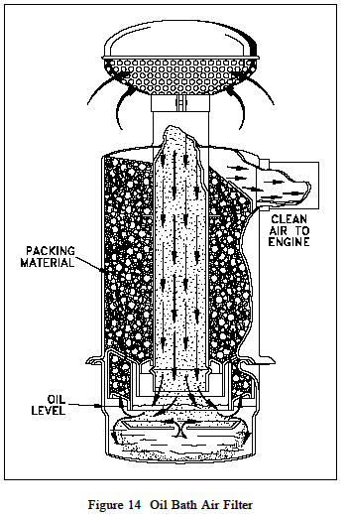

1. **Lubriation System:**

The system minimises the wear of rubbing surfaces of the engine. It comprises of lubricating oil tank, pump, filter and oil cooler. The lubrication oil is drawn from the lubricating oil tank by the pump and is passed through filter to remove impurities .The clean lubrication oil is delivered to the points which require lubrication. The oil coolers incorporated in the system keep the temperature of the oil low.

An internal combustion engine would not run for even a few minutes if the moving parts were allowed to make metal-to-metal contact. The heat generated due to the tremendous amounts of friction would melt the metals, leading to the destruction of the engine. To prevent this, all moving parts ride on a thin film of oil that is pumped between all the moving parts of the engine. The oil serves two purposes. One purpose is to lubricate the bearing surfaces. The other purpose is to cool the bearings by absorbing the friction- generated heat. The flow of oil to the moving parts is accomplished by the engine's internal lubricating system.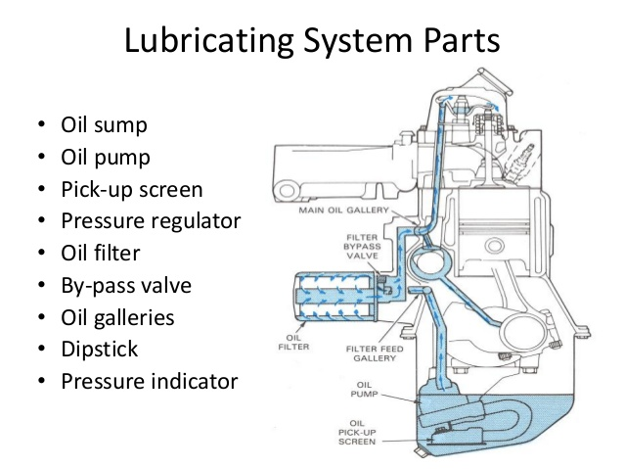

Oil is accumulated and stored in the engine's oil pan where one or more oil pumps take suction and pump the oil through one or more oil filters as shown in the figure. The filters clean the oil and remove any metal that the oil has picked up due to wear. The cleaned oil then flows up into the engine's oil galleries. A pressure relief valve(s) maintains oil pressure in the galleries and returns oil to the oil pan upon high pressure. The oil galleries distribute the oil to all the bearing surfaces in the engine. Once the oil has cooled and lubricated the bearing surfaces, it flows out of the bearing and gravity-flows back into the oil pan. In medium to large diesel engines, the oil is also cooled before being distributed into the block. This is accomplished by either internal or external oil cooler. The lubrication system also supplies oil to the engine’s governor.

**Cooling system:**

The heat released by the burning of fuel in the engine cylinder is partially converted into work. The remainder part of the heat passes through the cylinder wall, piston, rings etc. and may cause damage to system. In order to keep the temperature of the engine parts within the safe operating limits, cooling is provided. The cooling system consists of a water source, pump and cooling towers. The pump circulates water through cylinder and head jacket. The water takes away heat form the engine and it becomes hot. The hot water is cooled by cooling towers and re circulated for cooling.

**Two methods of cooling IC engines**

(i) Air Cooling

(ii)Liquid cooling

**(i)Air Cooling;**

Air Cooled System Air cooled system is generally used in small engines say up to 15-20 kW and in aero plane engines. In this system fins or extended surfaces are provided on the cylinder walls, cylinder head, etc. Heat generated due to combustion in the engine cylinder will be conducted to the fins and when the air flows over the fins, heat will be dissipated to air.

The amount of heat dissipated to air depends upon :

1. Amount of air flowing through the fins.

(b) Fin surface area.

(c) Thermal conductivity of metal used for fins.

**Advantages of Air Cooled System Following are the advantages of air cooled system** :

1. Radiator/pump is absent hence the system is light.

(b) In case of water cooling system there are leakages, but in this case there are no leakages.

(c) Coolant and antifreeze solutions are not required.

(d) This system can be used in cold climates, where if water is used it may freeze.

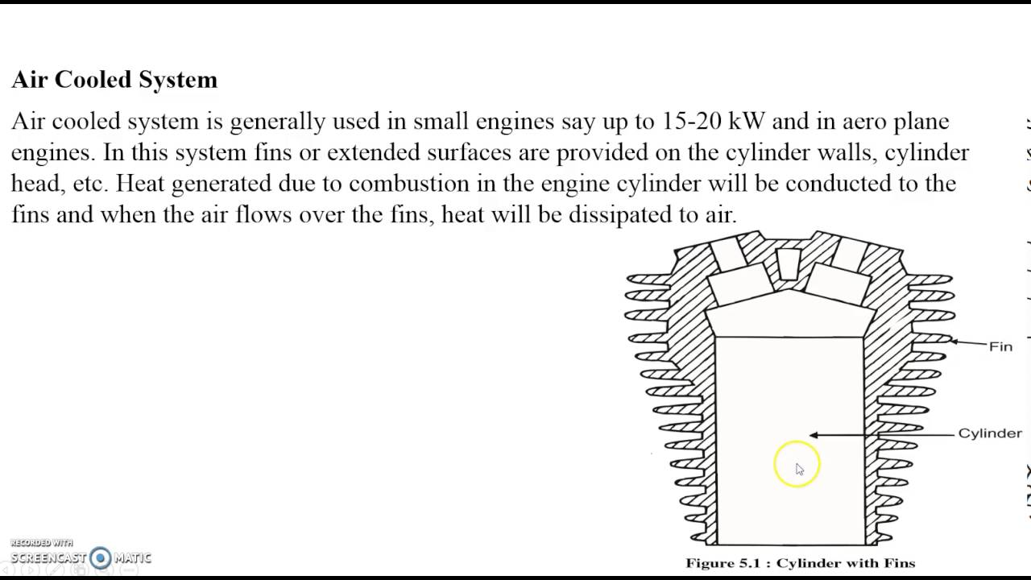

**Disadvantages of Air Cooled System**

(a) Comparatively it is less efficient.

(b) It is used in aero planes and motorcycle engines where the engines are exposed to air directly.

**WATER COOLING SYSTEM:**

In this method, cooling water jackets are provided around the cylinder, cylinder head, valve seats etc. The water when circulated through the jackets, it absorbs heat of combustion. This hot water will then be cooling in the radiator partially by a fan and partially by the flow developed by the forward motion of the vehicle. The cooled water is again recirculated through the water jackets.

**Types of Water Cooling System**

There are two types of water cooling system :

(i) Thermo Siphon System

(ii)Pump Circulation System

**(i) Thermo Siphon System:**

In this system the circulation of water is due to difference in temperature (i.e. difference in densities) of water. So in this system pump is not required but water is circulated because of density difference only.

**(ii)Pump Circulation System:**

In this system circulation of water is obtained by a pump. This pump is driven by means of engine output shaft through V-belts.

**Water cooling system mainly consists of :**

(a) Radiator

(b) Thermostat valve

(c) Water pump

(d) Fan

(e) Water Jackets

(f) Antifreeze mixtures.

**Supercharger:**

A supercharger is an air compressor used for forced induction of an internal combustion engine.

The higher concentration of oxygen provided by a super-

charger is matched with a larger amount of fuel from the fuel injectors thus boosting the power of the engine.

**GAS TURBINE PLANT**

**1 INTRODUCTION**

The gas turbine obtains its power by utilizing the energy of burnt gases and air, which is at high temperature and pressure by expanding through the several stages of fixed and moving blades (stator and rotor). To get a high pressure (of the order of 4 to 10 bar) of working fluid, which is essential for expansion a compressor, is required.

A simple gas turbine cycle consists of

1. a compressor
2. a combustion chamber
3. a turbine.

Since the compressor is coupled with the turbine shaft, it absorbs some of the power produced by the turbine and hence lowers the efficiency. The network is therefore the difference between the turbine work and work required by the compressor to drive it. Gas turbines are constructed to work mainly on oil and/or natural gas.

**ADVANTAGES OF GAS TURBINE POWER PLANT**

1. It is smaller in size and weight as compared to an equivalent steam power plant

1. The initial cost and operating cost of the plant is lower than an equivalent steam power plant.
2. The plant requires less water as compared to a condensing steam power plant.
3. The plant can be started quickly, and can be put on load in a very short time.
4. There are no standby losses in the gas turbine power plant whereas in steam power plant these losses occur because boiler is kept in operation even when the turbine is not supplying any load.
5. The maintenance of the plant is easier and maintenance cost is low.
6. The lubrication of the plant is easy. In this plant lubrication is needed mainly in compressor, turbine main bearing and bearings of auxiliary equipment.
7. The plant does not require heavy foundations and building.
8. There is great simplification of the plant over a steam plant due to the absence of boilers with their feed water evaporator and condensing system.

**DISADVANTAGES**

1. Major part of the work developed in the turbine is used to derive the compressor. Therefore, network output of the plant is low.

2. Since the temperature of the products of combustion becomes too high so service conditions become complicated even at moderate pressures.

3. Proper air filtering and combustion control to prevent corrosion problems.

**CLASIFICATION OF GAS TURBINES:**

The gas turbine a are mainly divided into two groups:

1. Constant pressure combustion gas turbine

(a) Open cycle constant pressure gas turbine

(b)Closed cycle constant pressure gas turbine

1. Constant cycle constant pressure gas turbine

**Constant pressure combustion gas turbine:**

**(a) Open cycle constant pressure gas turbine:**

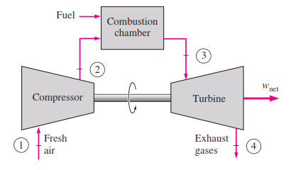

**Working Principal**

Fresh air enters the compressor at ambient temperature where its pressure and temperature are increased.

The high pressure air enters the combustion chamber where the fuel is burned at constant pressure. The high temperature (and pressure) gas enters the turbine where it expands to ambient pressure and produces work.

**Features:** •

* Gas-turbine is used in aircraft propulsion and electric power generation. •
* High thermal efficiencies up to 44%. •
* Suitable for combined cycles (with steam power plant) •
* High power to weight ratio, high reliability, long life •
* Fast start up time, about 2 min, compared to 4 hr for steam-propulsion systems •
* High back work ratio (ratio of compressor work to the turbine work), up to 50%, compared to few percent in steam power plants.

**Brayton Cycle**

Brayton cycle is the ideal cycle for gas-turbine engines in which the working fluid undergoes a closed loop. That is the combustion and exhaust processes are modelled by constant-pressure heat addition and rejection, respectively

The Brayton ideal cycle is made up of four internally reversible processes:

* 1-2 isentropic compression (in compressor)
* 2-3 const. pressure heat-addition (in combustion chamber)
* 3-4 isentropic expansion (in turbine)
* 4-1 const. pressure heat rejection (exhaust)

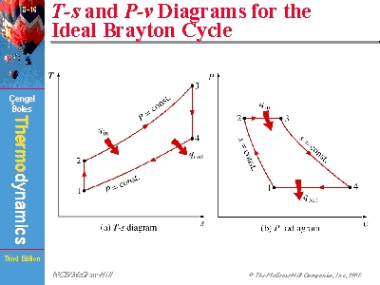

* **To improve the performance of the thermal efficiency below methods are employed**

(i)Intercoolinng

(ii)Reheating

(iii)Regenerative

**(i)Intercooling:**

In Intercooling a heat exchanger is used to cool the compressor gases at the time of compression process. When the compressor involves the high and low pressure unit in it, the intercooler could be installed between them to cool down the flow. This cooling process will decrease the work needed for the compression in the high pressure unit. The cooling fluid can be water , air. In marine gas turbines the sea water is used to cool the fluid. It is observed that a successful implementation of the inter-cooler can improve the gas turbine output.

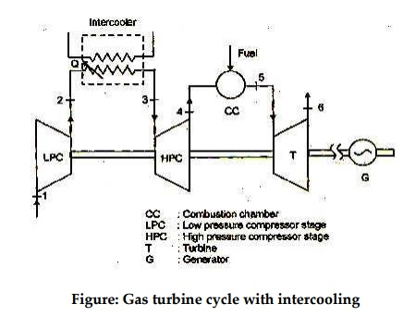

**(ii)Reheating**

Reheating is applied in a gas turbine in such a way that it increases the turbine work without increasing the compressor work or melting the turbine materials. When a gas turbine plant has a high pressure and low pressure turbine a reheater can be applied successfully. Reheating can improve the efficiency up to 3 % . A reheater is generally is a combustor which reheat the flow between the high and low pressure turbines.

In jet engines an afterburner is used to reheat. It is attached at the exhaust of the turbine. As a result the thrust is increased. But it takes a lot of fuel to increase the thrust.

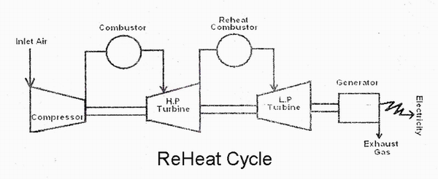

**(iii)Regenerative:**

Regeneration process involves the installation of a heat exchanger in the gas turbine cycle. The heat-exchanger is also known as the recuperator. This heat exchanger is used to extract the heat from the exhaust gas . This exhaust gas is used to heat the compressed air. This compressed and pre-heated air then enters the combustors. When the heat exchanger is well designed , the effectiveness is high and pressure drops are minimal. And when these heat exchangers are used an improvement in the efficiency is noticed. Regenerated Gas turbines can improve the efficiency  more than 5 % . Regenerated Gas Turbine work even more effectively in the improved part load applications.

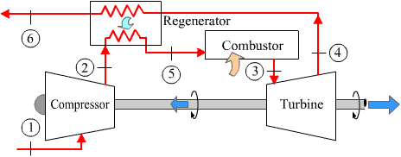

1. **Constant cycle constant pressure gas turbine:**

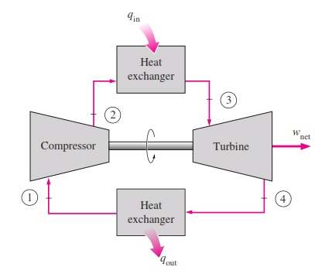

* The closed cycle gas turbine works on the principle of Joule’s or Brayton’s cycle
* In this turbine, the gas is compressed isentropically and then passed into the heating chamber. The compressor generally used is of rotary type.
* The compressed air is heated with the help of some external source and then made to flow over the turbine blades. The turbine used here is of reaction type.
* The gas while flowing over the blades of the turbine, gets expanded. From the turbine the gas is passed to the cooling chamber. Here the gas is cooled at constant pressure with the help of circulating water to its original temperature.
* Now the gas is again made to flow through the compressor to repeat the process.
* Here the same gas is circulated again and again in the working of a closed cycle gas turbine.

**COMBINATION OF GAS TURBINE CYCLE**

**Combination of gas turbine and steam power plants:**

* **Heating feed water with exhause gases:**

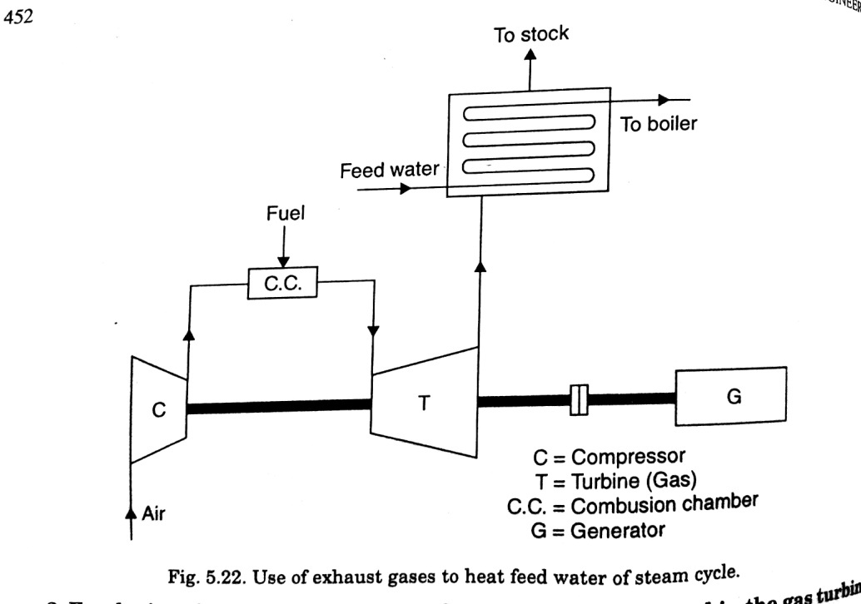

The combination results in the increase of the outputof work, since blending would not be required.

* **Employing the gases from the supercharged boiler to expand in the gas turbine**

It work under the pressure about 5 bar and the gases are expanded in the gas turbine,its exhaust being used to heat feed water before discharging through the stack.

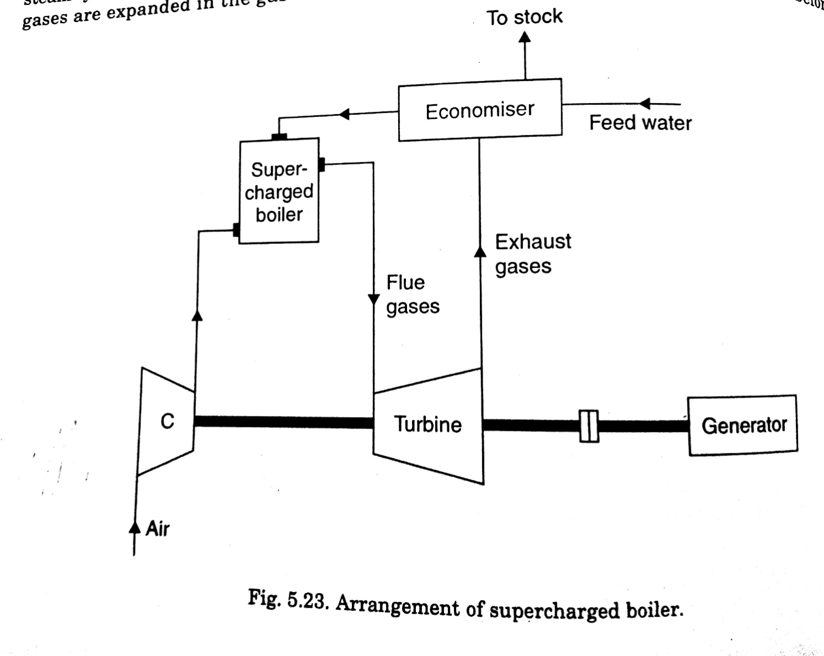

* **Employing the gases as combustion air in the steam boiler:**

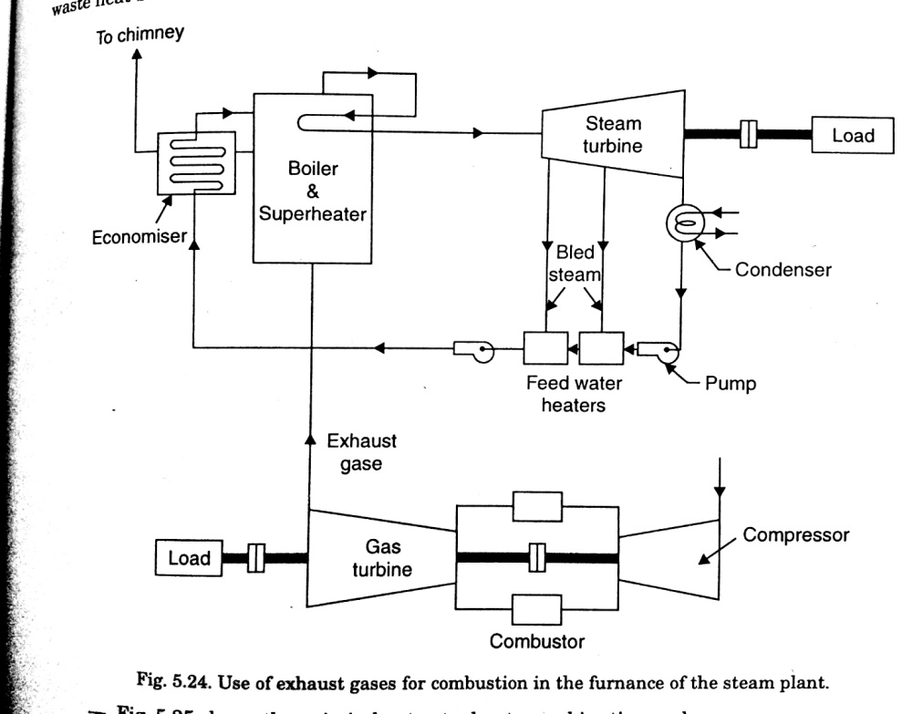

**Combination of gas turbine and diesel power plants:**

* The improvement is achieved by the three combinations

(i) Turbo-charging

(ii) Gas-generator

(iii) Compound engine

**(i) Turbo-charging:**

This is called supercharging.,the output of the gas turbine is to run the compressor.

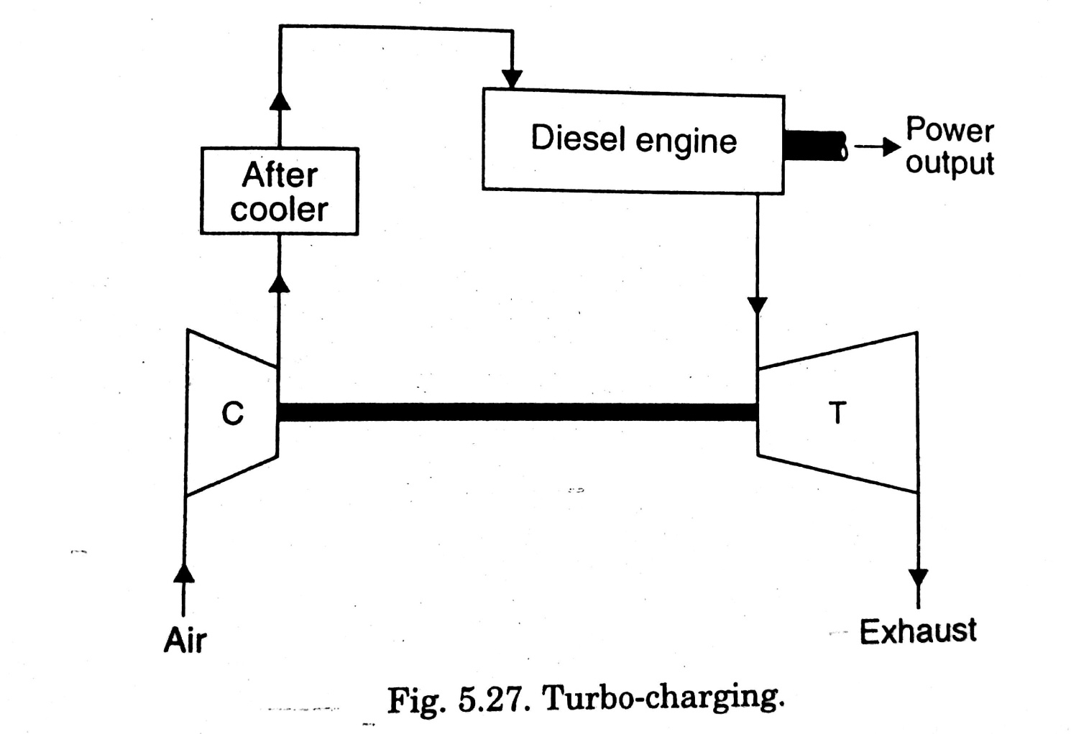

**(ii) gas generator:**

Here the compressors which supplies the compressed air to the diesel engine is not driven from gas turbine.

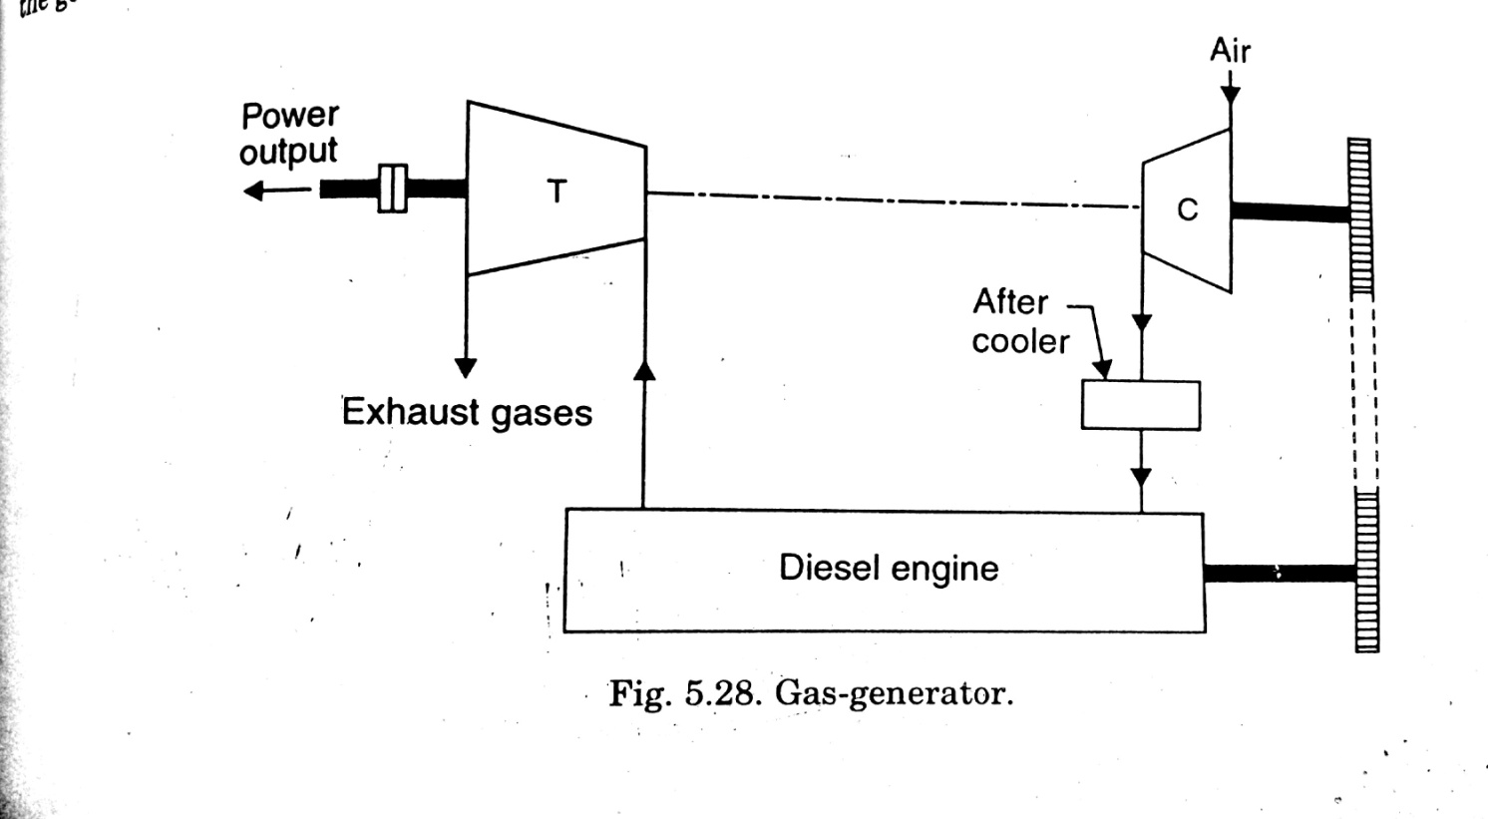

### Comparision Between Gas Turbine and Steam Turbine in Tabular form:

|  |  |  |
| --- | --- | --- |
| **S.no** | **Gas Turbine** | **Steam Turbine** |
| 1. | In gas turbine the compressor and combustion chamber are the important components. | In steam turbine the steam boiler and  accessoriesare the important components. |
| 2. | Less space for installation is required. | More space for installation is required. |
| 3. | The mass of gas turbine per kW produced is less. | The mass of the steam turbine per kW produced is more. |
| 4. | Less installation and running cost. | More installation and running cost. |
| 5. | With the changing load conditions, its control is easy. | Its control is difficult, with the changing load condition. |
| 6. | The starting of this turbine is easy and quick. | The starting of steam turbine is not easy and takes long time. |
| 7. | A gas turbine does not depend on water supply. | A steam turbine depends upon water supply. |
| 8. | Its efficiency is less. | Its efficiency is high. |
|  |  |  |
|  |  |  |

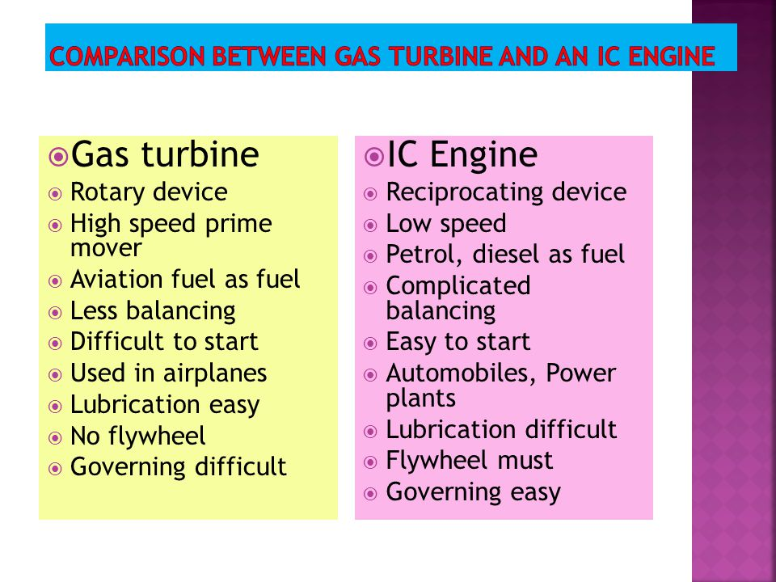

**DIRECT ENERGY CONVERSION**

Direct energy conversion (DEC) or simply direct conversion converts a charged particle's [kinetic energy](https://en.wikipedia.org/wiki/Kinetic_energy) into a [voltage](https://en.wikipedia.org/wiki/Voltage). It is a scheme for power extraction from [nuclear fusion](https://en.wikipedia.org/wiki/Nuclear_fusion).

**Solar Energy:**

Solar energy is radiant light and heat from the [Sun](https://en.wikipedia.org/wiki/Sun) that is harnessed using a range of ever-evolving technologies such as [solar heating](https://en.wikipedia.org/wiki/Solar_heating), [photovoltaics](https://en.wikipedia.org/wiki/Photovoltaics" \o "Photovoltaics), [solar thermal energy](https://en.wikipedia.org/wiki/Solar_thermal_energy), [solar architecture](https://en.wikipedia.org/wiki/Solar_architecture), molten salt power plants and [artificial photosynthesis](https://en.wikipedia.org/wiki/Artificial_photosynthesis)

It is an important source of [renewable energy](https://en.wikipedia.org/wiki/Renewable_energy) and its technologies are broadly characterized as either [passive solar](https://en.wikipedia.org/wiki/Passive_solar) or [active solar](https://en.wikipedia.org/wiki/Active_solar) depending on how they capture and distribute solar energy or convert it into [solar power](https://en.wikipedia.org/wiki/Solar_power).

**Solar power plant -General terms and introduction**

Definitions and terminology

**Beam Radiation** – solar radiation received from the Sun without being scattered by the atmosphere and propagating along the line joining the receiving surface and the sun. It is also referred as direct radiation. It is measured by a pyrehiliometer.

**Diffuse Radiation** – the solar radiation received from the Sun after its direction has been changed due to scattering by the atmosphere. It does not have a unique direction and also does not follow the fundamental principles of optics. It is measured by shading pyrenometer.

**Total Solar Radiation** – the sum of beam and diffused radiation on a surface. The most common measurements of solar radiation is total radiation on a horizontal surface often referred to as ‘global radiation’ on the surface. It is measured by pyrenometer.

**Irradiance (W/m2 )** – the rate at which incident energy is incident on a surface of unit area. The symbol G is used to denote irradiation.

**Irradiation (J/m2 )** – the incident energy per unit area on a surface, found by integration of irradiation over a specified time, usually an hour (I) or a day (H).

**Solar Constant -** The solar constant is the amount of incoming solar radiation per unit area, measured at the outer surface of Earth’s atmosphere, in a plane perpendicular to the rays

**Direct Normal Insolation (DNI)** - It is the direct component of the solar radiation incident normal to the collector; that is, the angle of incidence of solar radiation with the normal of the collector is zero throughout the day.

**Flat-Plate Collector**

It Is a device having an almost flat absorbing surface, with an area equal to the aperture of the collector. The solar radiation is collected on the absorbing surface of the collector.

**Construction Elements of a Solar Collector**

A**bsorber Plate or Selective Surface** Is a metal, glass or plastic surface, mostly black in color. It absorbs and converts radiation into thermal energy and then, by convection and conduction it is transferred to the circulating cold fluid.

**The Transparent Cover** Is the upper part of the collector covering the tide absorber plate. It is made from glass or transparent plastic sheet to permit penetration of solar beams. It therefore protects the absorber from environmental damages and decreases thermal loss.

The Collector Insulation Consists of a material with very low thermal conductivity. It is installed in **The Heat Transfer Medium** Flowing through the collector to transfer the heat from the absorber to the utilization system. Can be either air or a liquid, usually water.

**FUEL CELLS:**

A fuel cell produces electricity through a chemical reaction, but without combustion. It converts hydrogen and oxygen into water, and in the process also creates electricity. It’s an electro-chemical energy conversion device that produces electricity, water, and heat.

Fuel cells operates much like a battery, except they don’t require electrical recharging. A battery stores all of its chemicals inside and coverts the chemicals into electricity. Once those chemicals run out, the battery dies. A fuel cell, on the other had, receives the chemicals it uses from the outside; therefore, it won’t run out. Fuel cells can generate power almost indefinitely, as long as they have fuel to use.

The reactions that produce electricity happen at the electrodes. Every fuel cell has two electrodes, one positive, called the anode, and one negative, called the cathode. These are separated by an electrolyte barrier. Fuel goes to the anode side, while oxygen (or just air) goes to the cathode side. When both of these chemicals hit the electrolyte barrier, they react, split off their electrons, and create an electric current. A chemical catalyst speeds up the reactions here.

## Benefits of fuel cells

Wherever you need power, a fuel cell could be the solution

### Environmental Performance

Since hydrogen fuel cells don’t produce air pollutants or greenhouse gasses, they can significantly improve our environment.

### Energy Efficiency

Fuel cells are 2 to 3 times more efficient than combustion engines. For co-generation applications, where fuel cells generate both heat and electricity, efficencies can be close to 80%

### Versatile

Fuel cells are scalable, and provide everything from mill watts to megawatts of power in a variety of uses - from cell phones, to cars, to entire neighborhoods.

### Health Benefits

### Hydrogen fuel cells only produce heat and water – no toxins, particles, or greenhouse gasses, which means cleaner air for us to breathe.

### Fuel Flexibility

There are many types of fuel cells, and each can operate in a clean manner using different fuels including hydrogen, natural gas, methanol, ethanol, biogas.

### Fuel Flexibility

There are many types of fuel cells, and each can operate in a clean manner using different fuels including hydrogen, natural gas, methanol, ethanol, biogas.

**Thermoelectric effect:**

The **thermoelectric effect** is the direct conversion of [temperature](https://en.wikipedia.org/wiki/Temperature) differences to electric [voltage](https://en.wikipedia.org/wiki/Voltage) and vice versa. A thermoelectric device creates voltage when there is a different temperature on each side. Conversely, when a voltage is applied to it, it creates a temperature difference. At the atomic scale, an applied temperature [gradient](https://en.wikipedia.org/wiki/Gradient) causes charge carriers in the material to diffuse from the hot side to the cold side.

**THERMOIONIC:**

It isrelating to electrons emitted from a substance at very high temperature.

**thermionic emission**

It is the thermally induced flow of charge carriers from a surface or over a potential-energy barrier. This occurs because the thermal energy given to the carrier overcomes the work function of the material

**MHD GENERATION:**

The **MHD generation** or, also known as **magneto hydrodynamic power generation** is a direct energy conversion system which converts the heat energy directly into electrical energy, without any intermediate mechanical energy conversion, as opposed to the case in all other power generating plants. Therefore, in this process, substantial fuel economy can be achieved due to the elimination of the link process of producing mechanical energy and then again converting it to electrical energy

## Principle of MHD Generation

The principal of **MHD power generation**is very simple and is based on [Faraday’s law of electromagnetic induction](https://www.electrical4u.com/faraday-law-of-electromagnetic-induction/), which states that when a [conductor](https://www.electrical4u.com/electrical-conductor/) and a magnetic field moves relative to each other, then [voltage](https://www.electrical4u.com/voltage-or-electric-potential-difference/) is induced in the conductor, which results in flow of [current](https://www.electrical4u.com/electric-current-and-theory-of-electricity/) across the terminals.

### MHD Cycles and Working Fluids

The **MHD cycles** can be of two types, namely

1. Open Cycle MHD.
2. Closed Cycle MHD.

The detailed account of the types of MHD cycles and the working fluids used, are given below.

#### Open Cycle MHD System

In open cycle MHD system, atmospheric air at very high temperature and pressure is passed through the strong magnetic field. Coal is first processed and burnet in the combustor at a high temperature of about 2700oC and pressure about 12 ATP with pre-heated air from the plasma. Then a seeding material such as potassium carbonate is injected to the plasma to increase the electrical conductivity. The resulting mixture having an electrical conductivity of about 10 Siemens/m is expanded through a nozzle, so as to have a high velocity and then passed through the magnetic field of MHD generator. During the expansion of the gas at high temperature, the positive and negative ions move to the electrodes and thus constitute an electric current. The gas is then made to exhaust through the generator. Since the same air cannot be reused again hence it forms an open cycle and thus is named as open cycle MHD.

#### Closed Cycle MHD System

As the name suggests the working fluid in a closed cycle MHD is circulated in a closed loop. Hence, in this case inert gas or liquid metal is used as the working fluid to transfer the heat. The liquid metal has typically the advantage of high electrical conductivity, hence the heat provided by the combustion material need not be too high. Contrary to the open loop system there is no inlet and outlet for the atmospheric air. Hence, the process is simplified to a great extent, as the same fluid is circulated time and again for effective heat transfer.

### Advantages of MHD Generation

The advantages of MHD generation over the other conventional methods of generation are given below.

1. Here only working fluid is circulated, and there are no moving mechanical parts. This reduces the mechanical losses to nil and makes the operation more dependable.
2. The temperature of working fluid is maintained by the walls of MHD.
3. It has the ability to reach full power level almost directly.
4. The price of **MHD generators** is much lower than conventional generators.
5. MHD has very high efficiency, which is higher than most of the other conventional or non-conventional method of generation.